**NUCLEAR PHYSICS**

**Exercises**

**Section 38.1 Elements, Isotopes, and Nuclear Structure**

**13. Interpret** This problem involves writing the conventional symbols for three isotopes of radon.

**Develop** The conventional symbol for a nucleus X is 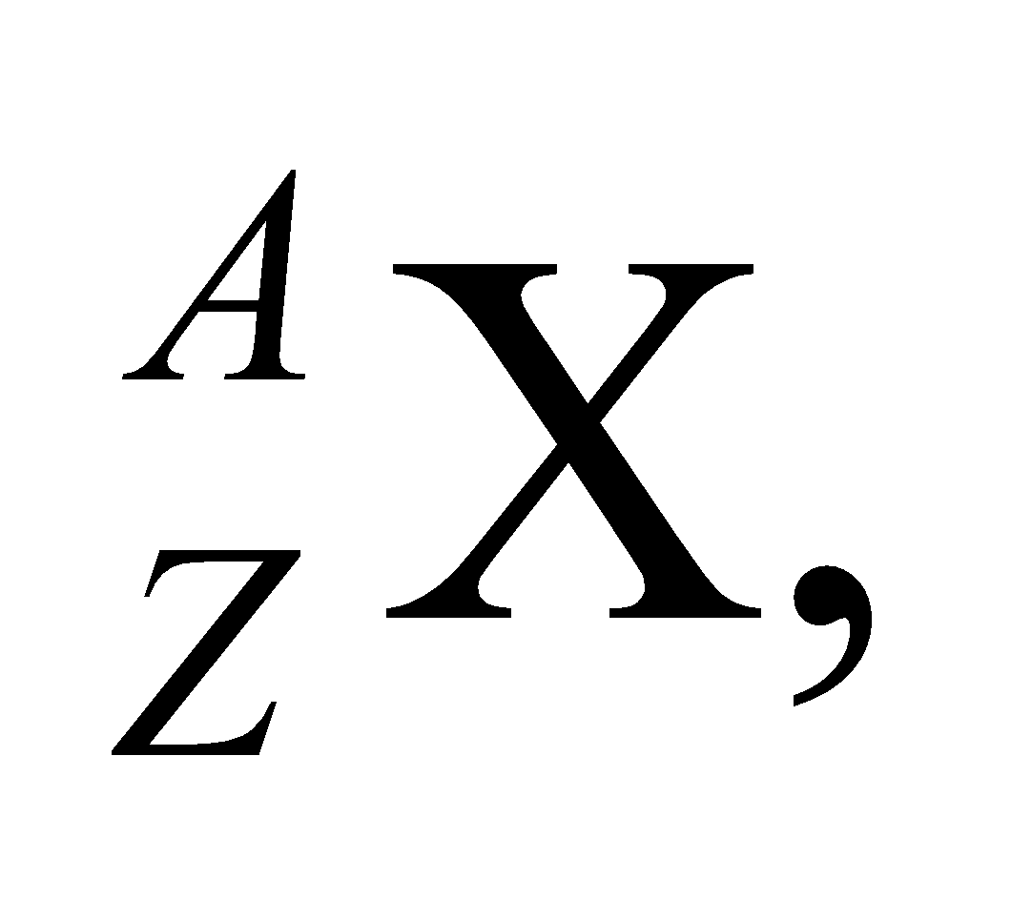 where *A* is the mass number and *Z* is the atomic number.

**Evaluate** With the number of protons (*Z* = 86 for all radon isotopes) and neutrons (N = A − Z) given, the mass numbers *A* of the three isotopes are, respectively,

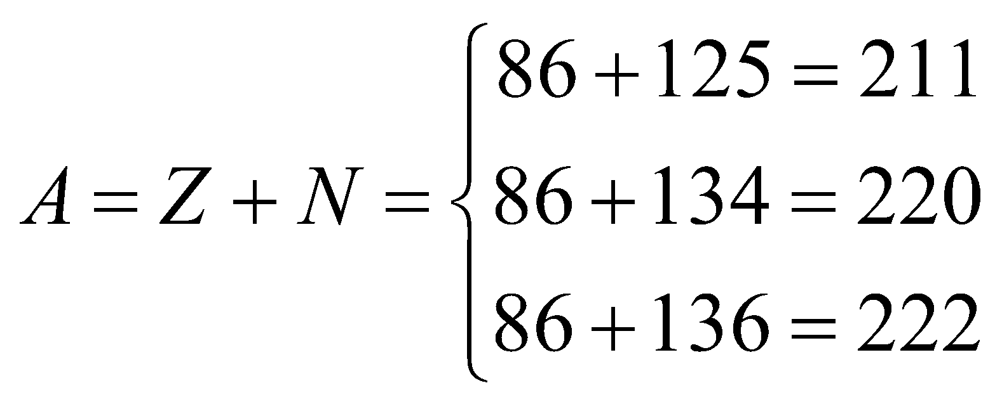

Therefore, the nuclear symbols are 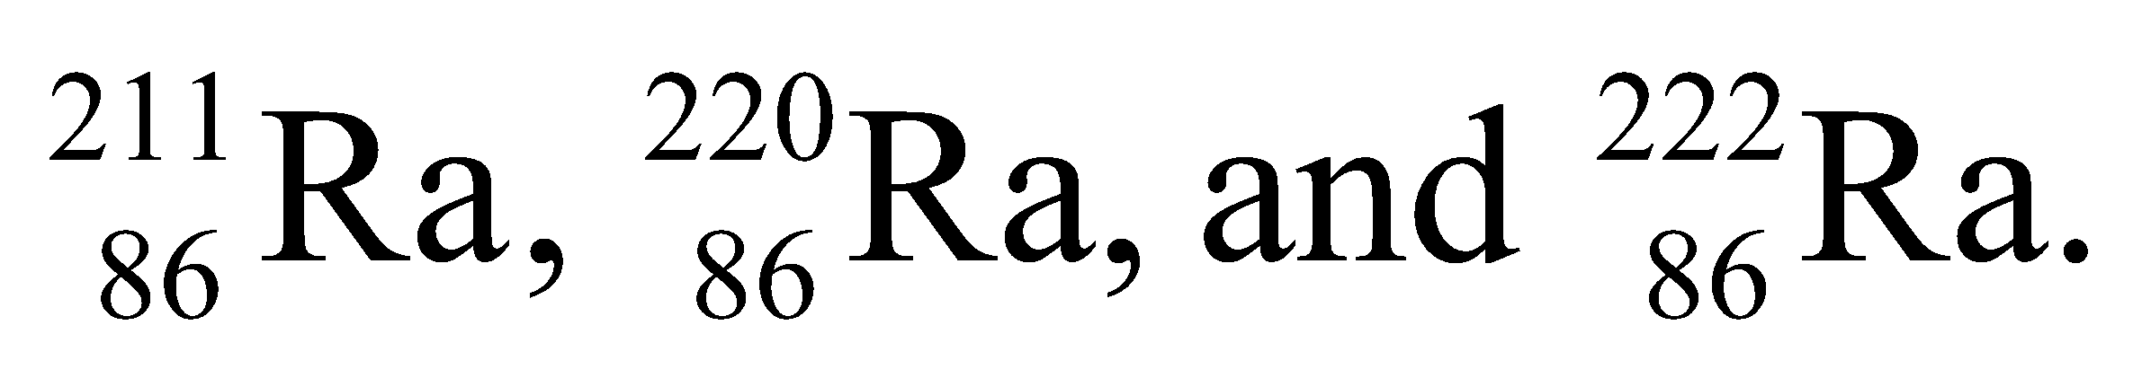

**Assess** Isotopes of a given element have the same number *Z* of protons but different number of neutrons (and thus a different value for *A*).

**14. Interpret** We are to give the symbol for the isotope of Ge with 44 neutrons.

**Develop** The mass number *A* = *Z* + *N*, where *N* = 44 is the number of neutrons. For Ge (a semiconductor under silicon in the periodic table), *Z* =32.

**Evaluate** The mass number *A* = 32 + 44 = 76, so its symbol is 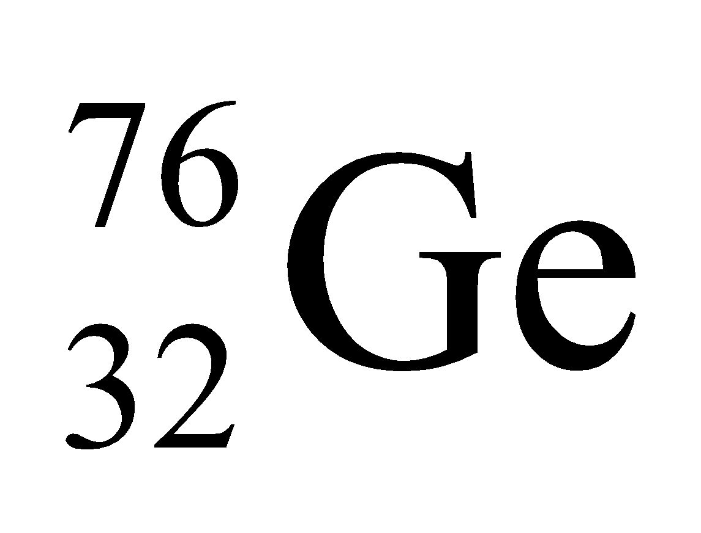.

**Assess** Recall that the mass of the isotope is given by the sum of the neutrons and protons in the nucleus.

**15. Interpret** We are given the symbol for two nuclei and asked to compare the number of nucleons and charges between them.

**Develop** The comparison can be made by noting that the conventional symbol for a nucleus X is 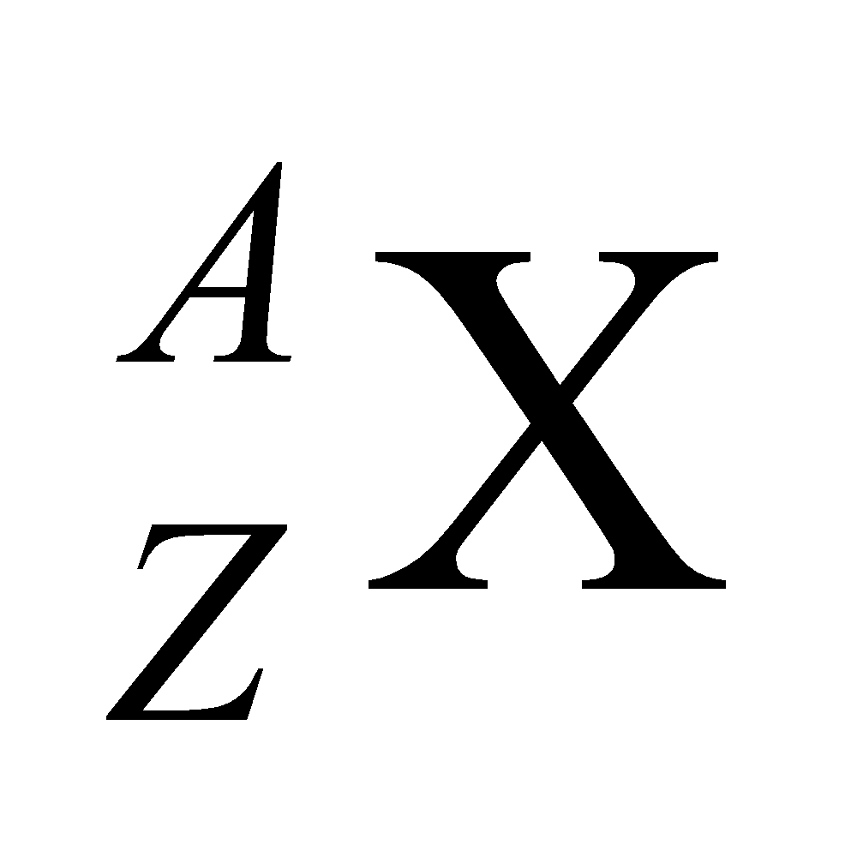 where *A* is the mass number and *Z* is the atomic number.

**Evaluate** **(a)** The mass number (number of nucleons) is *A* = 35 for both.

**(b)** The charge *Ze* of a potassium nucleus (*Z* = 19) is two electronic charge units greater than that for a chlorine nucleus, which has *Z* =17.

**Assess** Equality in mass number *A* does not imply equality in atomic number *Z*. Two nuclei have the same *Z* only when they are isotopes.

**16. Interpret** We are to compare the radius of the proton with the Bohr radius, which is a typical size to use for an atom.

**Develop** The “radius” of the proton may be estimated by applying Equation 38.1, 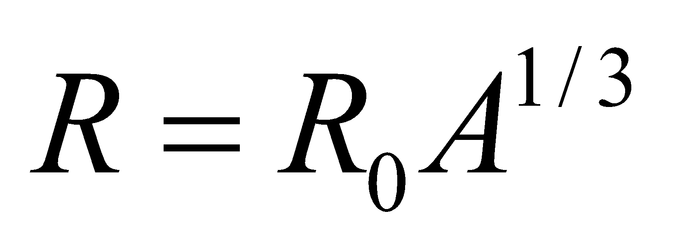 to a hydrogen nucleus (*A* = 1), which gives *R*H = 1.2 fm (the constant *R*0 = 1.2 fm). From the derivation of Equation 34.12a, the Bohr radius is *a*0 = 52.9 pm.

**Evaluate** Comparing the two gives

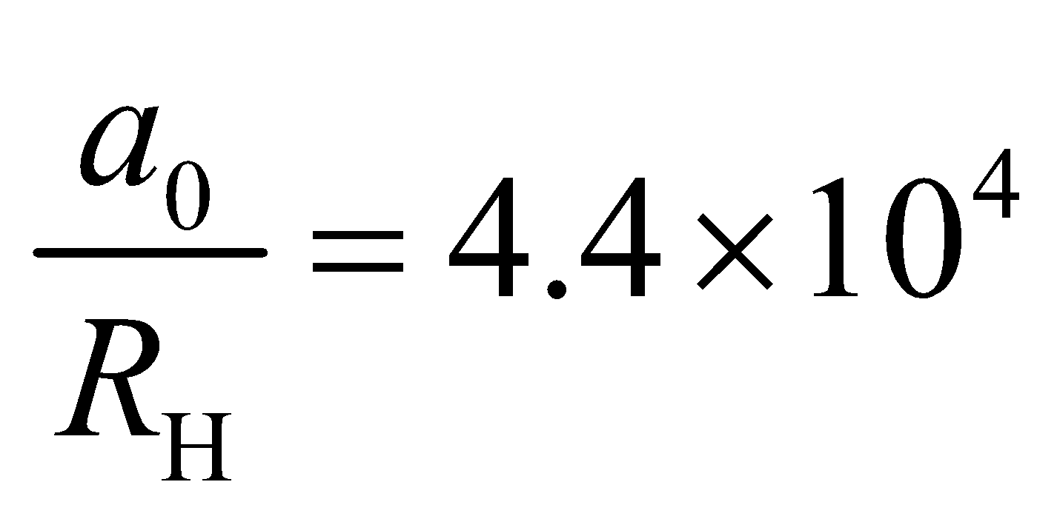

so the Bohr radius is about 44,000 times larger than the radius of a proton.

**Assess** In terms of volume, the fraction of space in a hydrogen atom that is not empty space is

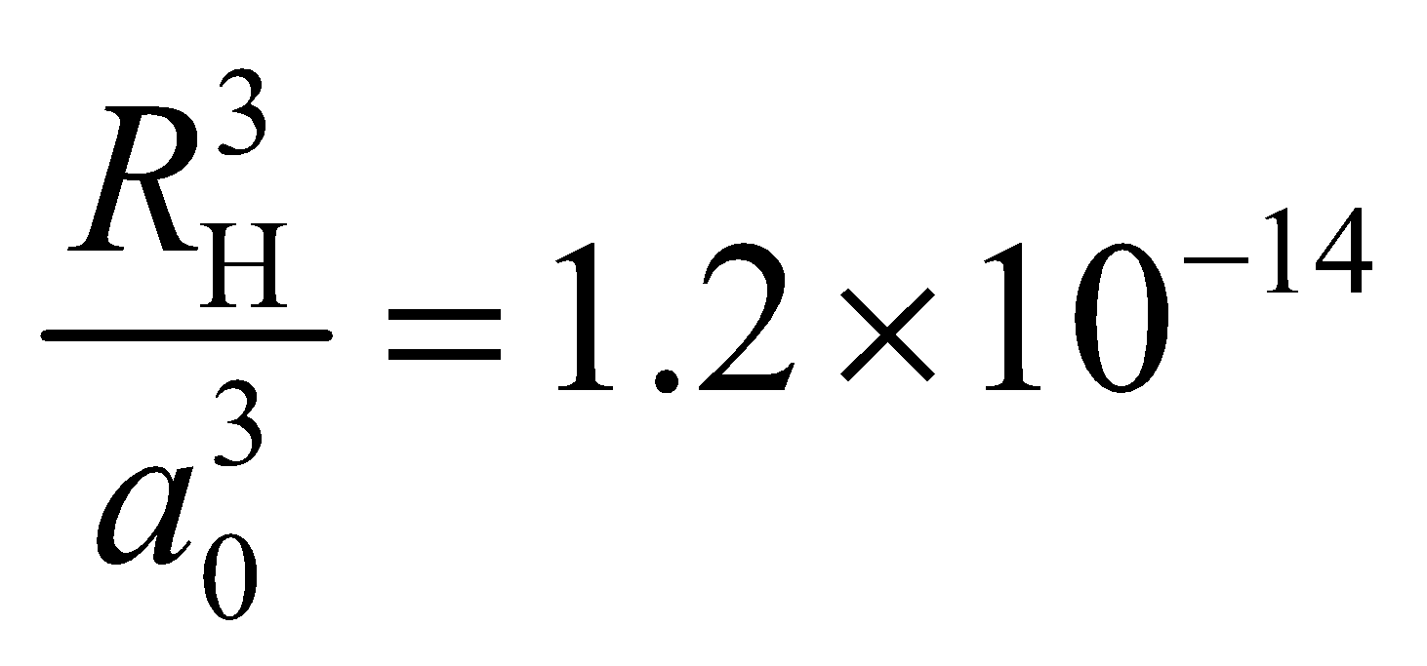

In other words, the hydrogen atom is mostly empty space!

**17. Interpret** We are to deduce the size of the fission products of 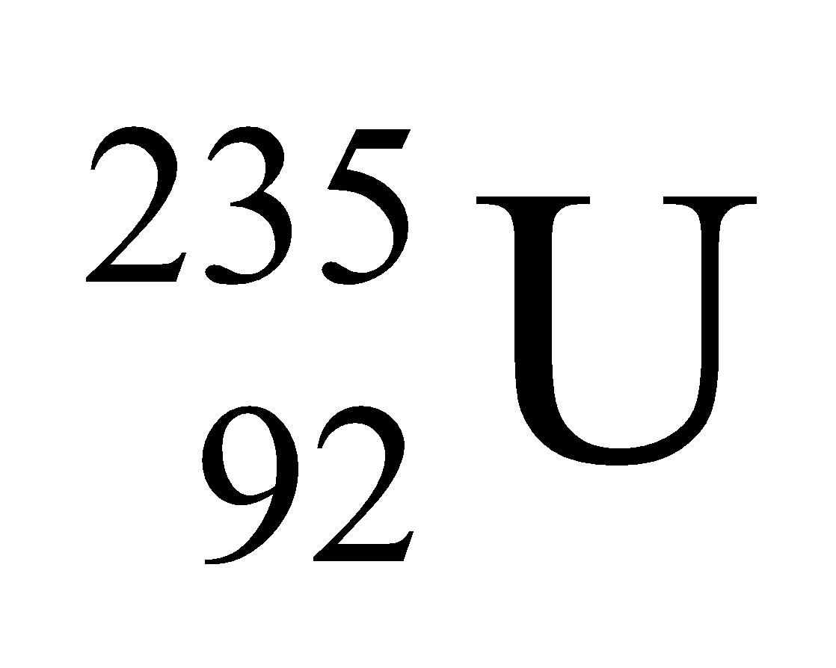, and find the radius of the daughter nuclei, given that they are of the same size.

**Develop** The nuclear radius can be estimated using Equation 38.1:

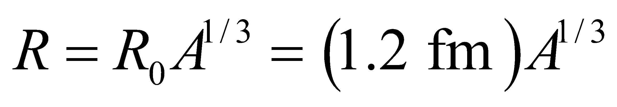

Given that the daughter nuclei are of the same size, the will each have half the number of nucleons of the parent nucleus, which has *A* = 235. Thus, the daughter nuclei will have *A* = 235/2 = 117 or 118.

**Evaluate** Inserting A = 117 or 118 into the expression above for the radius gives

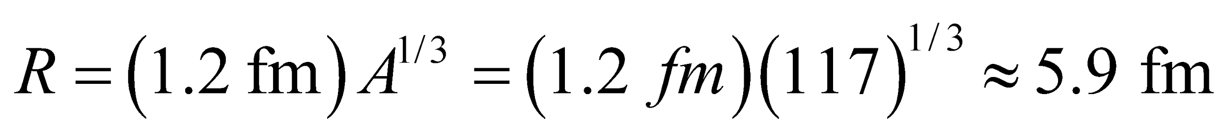

**Assess** Equation 38.1 is a good approximation for *R* since nucleons are packed tightly into the nucleus. The tight packing also suggests that all nuclei have roughly the same density.

**Section 38.2 Radioactivity**

**18. Interpret**  This involves radioactive decay. We are to determine the number of half-lives it takes for a radioactive sample to decay to 10% of its initial activity.

**Develop** Apply Equation 38.3b with *N* = *N*0/10 and solve for *t* in terms of *t*1/2.

**Evaluate** The number of half-lives required is

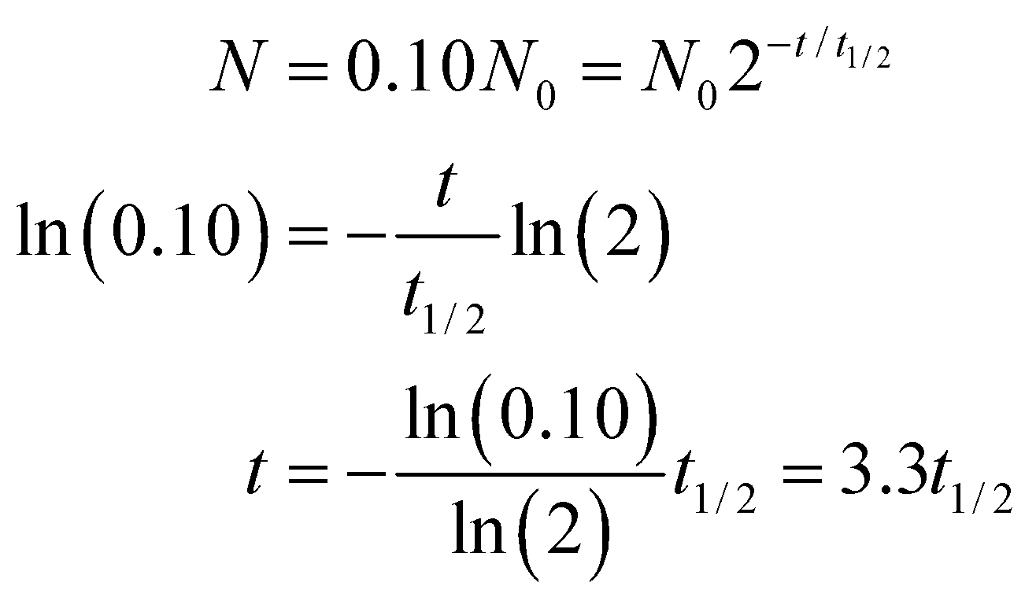

**Assess** Let’s see if our result makes sense. After one half-life, the activity is 1/2 the initial activity, after 2 it’s ¼ and after 3 it’s 1/8. The target of 10% of the original activity is just a bit less than 1/8, so our answer of a little more than three half-lives seems about right.

**19. Interpret** In this problem we are asked to write down all possible beta-decay processes for 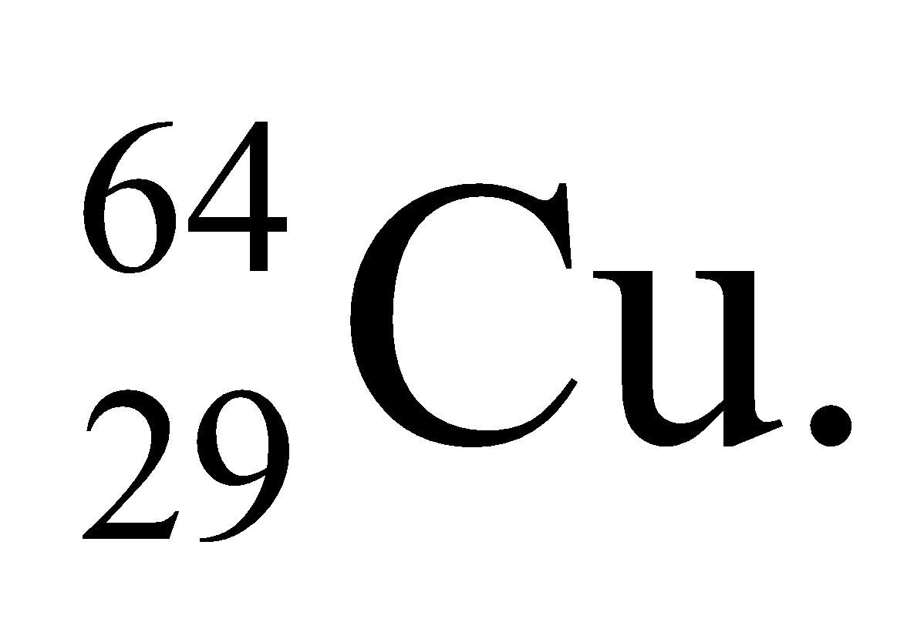

**Develop** As detailed by Equations 38.5a, 38.5b, and 38.5c, beta decay in 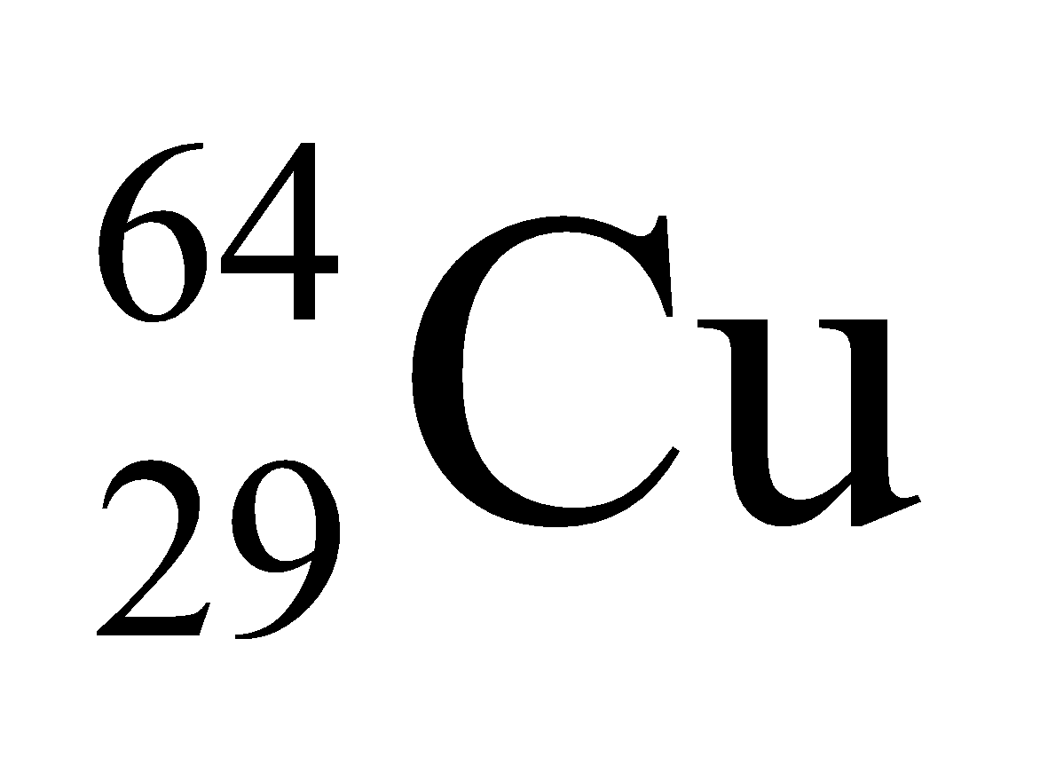 can involve positron-neutrino or electron-anti-neutrino emission, or electron capture. In each reaction, charge and mass number must be conserved.

**Evaluate** The reactions are

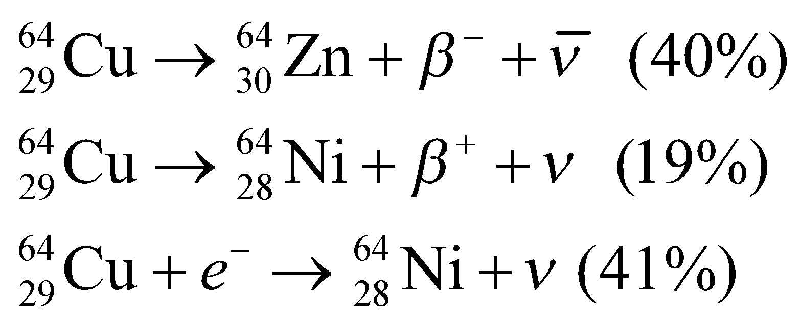

**Assess** In each decay mode, charge and mass number are conserved.

**20. Interpret** We are to give the reactions for the two given nuclei using data from Figure 38.7.

**Develop** Radon-222 decays by emitting two neutrons and two protons, which constitutes an alpha particle. Thus, *A* is decremented by 4 nucleons and *Z* is decremented by 2 protons so the daughter nucleus has *A* = 222 − 4 = 218 and *Z* = 86 − 2 = 84 (i.e., Po). The decay of lead-214 proceeds by the conversion of a neutron into a proton via beta decay. The mass number *A* is unchanged (addition of a proton and loss of a neutron), and the atomic number *Z* is incremented by one, so the daughter nucleus has *Z* = 82 + 1 = 83 (i.e., Bi) and *A* = 214 +1 − 1 = 214.

**Evaluate (a)** The decay reaction for radon-222 is

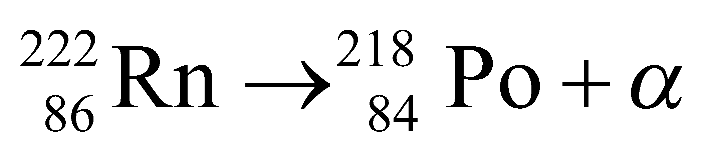

**(b)** The reaction for lead-214 is

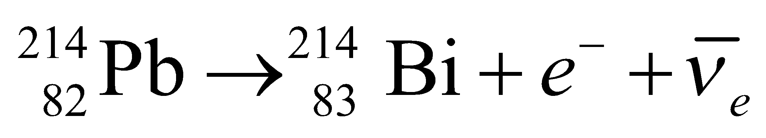

**Assess** Charge and mass are conserved in each reaction.

**21. Interpret** This problem is an exercise in conversion between Ci and Bq.

**Develop** Section 38.2 gives the relation between Ci and Bq: 1 Ci = 3.7 × 1010 Bq.

**Evaluate** The activity of the milk sample in SI units is

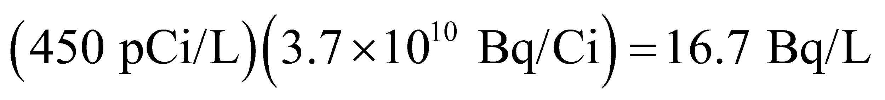

**Assess** The more modern unit is the Bq.

**22. Interpret** The problem considers how long a prescribed dose of carbon-11 will remain significantly radioactive following a PET scan.

**Develop** The radioactivity of a sample is proportional to the number, *N*, of radioactive atoms it contains. Over time, this number decreases according to Equation 38.3b, 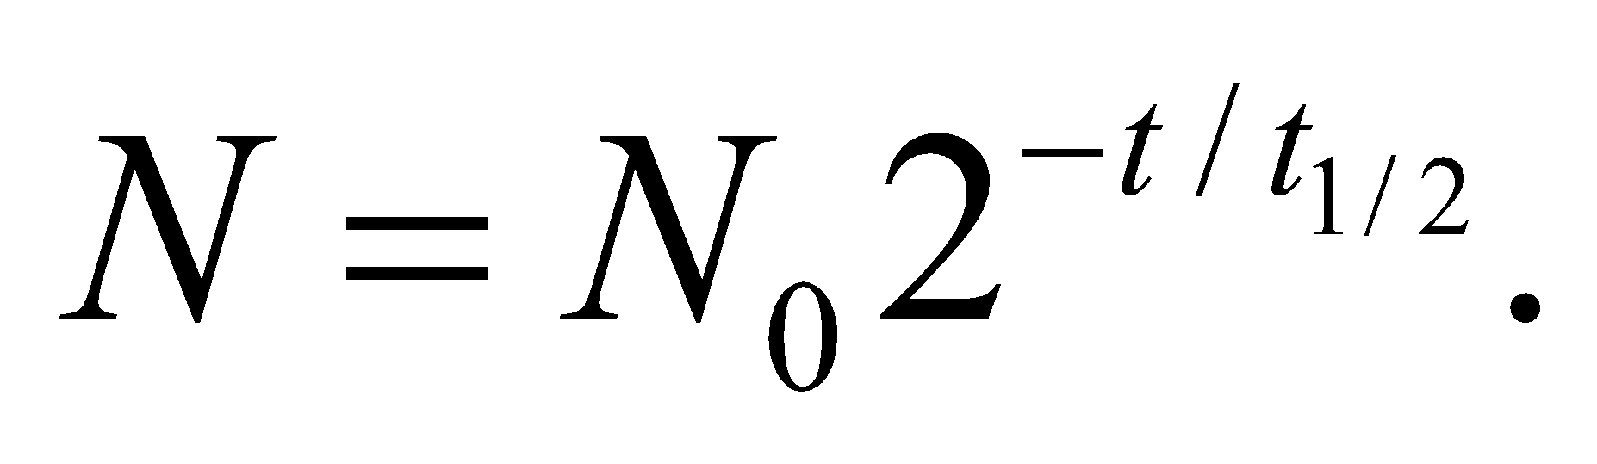The half-life of C-11 is given as 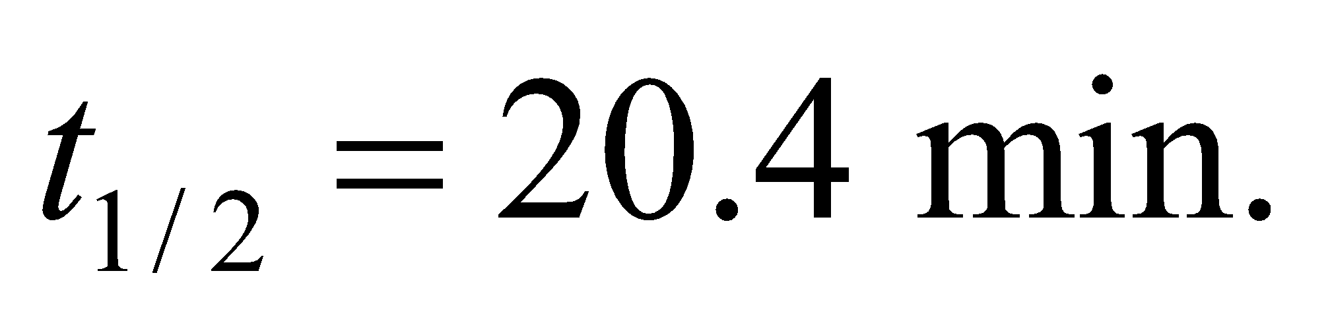

**Evaluate**  (a) The time it will take for the activity of C-11 to drop from 2 billion to 7000 becquerel (Bq) is the same as the time it takes for the number of C-11 to drop by the same factor:

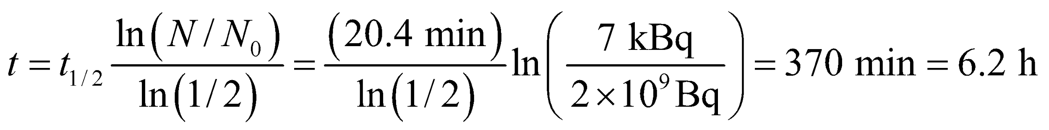

(b) As described in Equation 38.5b, positron emission converts a proton to a neutron:

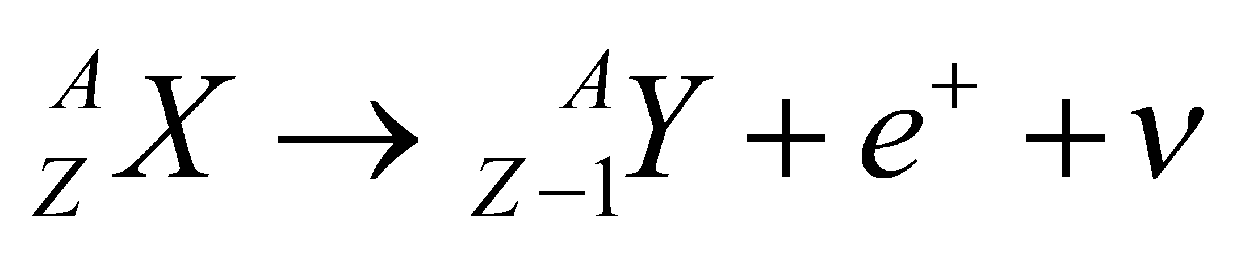

The carbon-11 nucleus 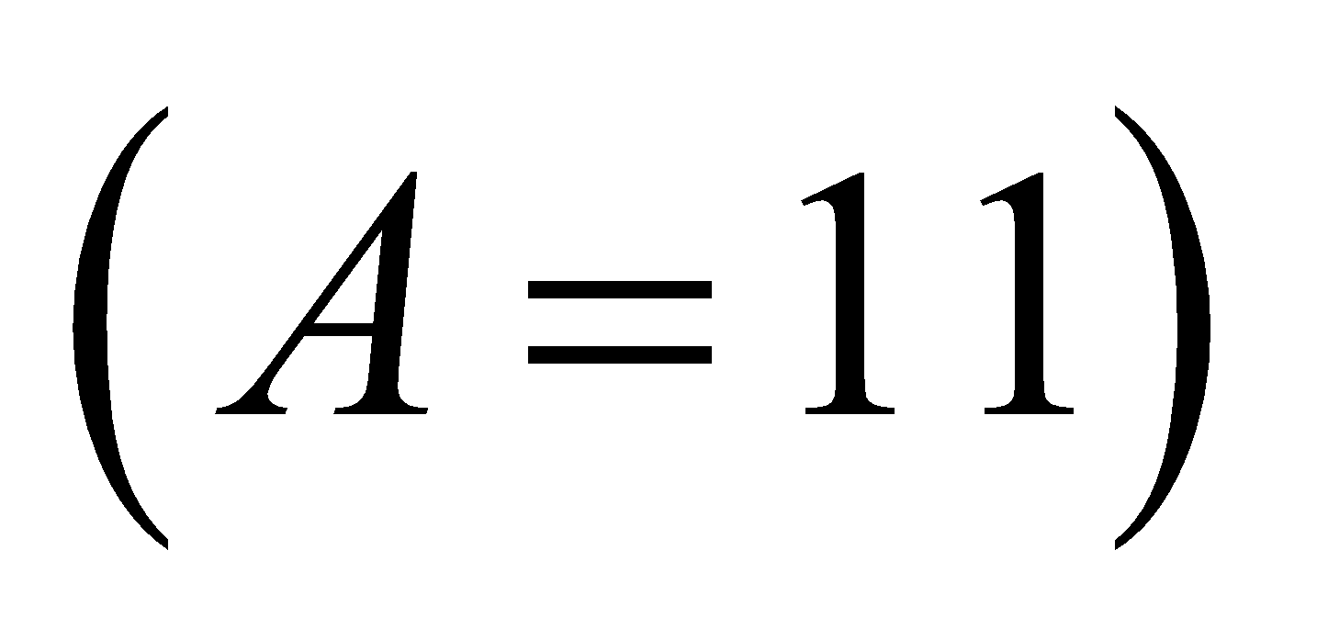has 6 protons 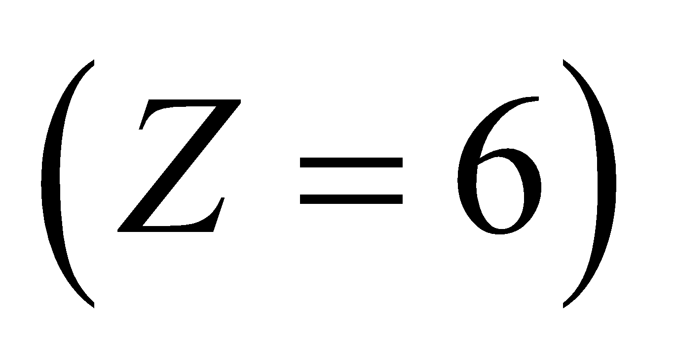 and 5 neutrons. If it decays through positron emission (Equation 38.5b), then its atomic number drops by one to 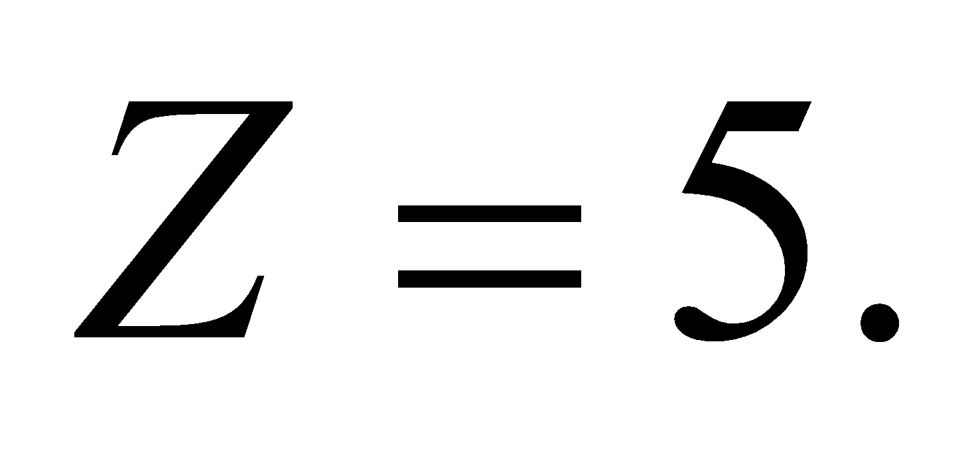 In the Periodic Table, that would correspond to boron, specifically 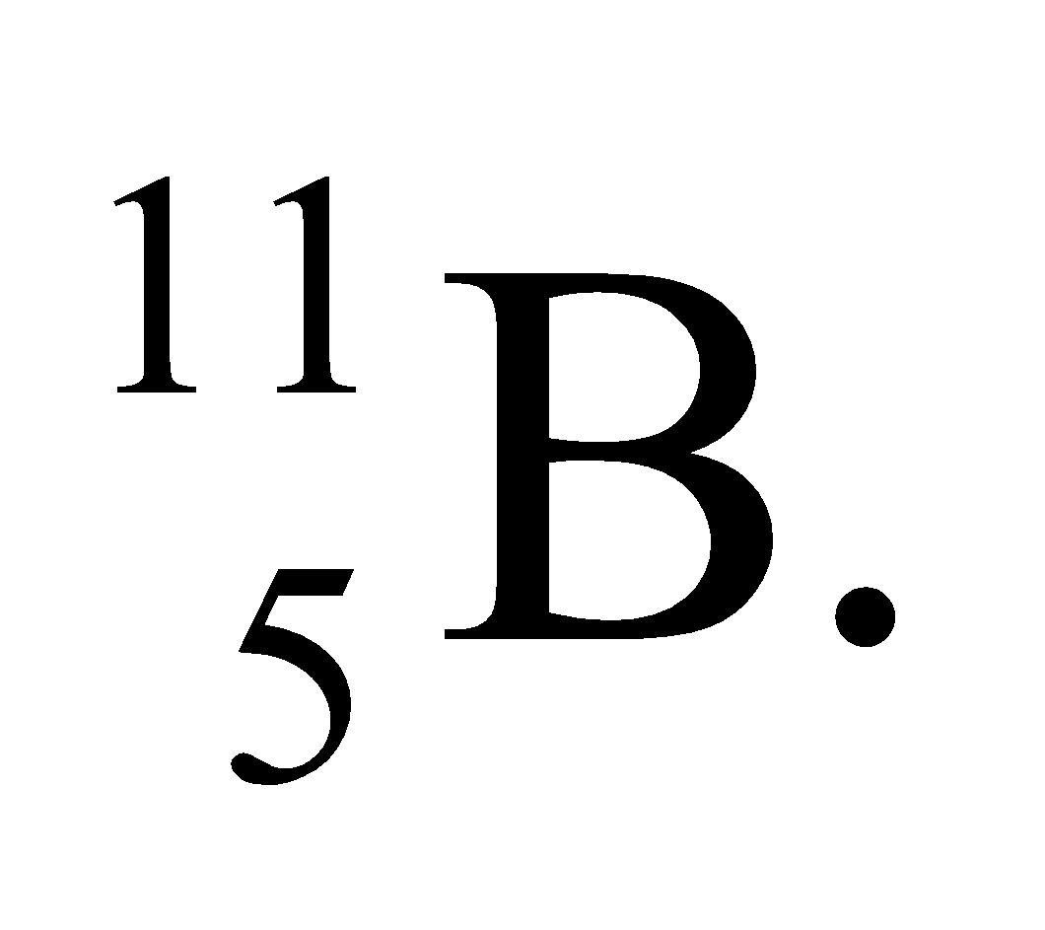

**Assess** For medical scans, a short lifetime such as that for C-11 is desirable, so that the total radiation exposure is limited.

**23. Interpret** This is a problem about the decay of 90Sr. We are to find the time it will take for the activity of 90Sr to decay to the 99% and 99.9% of its original activity.

**Develop**  From Table 38.1, we find the half-life of 90Sr to be 29 years. Solving for the elapsed time *t* in Equation 38.3b, 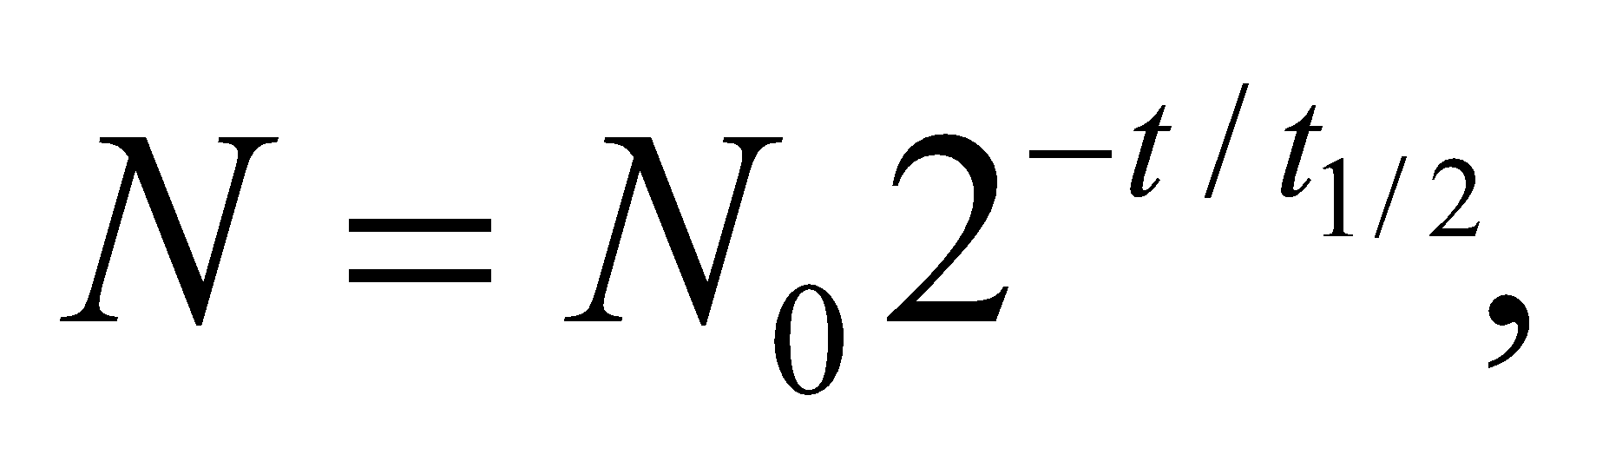 the time elapsed since the bomb tests is

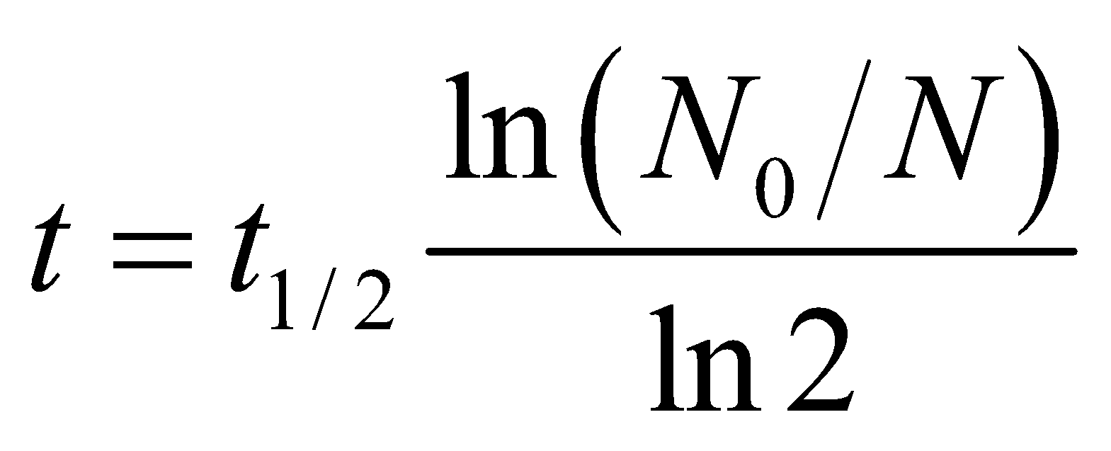

The fraction *N*/*N*0 of 90Sr that remains is one minus the fraction that decays.

**Evaluate** **(a)** For 99% of the radioactive contaminant to decay, or 1% to remain (*N*/*N*0 = 1.00 − 0.99 = 0.01) the time required is

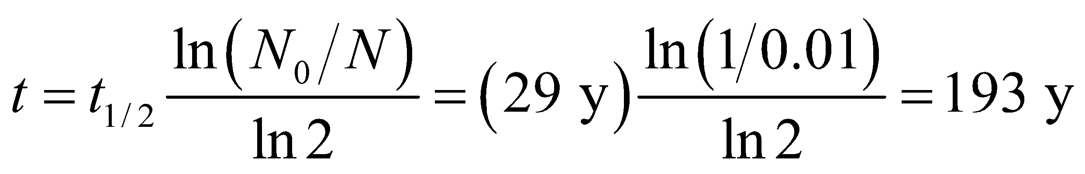

**(b)** Similarly, for 99.9% of the radioactive contaminant to decay, or 0.1% to remain, the time required is

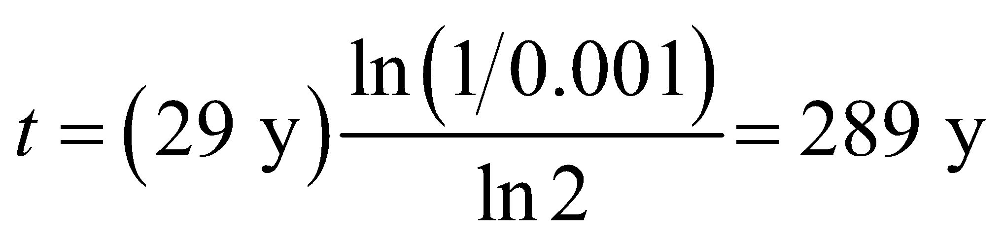

**Assess** Since 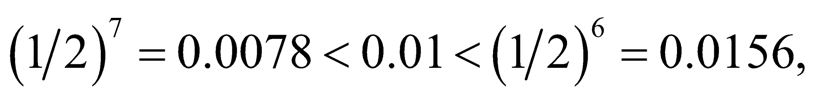 for 1% of contaminant to remain, 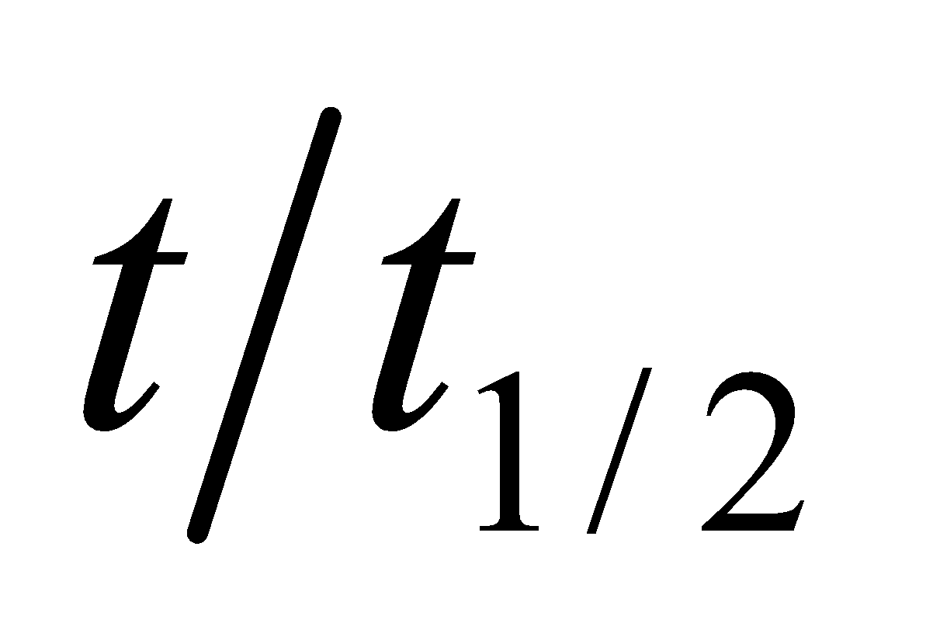 must be between 6 and 7, so our result of 193/29 = 6.66 is reasonable. Similarly reasoning also shows that our result for **(b)** is about right.

**Section 38.3 Binding Energy and Nucleosynthesis**

**24. Interpret** We are to find the total binding energy of the given nucleus, given its nuclear mass.

**Develop** Solve Equation 38.7

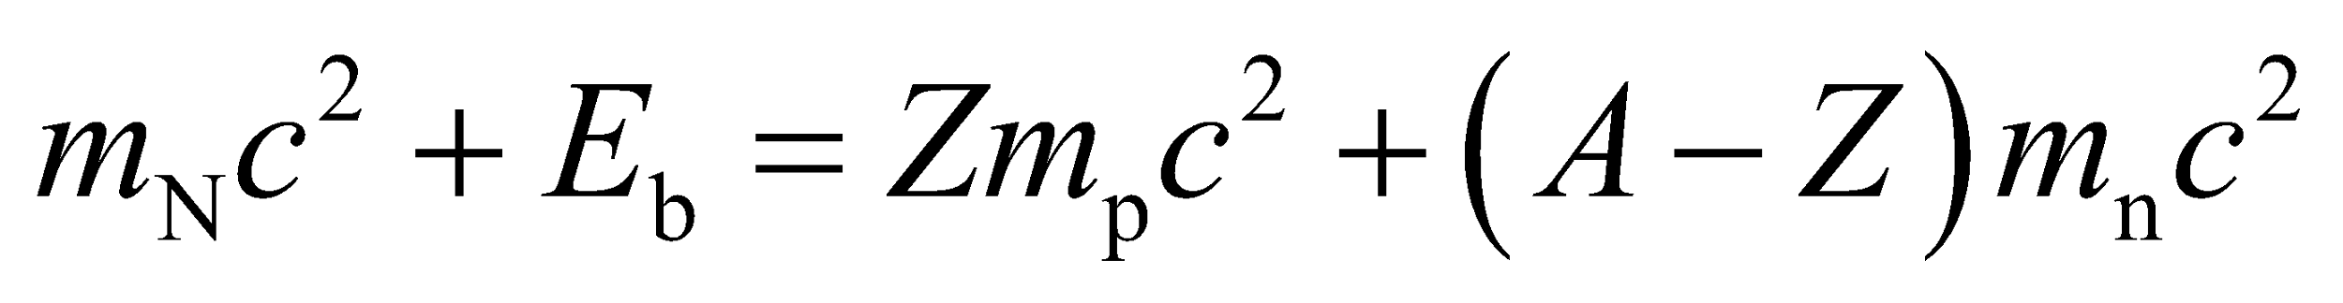

for the binding energy *E*b, with the help of the data from Table 38.2.

**Evaluate** The binding energy of 16O is



**Assess** This works out to about 8 MeV/nucleon.

**25. Interpret** We’re given the binding energy per nucleon for 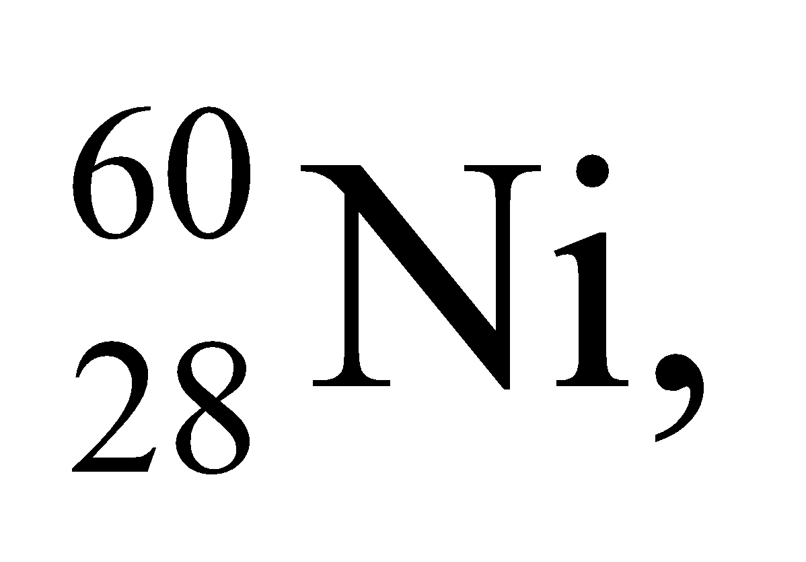 and asked to find its atomic mass.

**Develop** Using Equation 38.7, the binding energy of a nucleus can be written as

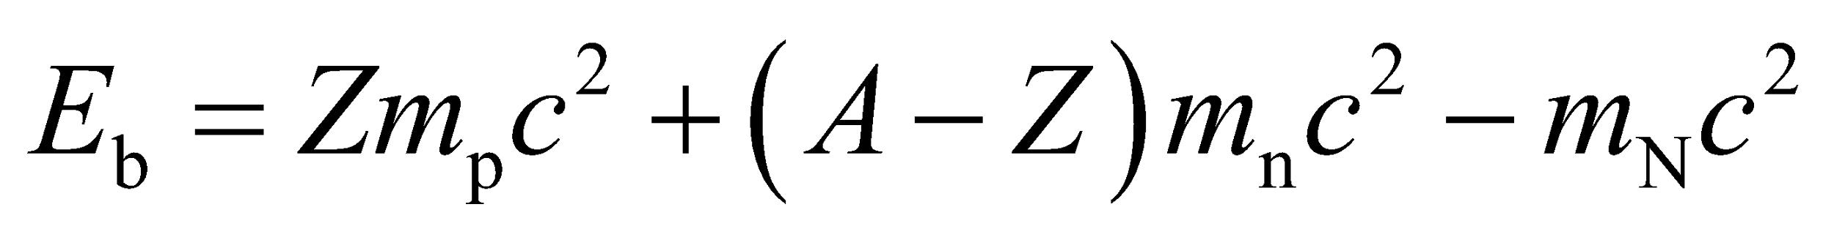

where *m*b, *m*n, and *m*N are the masses of the protons, neutrons, and the nucleus, respectively. The total nuclear binding energy of 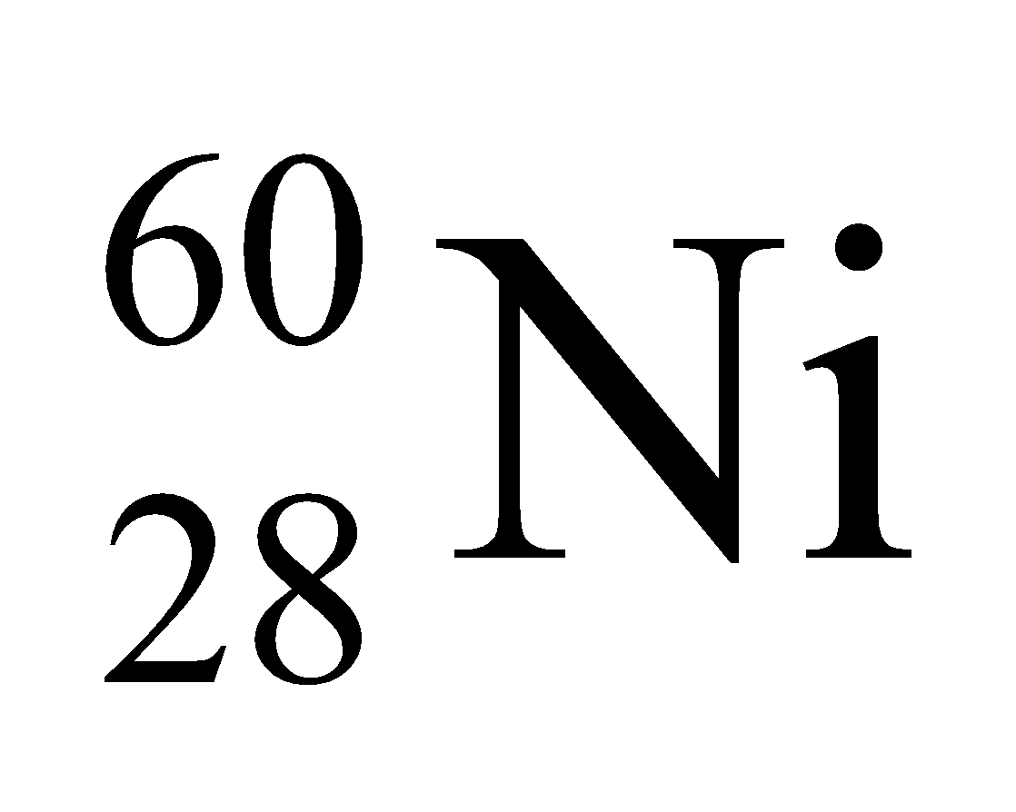 is the number of nucleons (*A* = 60) times the given binding energy per nucleon, or

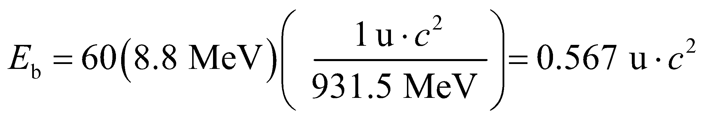

The result can be used to solve for the atomic mass of .

**Evaluate** If we express Equation 38.7 in terms of atomic masses, by adding *Z* = 28 electron rest energies

(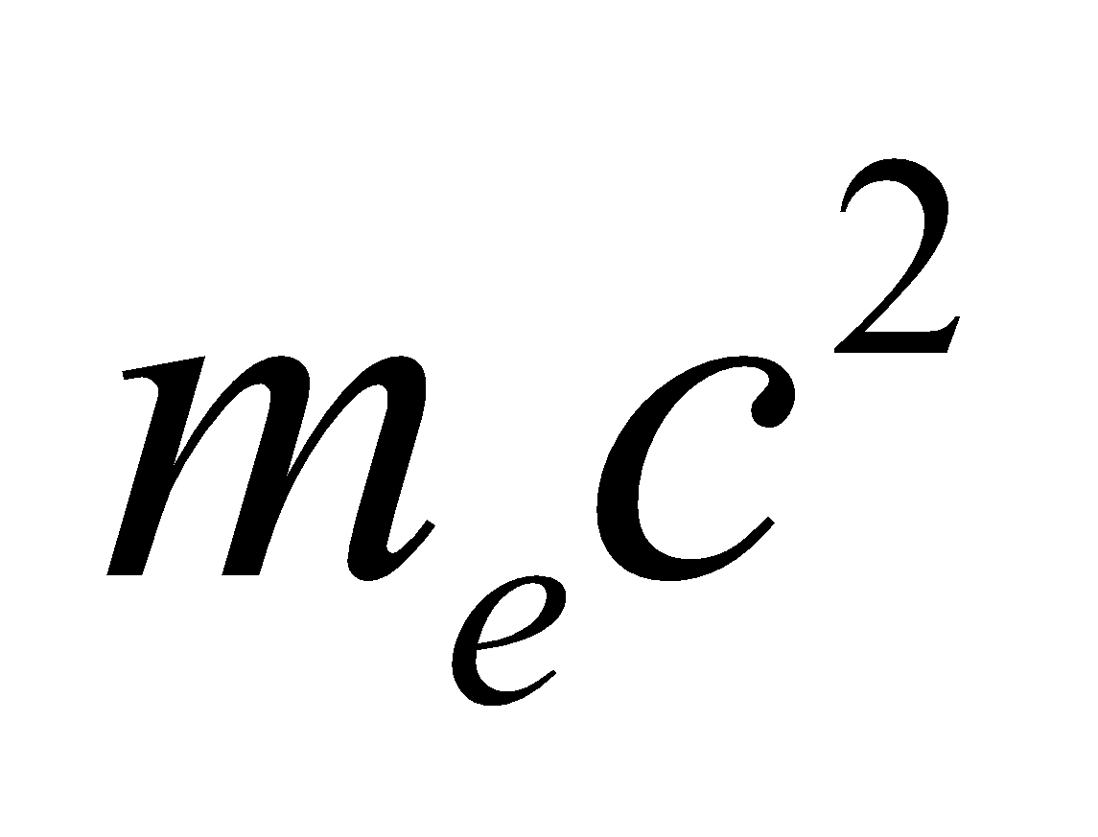) to both sides, and neglect atomic binding energies, we obtain:



where we have retained only two figures after the decimal point because the binding energy is known with that precision.

**Assess** The actual binding energy of 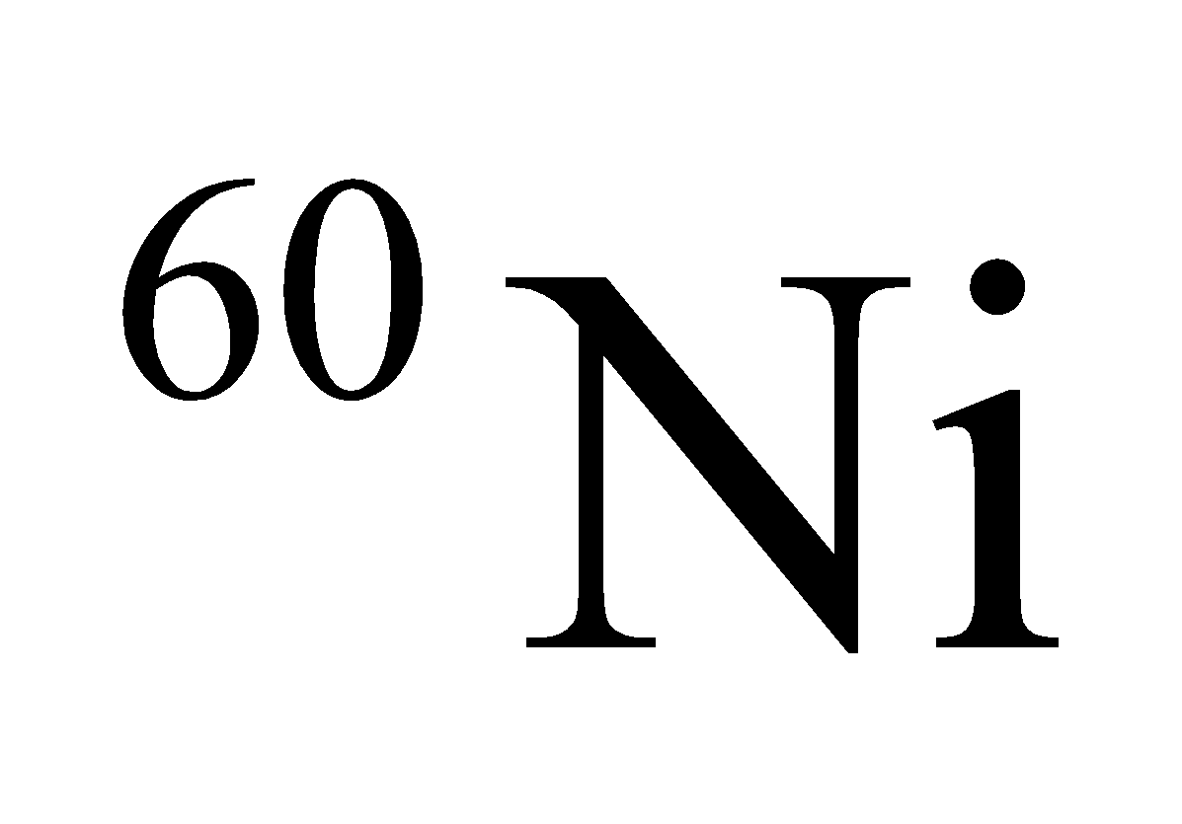 is so close to 8.8 MeV/nucleon that the accuracy of the atomic mass just calculated is better than one might expect from data given to two significant figures.

**26. Interpret** We are to find the nuclear mass of the given element, using its known atomic mass.

**Develop** To obtain the nuclear mass, subtract the mass of *Z* = 94 electrons from the given atomic mass of plutonium, and neglect the atomic binding energy.

**Evaluate** The nuclear mass of plutonium-239 is



**Assess** The nuclear mass differs from the atomic mass by about 0.02%.

**27. Interpret** In this problem we are asked to find the binding energy per nucleon for 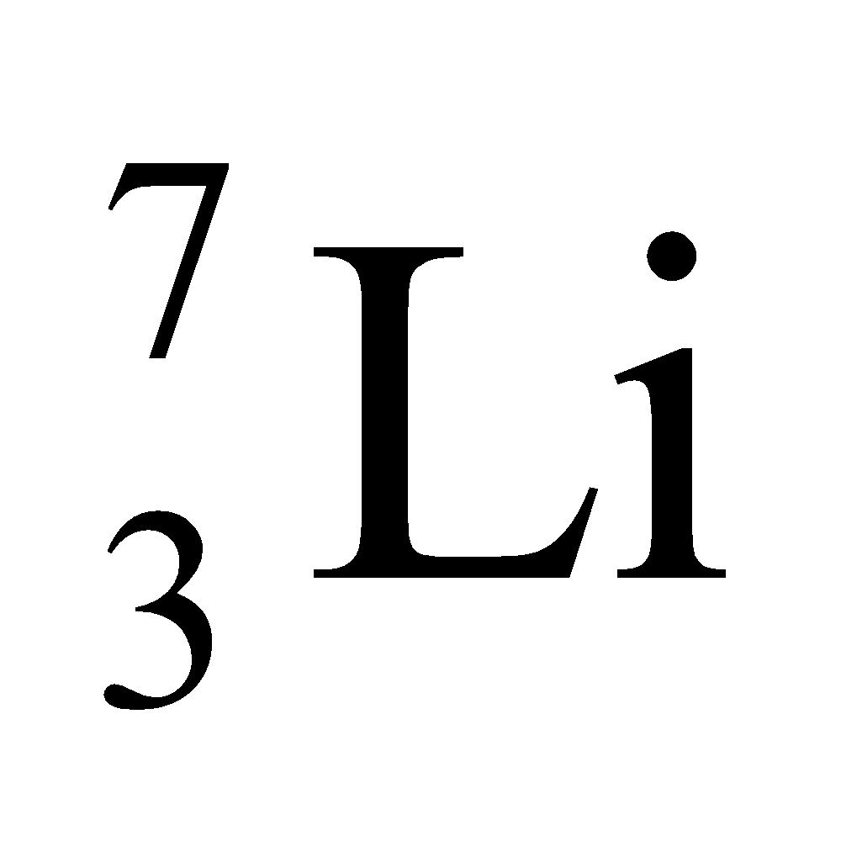 given its nuclear mass.

**Develop** Using Equation 38.7, the binding energy per nucleon of a nucleus can be written as

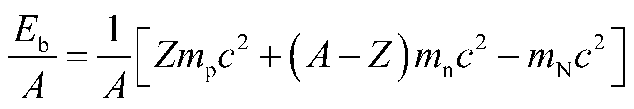

where *m*p, *m*n, and *m*N are the masses of the protons, neutrons, and the nucleus, respectively.

**Evaluate** Substituting the values given, we find

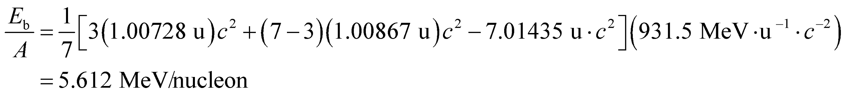

**Assess** The binding energy per nucleon as a function of *A* is plotted in Fig. 38.9. For very light nuclides such as 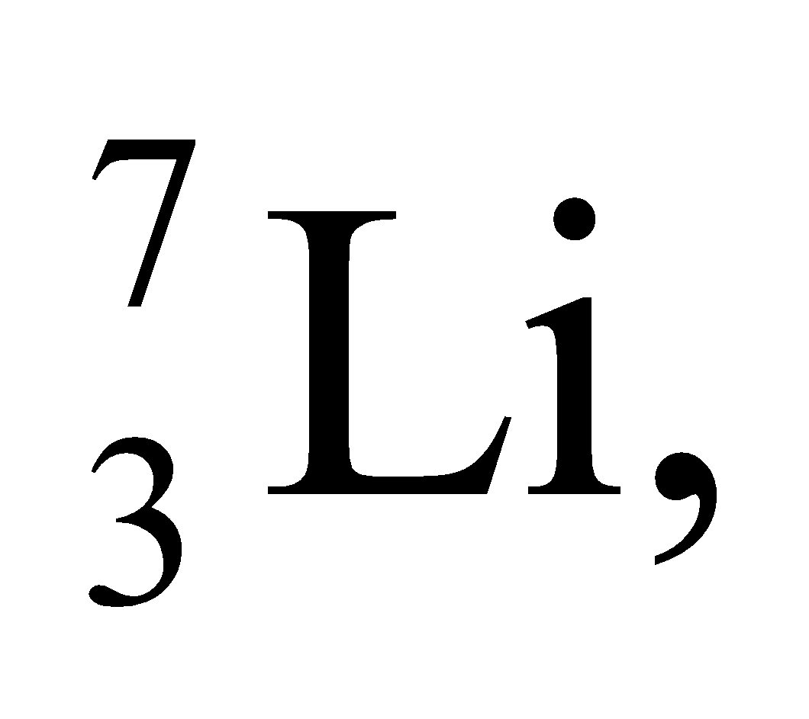 the energy is low because the nuclear force is not yet saturated for so few nucleons.

**Section 38.4 Nuclear Fission**

**28. Interpret** This problem involves a reaction in which 235U is fissioned via a reaction involving a neutron. We are given the decay products except for one daughter nucleus, which we are to find.

**Develop** The fission reaction described is

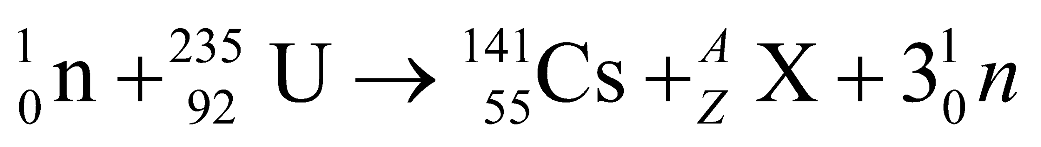

Apply conservation of mass and atomic number to find the daughter nucleus X.

**Evaluate** Conservation of mass number and atomic number requires 1 + 235 = 141 + 3 + *A* and 0 + 92 = 55 + 0 + *Z*, so *A* = 92 and *Z* = 37. Reference to Appendix D identifies this nuclide as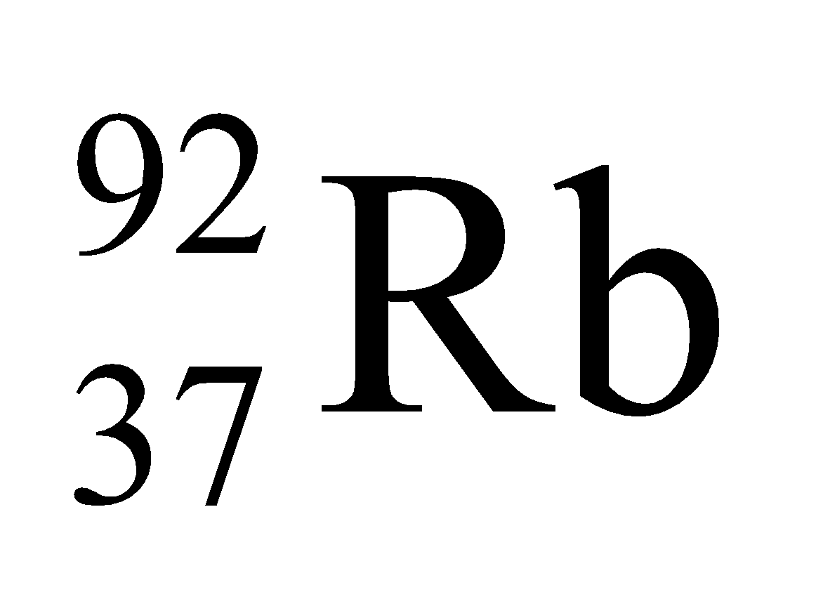.

**Assess** Thus, 141Cs and 92Rb are byproducts of nuclear fission reactors.

**29. Interpret** This problem is about the number of neutrons released in the fission of 235U. We are given the daughter nuclei produced in neutron-induced fission of 235U and are asked to find the number of neutrons released.

**Develop** This reaction is described by the formula

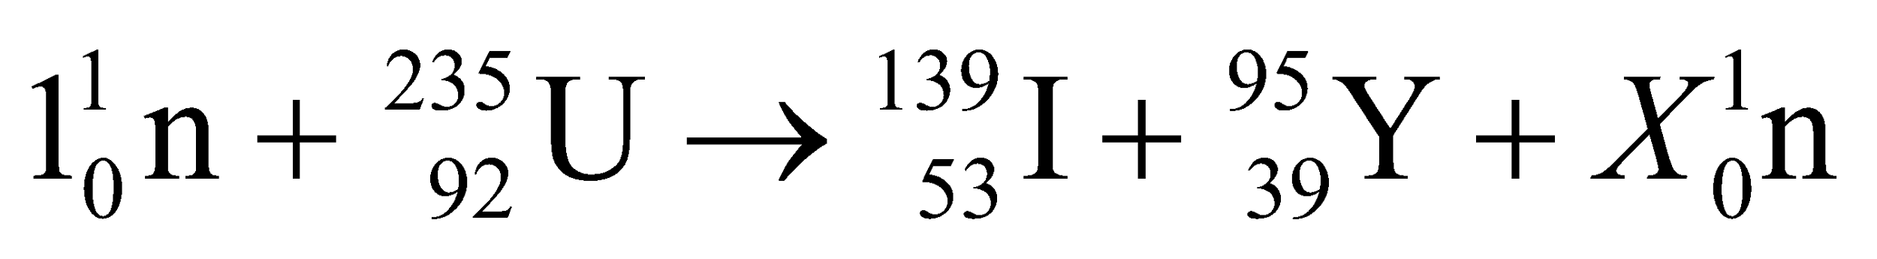

Thus, the initial number of neutrons is 1 + (235 − 92) = 144. The final number of neutrons, which must be the same because charge is conserved and the number of protons does not change, is 144 = (139 − 53) + (95 − 39) + *X*.

**Evaluate** Solving the equation above for the number of neutrons *X* gives *X* = 144 − (139 − 53) − (95 − 39) = 2.

**Assess** As expected, the fission process produces two middle-weight products with notably unequal masses. The number of neutrons released is in accordance with conservation of the number of nucleons.

**30. Interpret** We are to give the complete formula for the given reaction, for which we must first find one of the two daughter nuclei.

**Develop** Apply conservation of charge and nucleons in the reaction

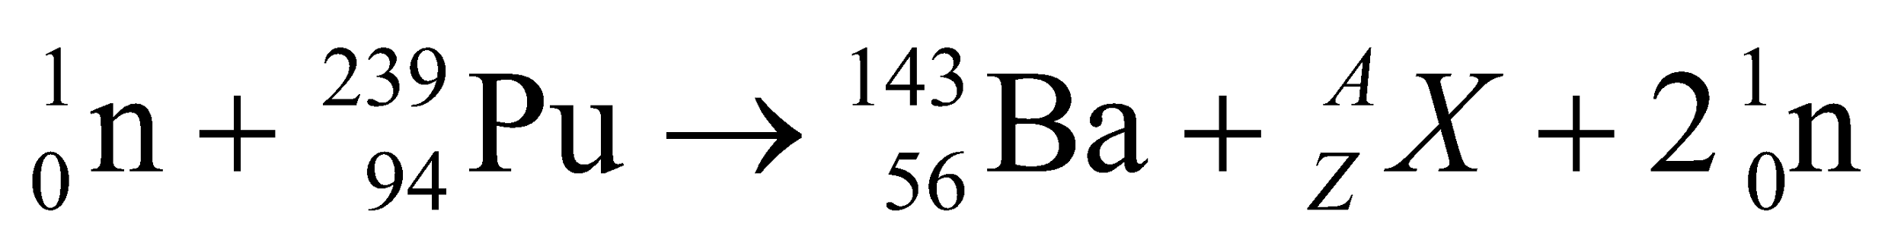

Conservation of charge gives 0 + 94 = 56 + *Z* + 0, or *Z* = 38. Conservation of nucleon number gives 1 + 239 + 143 + *A* + 2, or *A* = 95.

**Evaluate** Thus, the missing nucleon is 95Sr and the complete reaction is 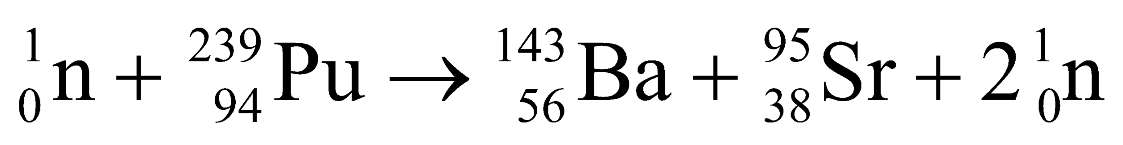.

**Assess** The conservation of charge and mass number are respected in this reaction.

**31. Interpret** We are given the power output in a fission reactor and energy released per fission event and are asked to find the fission rate.

**Develop** We assume that all of the energy released in fissions goes into thermal power. Thus,

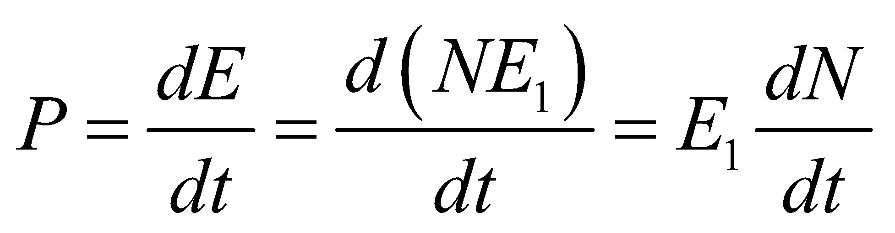

where *E*1 = 200 MeV is the energy released per fission event and *P* = 3.2 GW.

**Evaluate** The fission rate *dN*/*dt* is

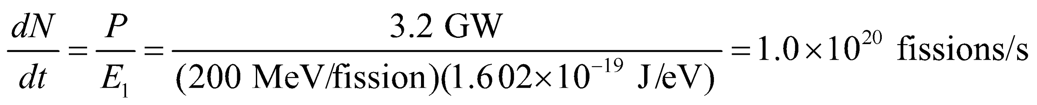

**Assess** A very high fission rate is required to achieve this power output.

**Section 38.5 Nuclear Fusion**

**32. Interpret** We are to sum up the energies released in each step of the proton-proton cycle to verify that the net energy released is as given in the text.

**Develop** In the proton-proton cycle, reactions 38.9a and 38.9b occur twice for each 4He-nucleus produced in reaction 38.9c.

**Evaluate** The net energy yield is 2(0.42 + 5.49 + 1.02) MeV + 12.86 MeV = 26.72 MeV. This agrees with the value given in the text.

**Assess** The individual *Q*-values, or energy released, given in these reactions can be verified from tabulated isotope masses.

**33. Interpret** This problem is about the Lawson criterion for D-T fusion. We are interested in the density of the nuclei required to meet this criteria for the given confinement time.

**Develop** The Lawson criterion for D-T fusion is 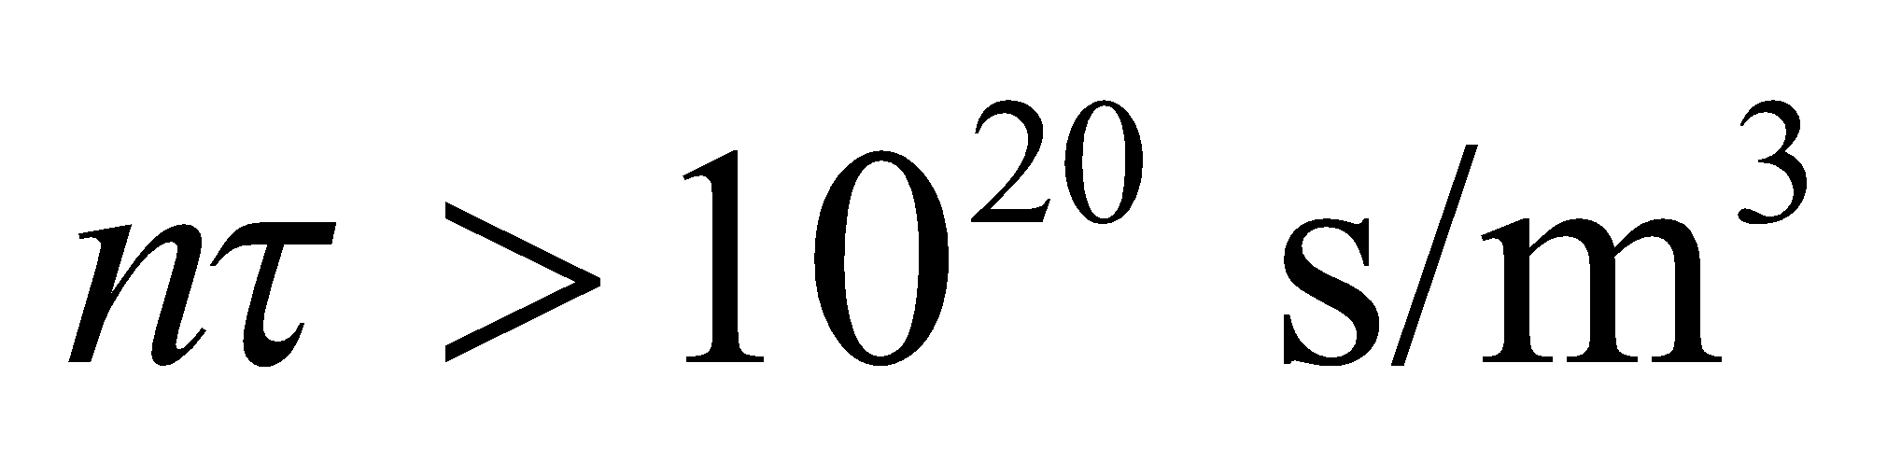 (Equation 38.11). This condition allows us to solve for *n*.

**Evaluate** For *τ* = 0.5 s, a particle density of

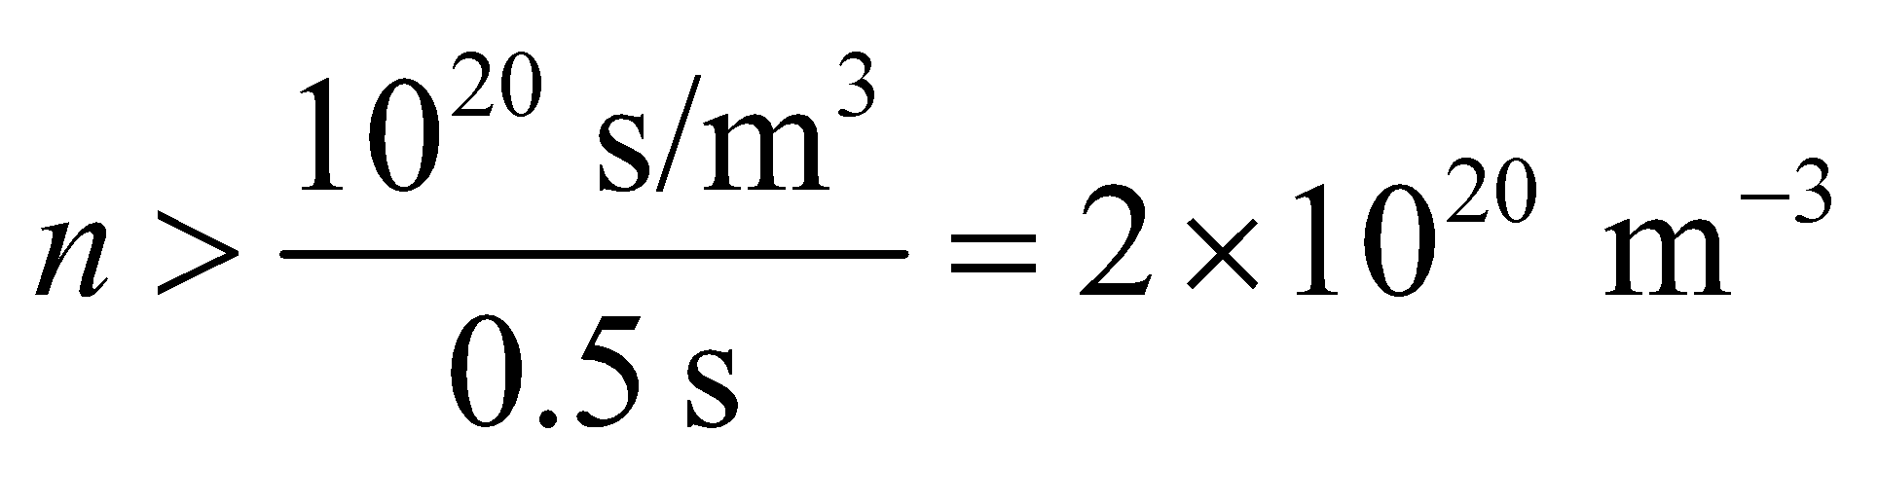

would be required.

**Assess**This is a very high density. From the Lawson criterion, we see that in order to achieve self-sustaining fusion, we must have a high nuclei density and confine them long enough such that the product *nτ* exceeds 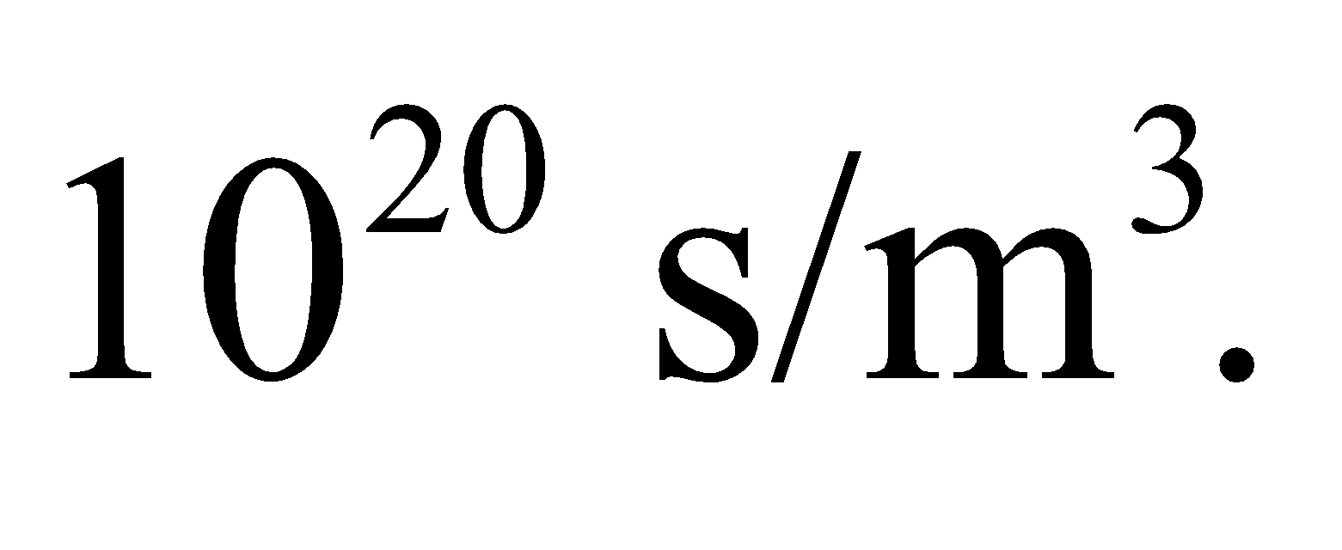 So far, the approach has not yet produced a sustained energy yield.

**34. Interpret** We are given a confinement time for D-T fusion and are asked to find the corresponding density required to satisfy the Lawson criterion.

**Develop** Apply Equation 38.11 for D-T fusion, using *τ* = 0.1 ns.

**Evaluate** For a confinement time as short as 0.1 ns, the Lawson criterion (Equation 38.11) demands a particle density of

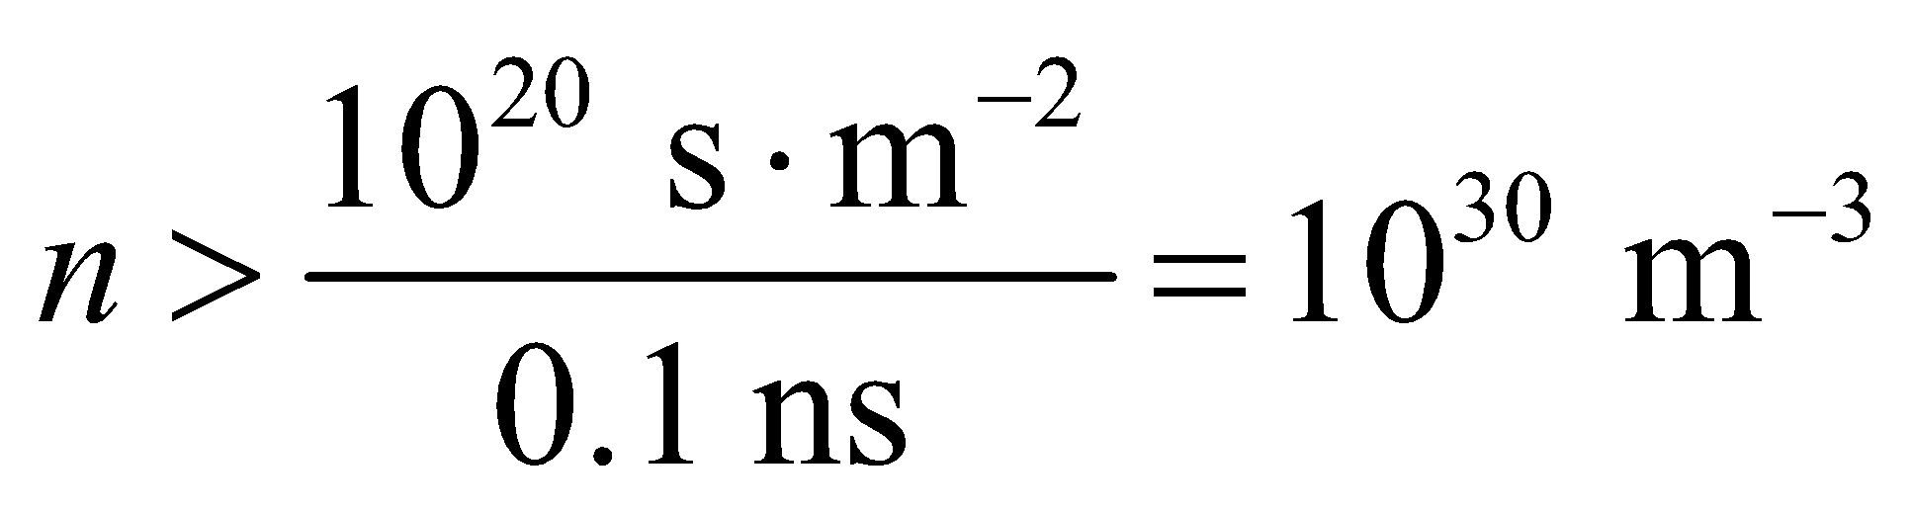

**Assess** This is 30 times the particle density of water molecules under ordinary conditions.

**35. Interpret** Using the Lawson criterion, we are to find the required confinement time for D-T fusion, given the plasma density.

**Develop** The D-T Lawson criterion is 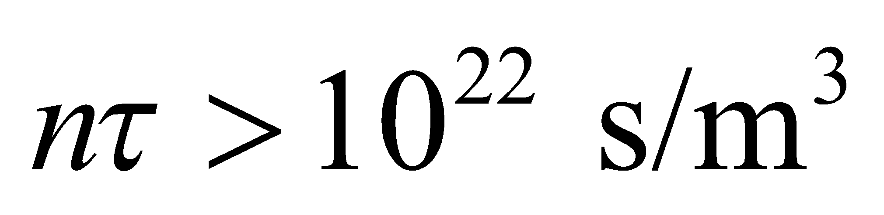 (Equation 38.10), and the number density given in the problem is *n* = 1019 m−3. We will solve for the confinement time *τ*.

**Evaluate** The confinement time must satisfy

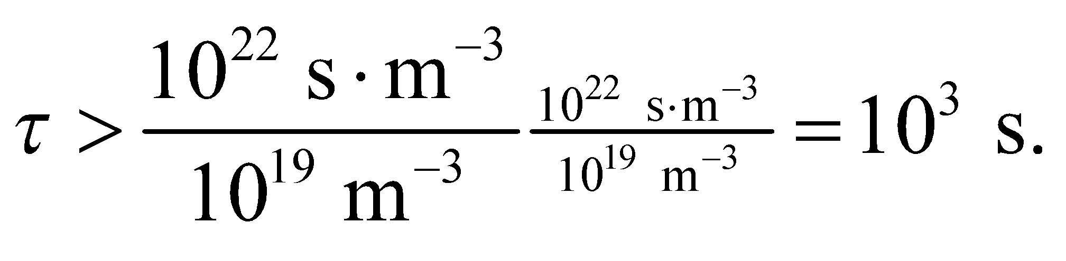

**Assess** This confinement time is inconveniently long, but creating a greater particle density so as to decrease the time is also difficult.

**Problems**

**36. Interpret** We are to estimate the diameter of the Earth required for it to have a density equal to that of nuclear matter.

**Develop** The density of the Earth

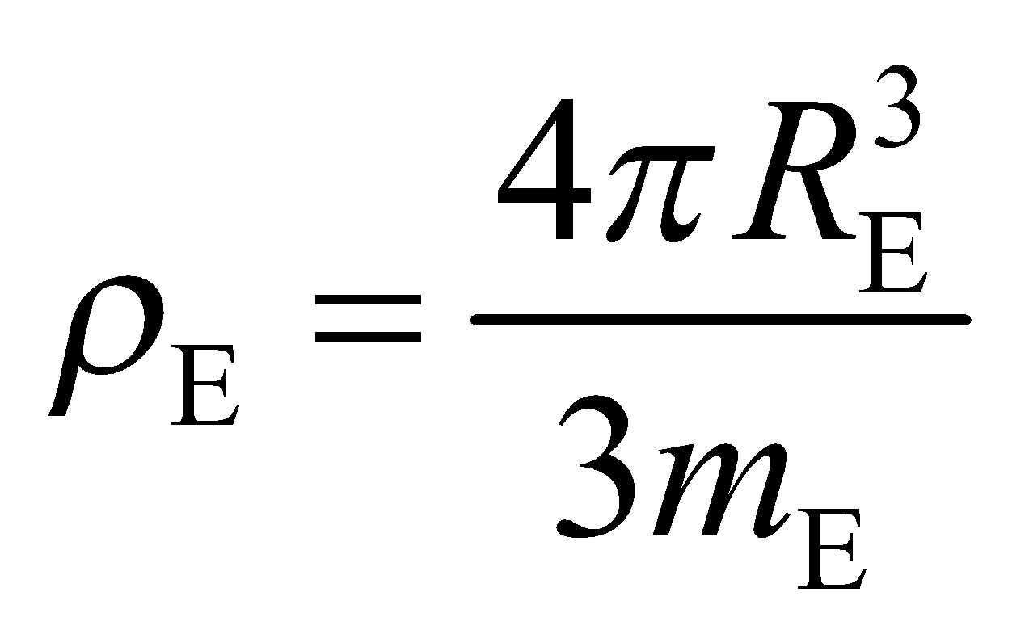

may be estimated using data from Appendix E, which gives *m*E = 5.97 × 1024 kg. The density of nuclear matter is given in the text following Figure 38.3 as approximately *ρ*N = 1017 kg/m3. Equating the two densities allows us to solve for *R*E.

**Evaluate** The radius required for the Earth to achieve nuclear density is approximately

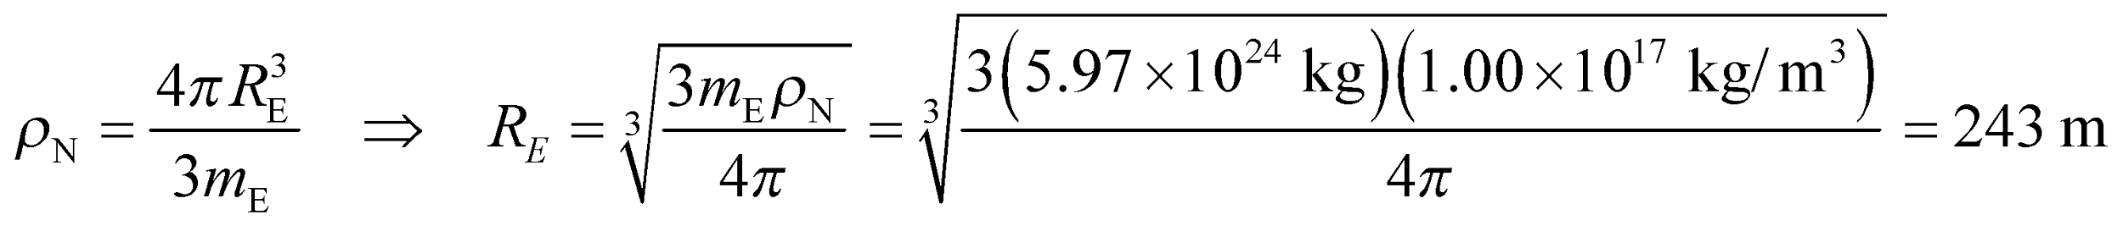

so the diameter is approximately 486 m.

**Assess** This is some 4 orders of magnitude less than the actual diameter of the Earth.

**37. Interpret** We are to find the energy required to flip the spin state of a proton, which acts like a magnetic dipole, in the Earth’s magnetic field.

**Develop** As discussed in Example 38.1, a proton acts like a magnetic dipole whose component along the magnetic field is 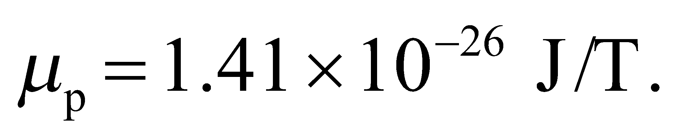 The energy needed to flip the spin (Equation 26.16) is

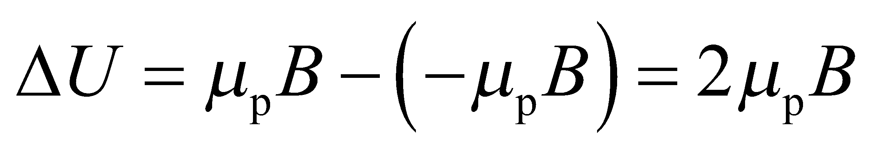

**Evaluate** With 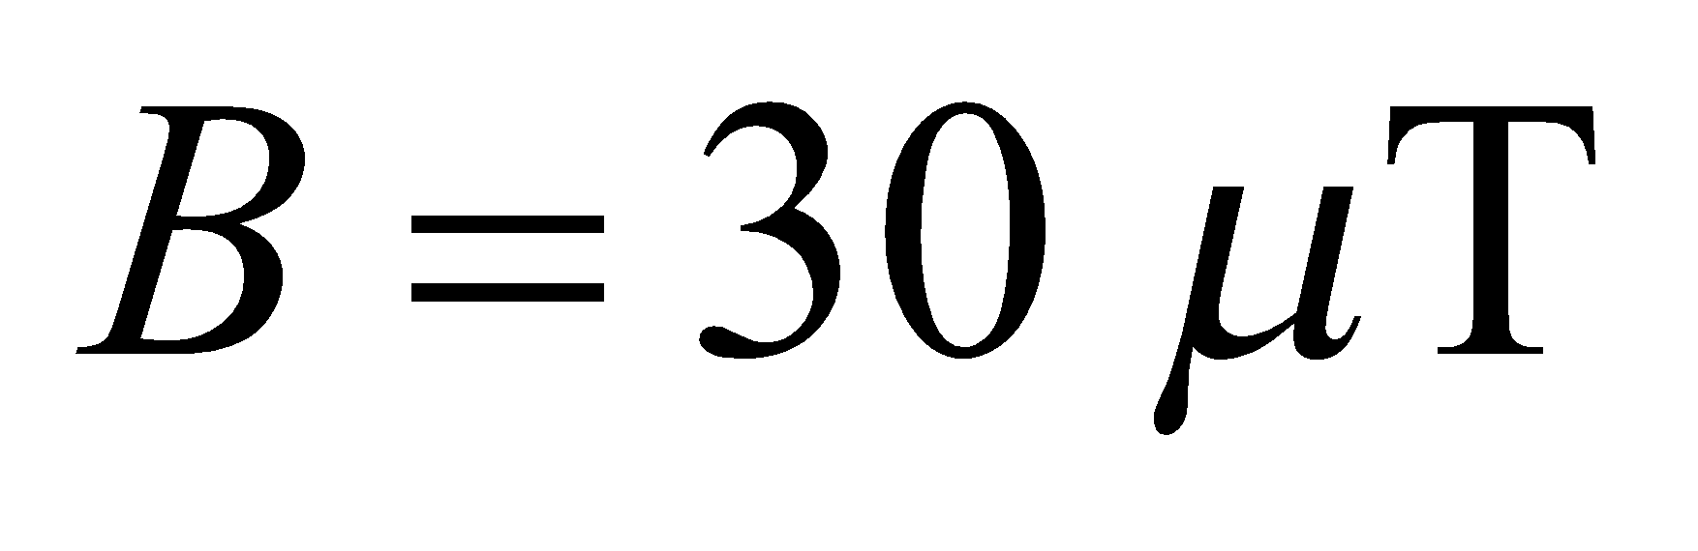 we get



**Assess** The frequency of a photon with this energy, 1.28 kHz, is in the audible range!

**38. Interpret** Given the frequency of the transmitter coil in an NMR spectrometer, we are to find the strength of the unperturbed magnetic field.

**Develop** The energy required to flip a magnetic dipole in a magnetic field is (Equation 26.16)



where *μ*p = 1.41 × 10−26 J/T is the magnetic dipole of protons (see Example 38.1). The energy supplied by the transmitter coil is *E* = *hf*, which we can equate to *ΔU* to solve for the magnetic field B.

**Evaluate** The spin-flip transition energy is

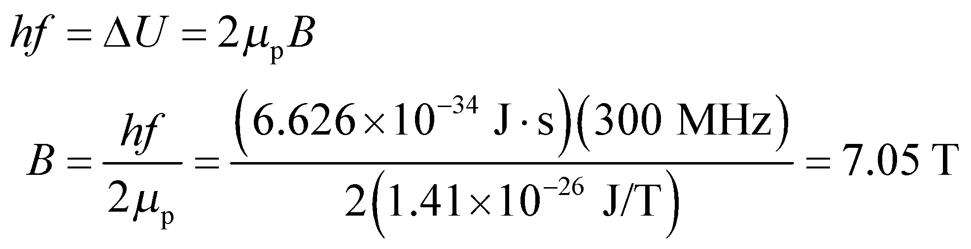

**Assess** This is a typical magnetic field strength for an NMR spectrometer.

**39. Interpret** In this problem, we are asked to find the binding energy per nucleon for 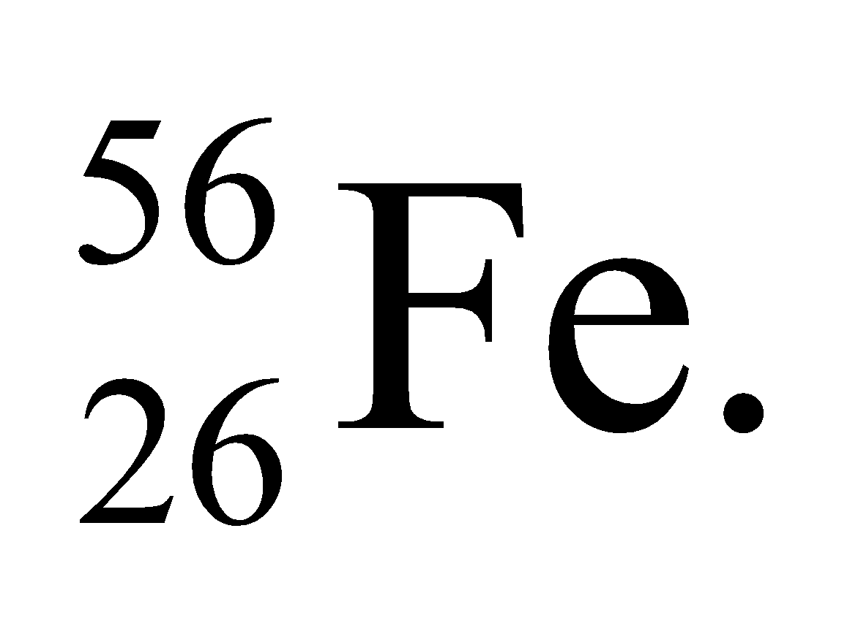

**Develop** Using Equation 38.7, the binding energy of a nucleus can be written as

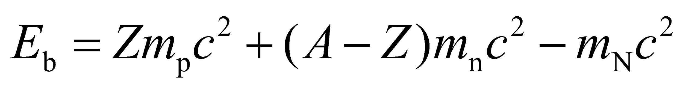

where *m*p, *m*n, and *m*N are the masses of the proton, neutron, and the nucleus, respectively.

**Evaluate** Since the nuclear mass is given, the above equation gives directly



Therefore, the binding energy per nucleon is

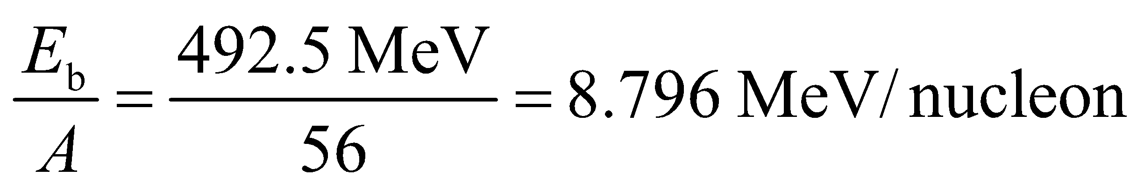

The result is in good agreement with the curve given in Fig. 38.9.

**Assess** This result is very close to the peak of the curve in Fig. 38.9. Nuclei with mass numbers around *A* = 60 are most tightly bound.

**40. Interpret** This problem is similar to Problem 38.25. We are to find the atomic mass of 193Ir, given its binding energy per nucleon.

**Develop** Apply the solution strategy used in Problem 38.25. From the periodic table, we see that, for Ir, *Z* = 77 so the number of neutrons is *N* = *A* − *Z* = 193 − 77 = 116.

**Evaluate** As in the solution to Exercise 25,

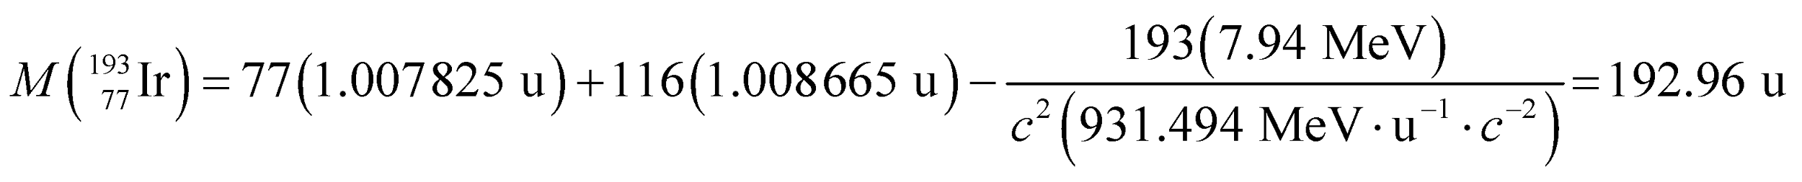

**Assess** Three figure accuracy in the binding energy per nucleon affects the third decimal place in this result.

**41. Interpret** This problem is about the age of the Earth in half-lives of the isotopes specified.

**Develop** From Table 38.1, the half-lives are 5730 y for 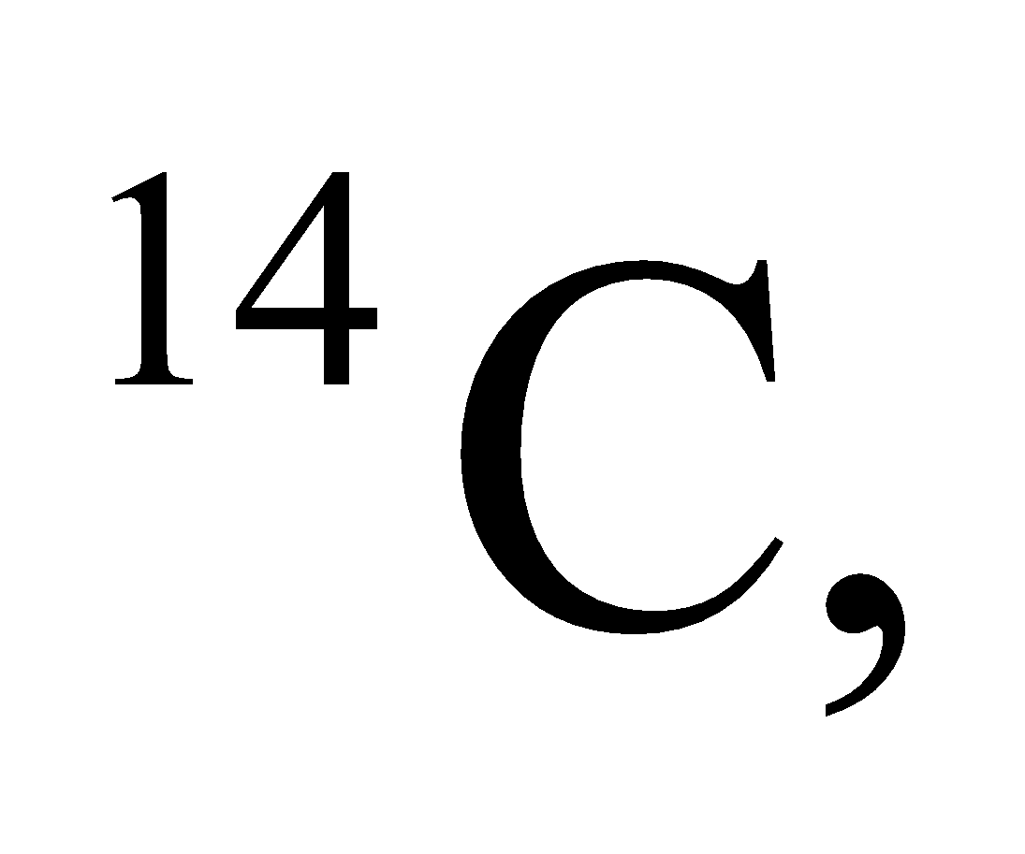 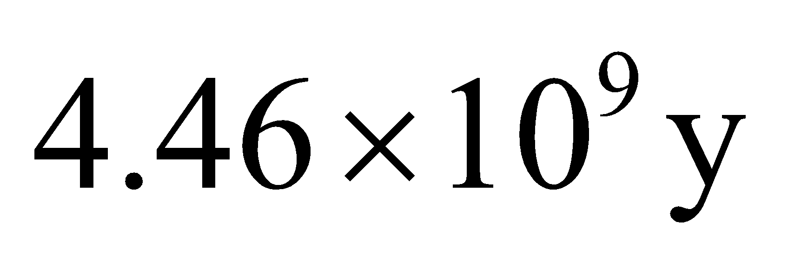 for 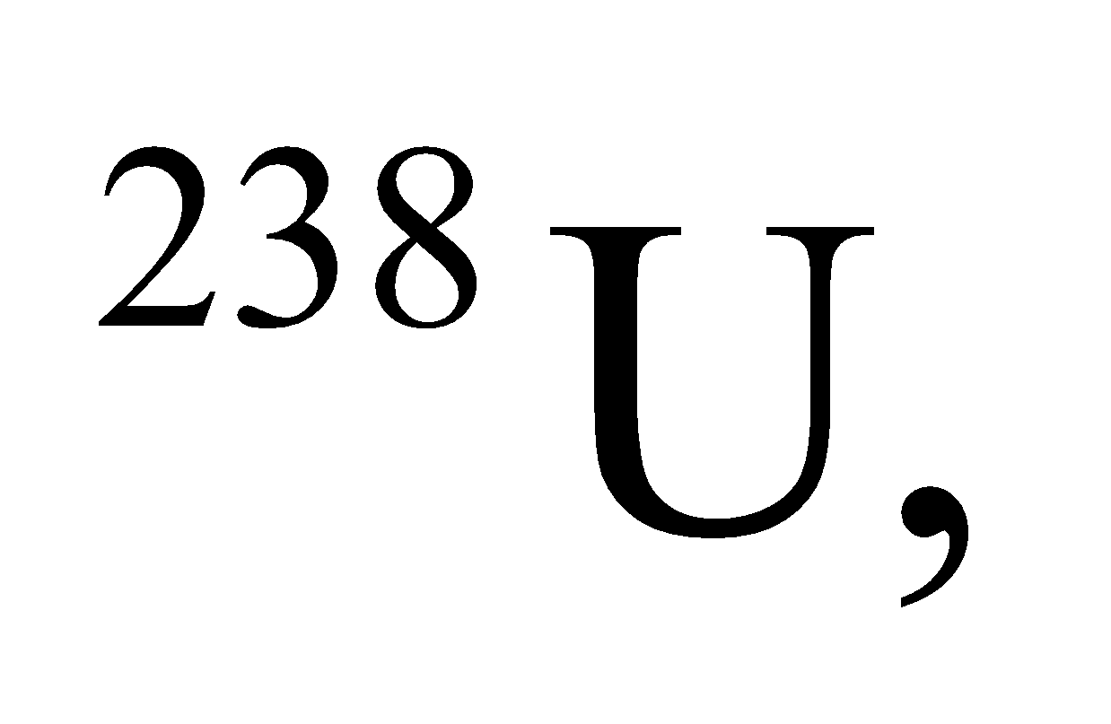 and 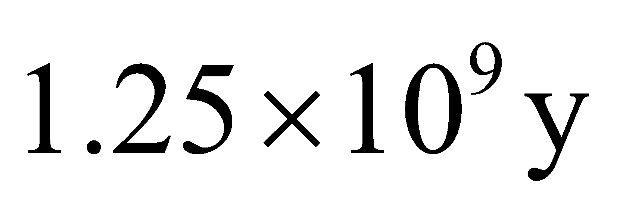 for 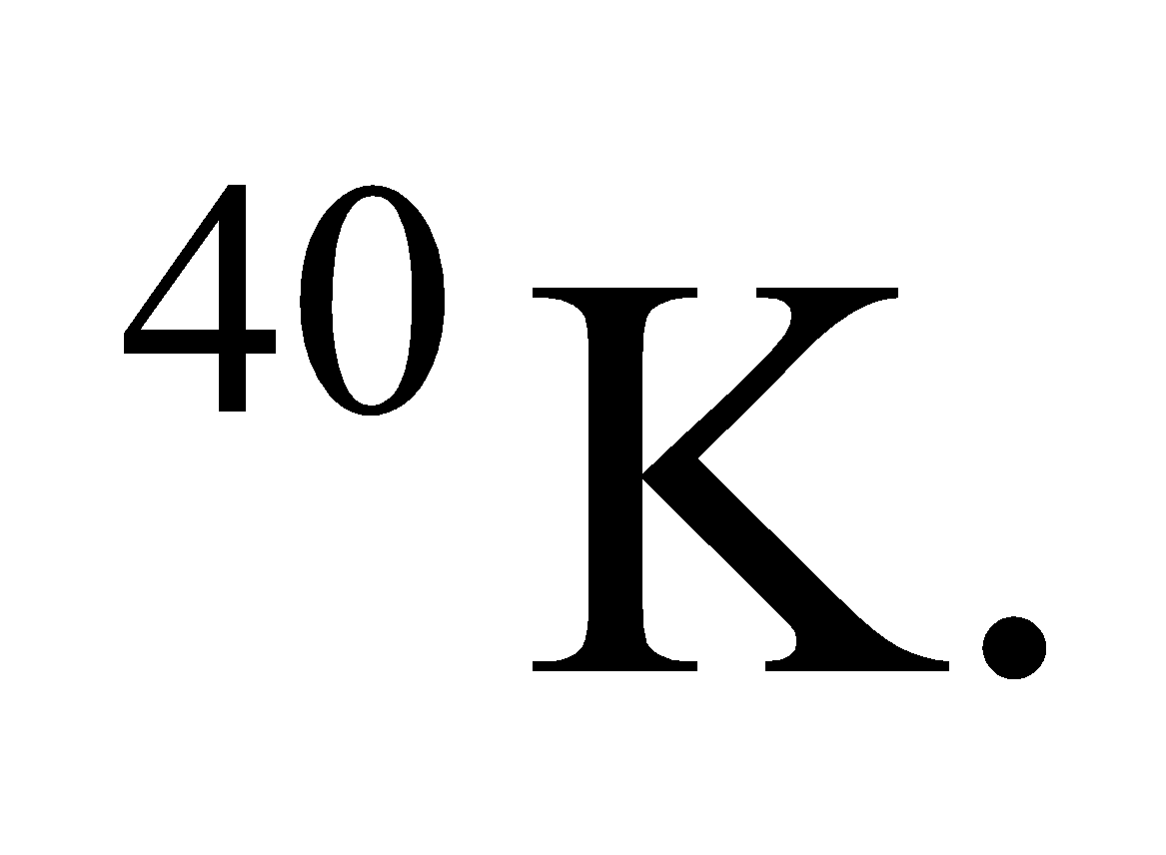 Starting with 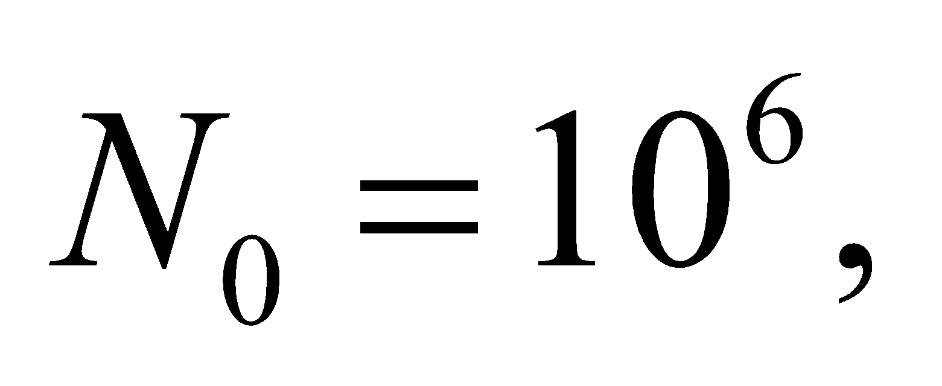 the number of atoms remaining after 4.5 billion years can be found with Equation 38.3b, 

**Evaluate** For C-14, the number of half-lives since the Earth formed is so large, 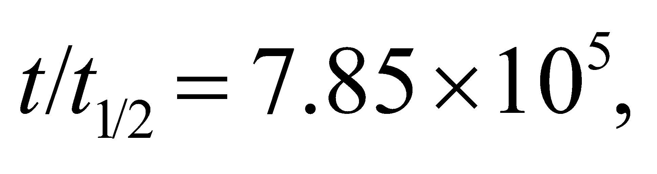that the number of these atoms left will be zero. The half-life of U-238 is roughly equal to Earth's lifetime, 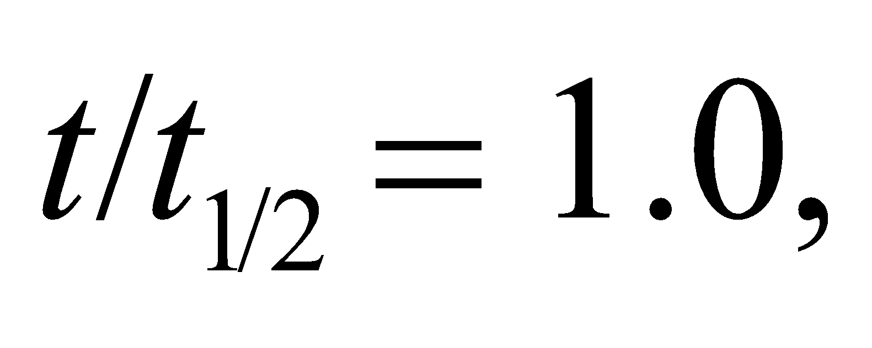 so the number of atoms left is

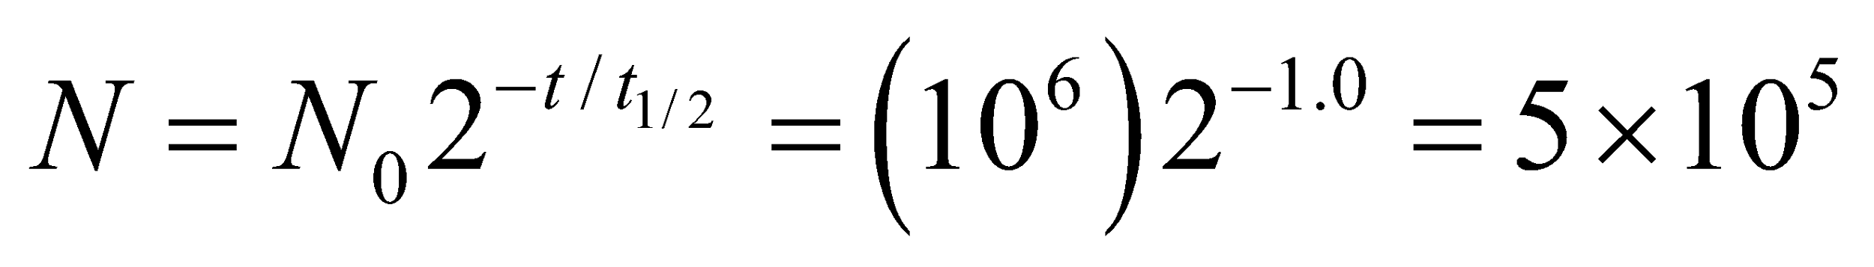

Lastly, the number of half-lives for K-40 is 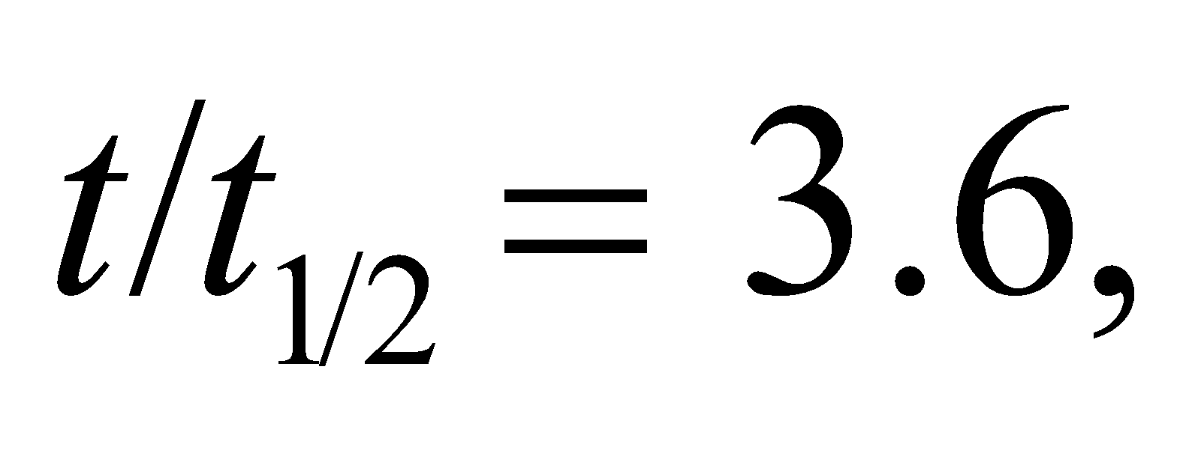 so

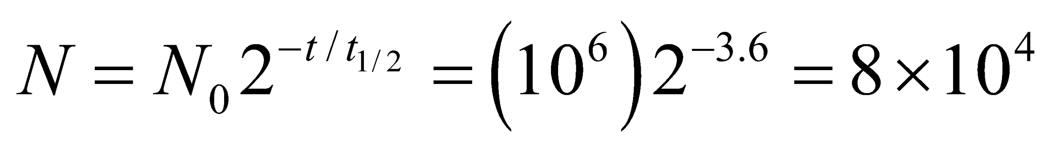

Thus, U-238 and K-40 are suitable for dating Earth's oldest rocks.

**Assess** Uranium is often used for radiometric dating of rocks. A geologist can determine how many U-238 atoms a rock sample originally had by estimating the excess number of lead atoms (Pb-206) in it: 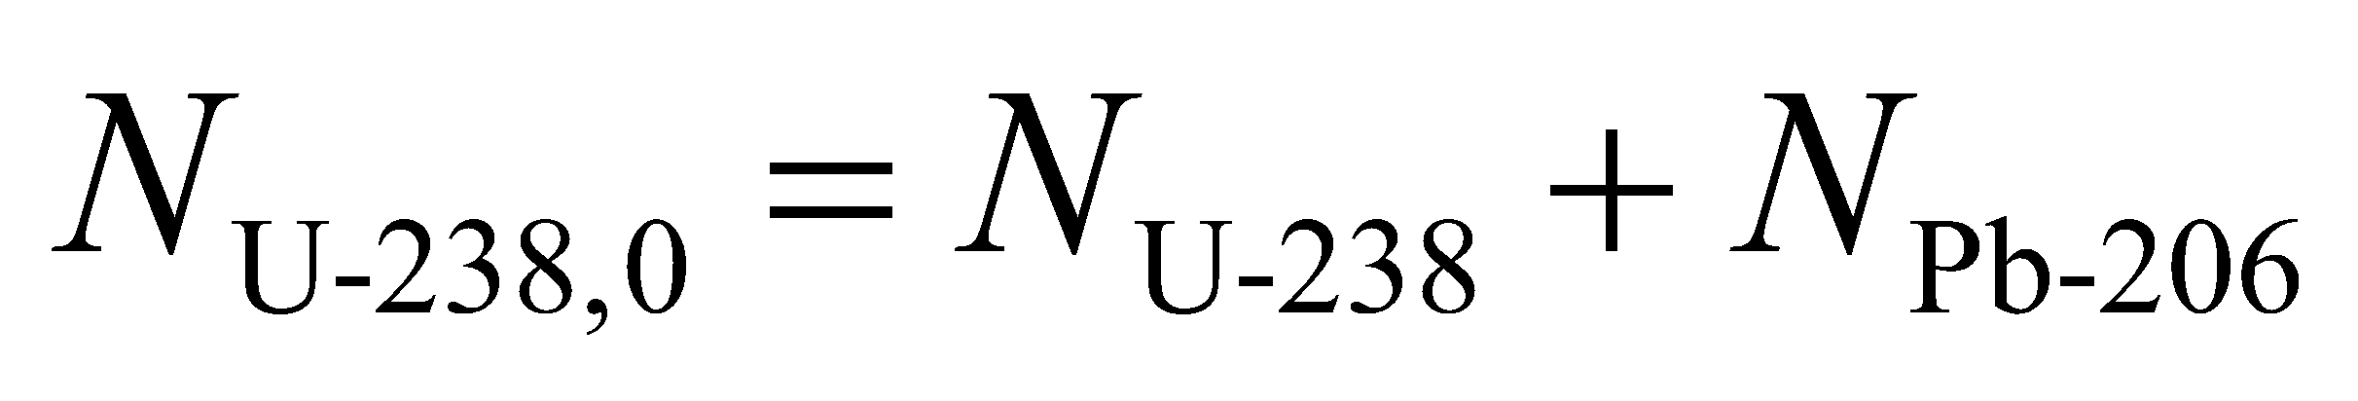. This is because Pb-206 is what becomes of a U-238 atom when it decays, as shown in Figure 38.7.

**42. Interpret** Given the radioactivity of a sample at two points in time, we are to find the material’s half-life.

**Develop** Because activity is proportional to the number of nuclei, the decay with the same time constant, so we can use Equation 38.3b

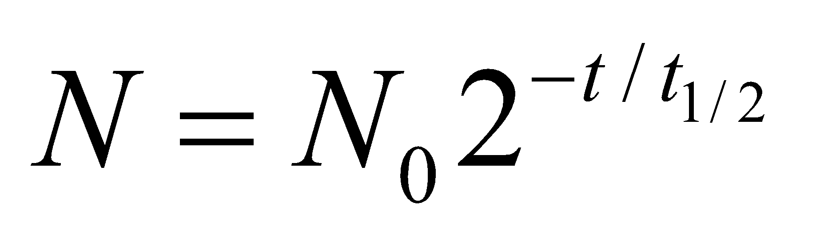

to find the half-life.

**Evaluate** Solving the expression above for the half-life gives

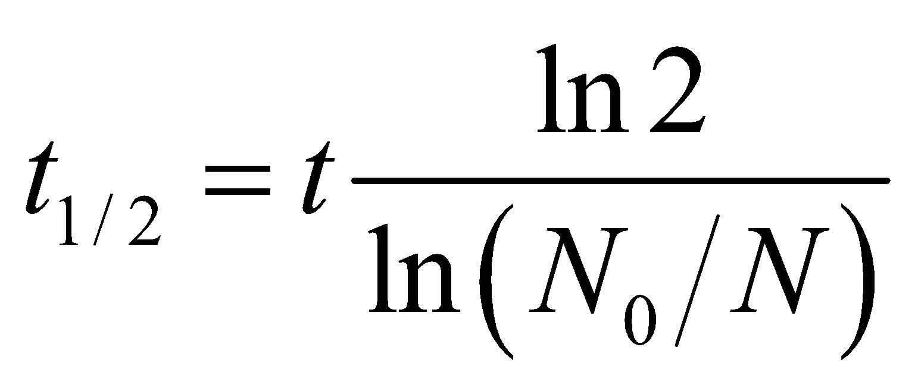

Inserting t = 30 min, *N*0 = 2.4 MBq and *N* = 1.9 MBq, we find

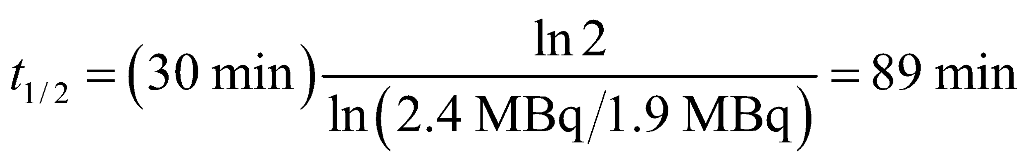

**Assess** This corresponds to a decay constant of

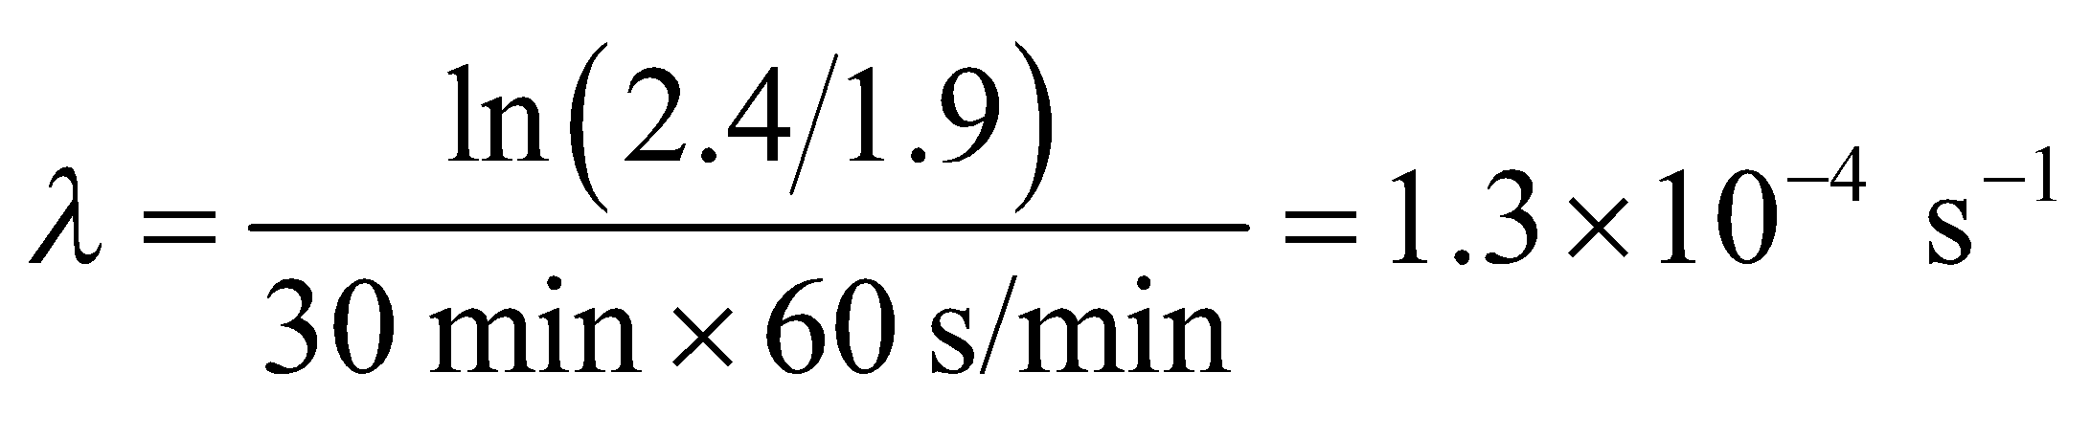

**43. Interpret** You need to determine when a house with excess radon will be safe to reenter.

**Develop** The half-life of Rn-222 is 3.82 days, from Table 38.1. Since the activity is proportional to the number of atoms, you can use Equation 38.3b, 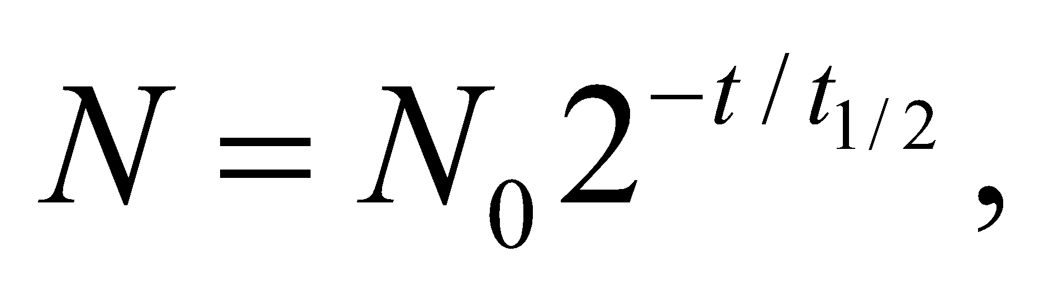to see how long until the activity drops from 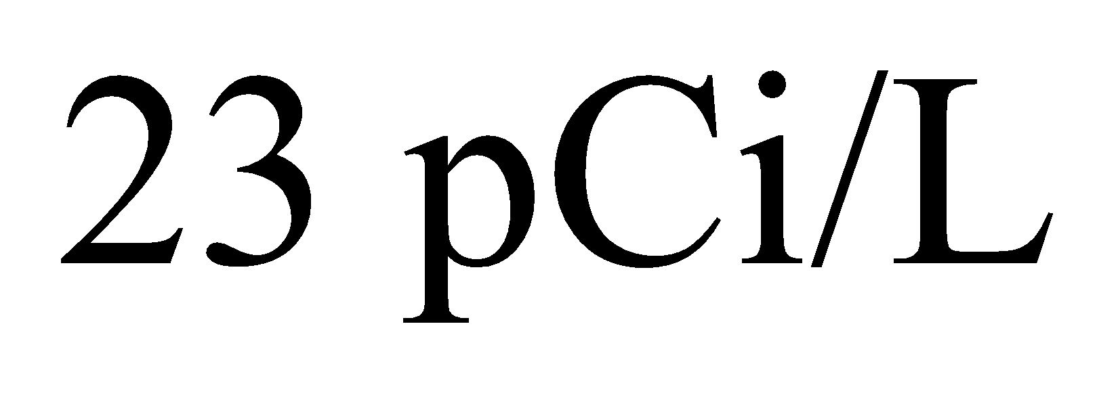to 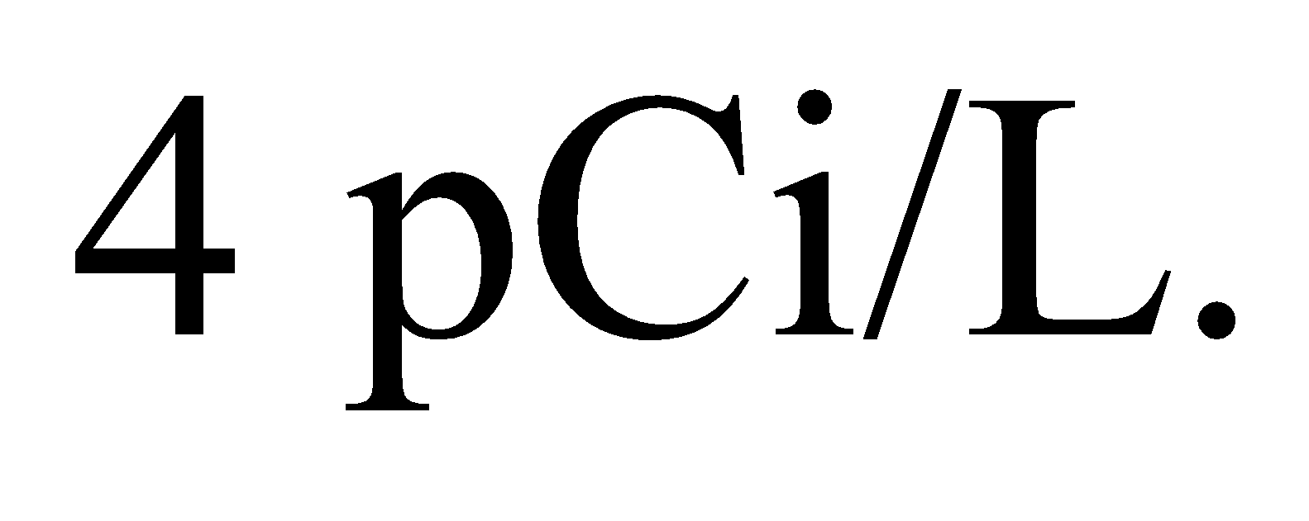

**Evaluate** Rearranging the equation for the number of atoms gives

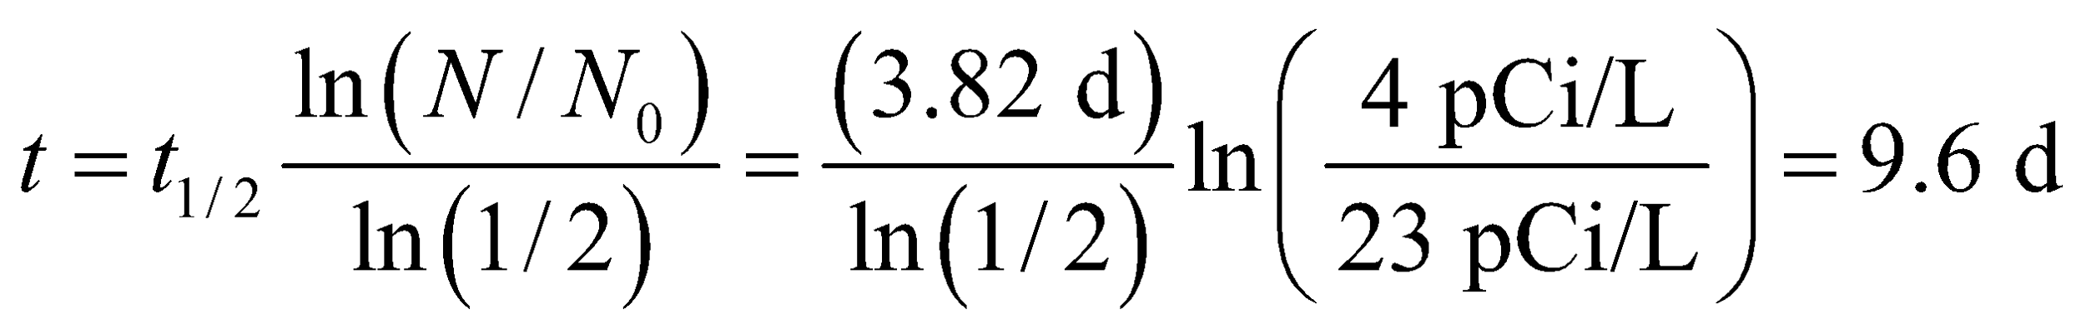

**Assess** This would be the maximum time to wait before returning to the house. The time can be less if windows are opened and the air is allowed to circulate.

**44. Interpret** We are to plot the activity of 13N as a function of time on a semi-log plot and explain the result, including the significance of the slope of the line.

**Develop** The number of nuclei remaining after time *t* is, from Equation 38.3b,

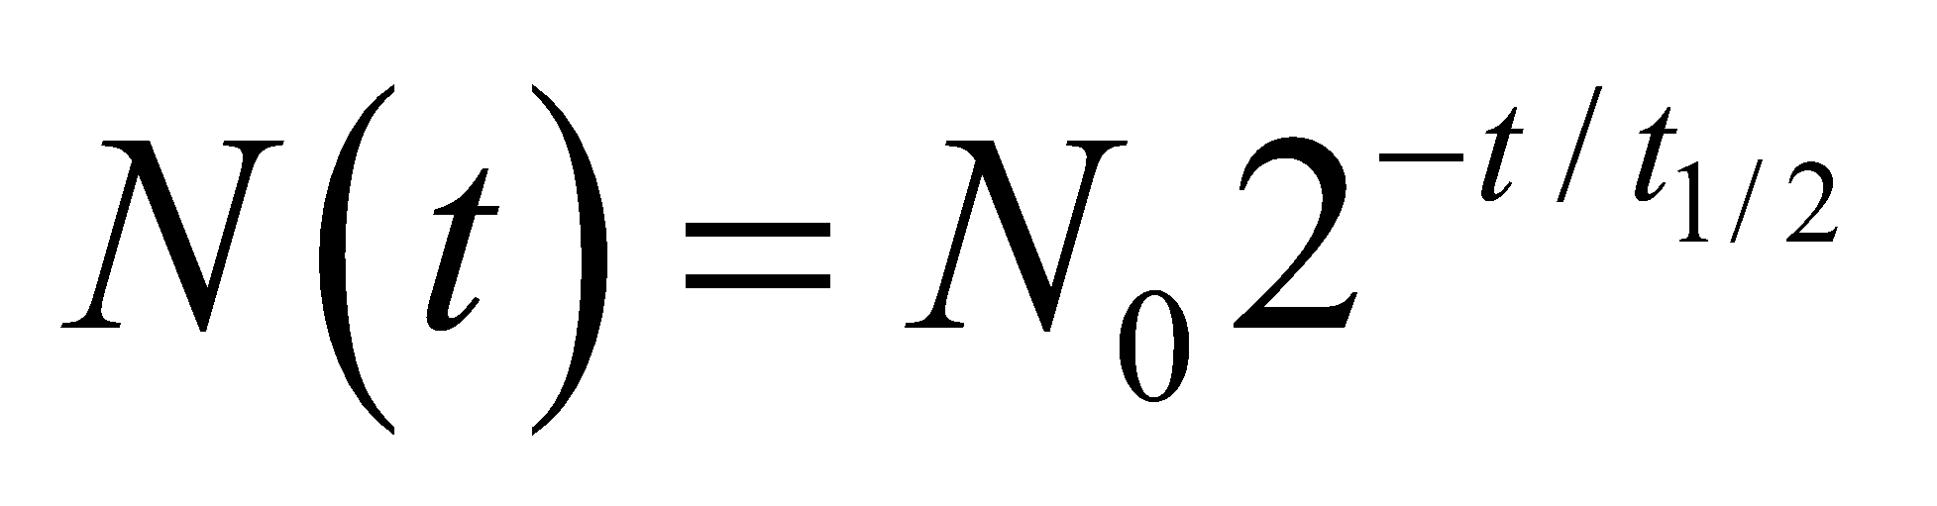

so

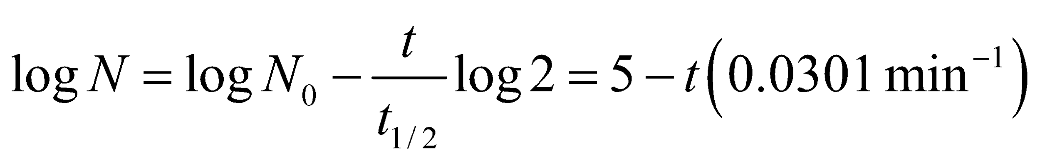

where *N*0 = 105 and *t* 1/2 = 10 min. (Note that logarithmic graphs are normally base ten.)

**Evaluate** This function is plotted below on a semi-log plot. The plot is a straight line because, on a semi-log scale, the function is of the form *y* = *ax* + *b* with

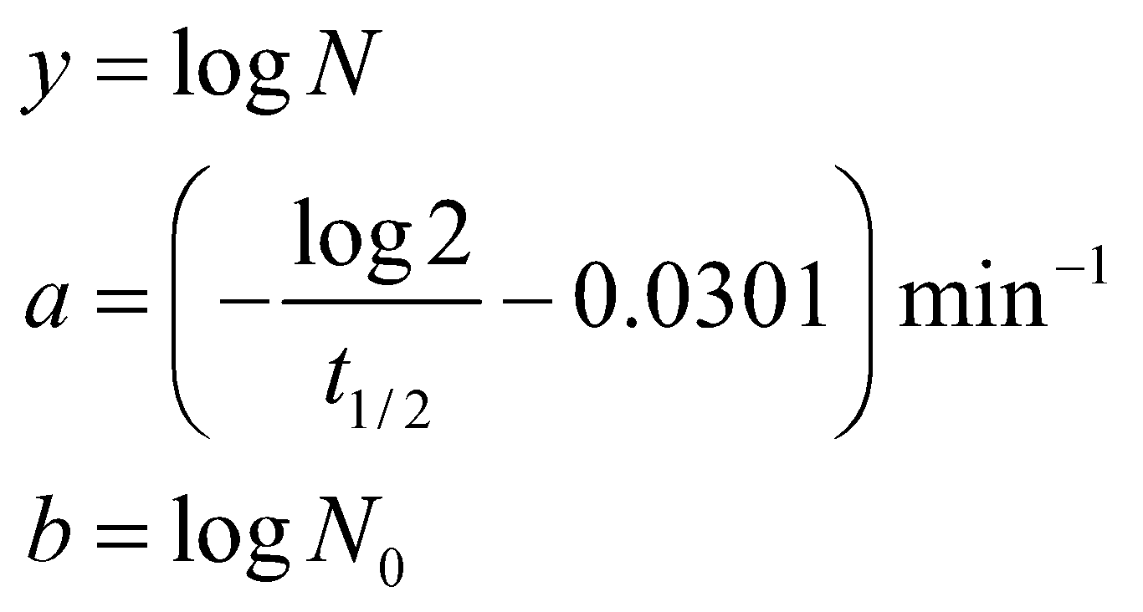

The slope is related to the half-life according to

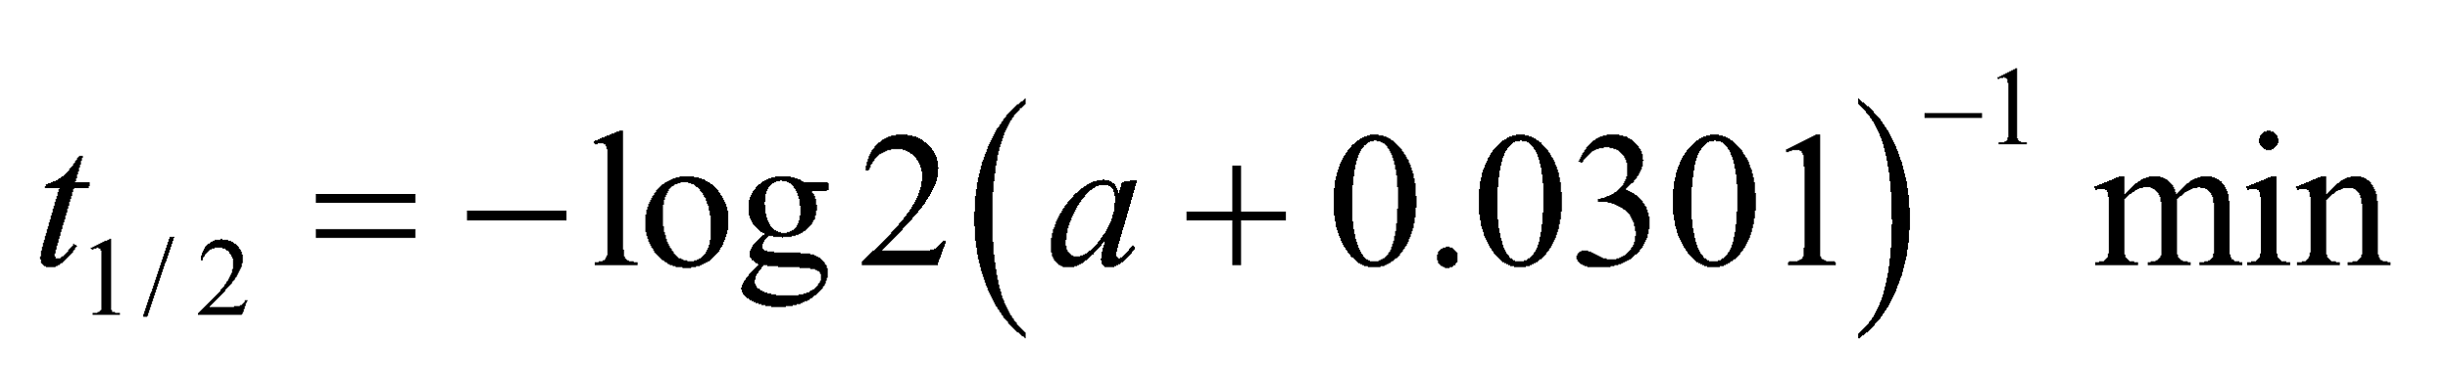

so the steeper the slope, the shorter the half-life (and vice-versa).



**Assess** The time range specified in this case covers six half-lives.

**45. Interpret** This problem concerns the decay of 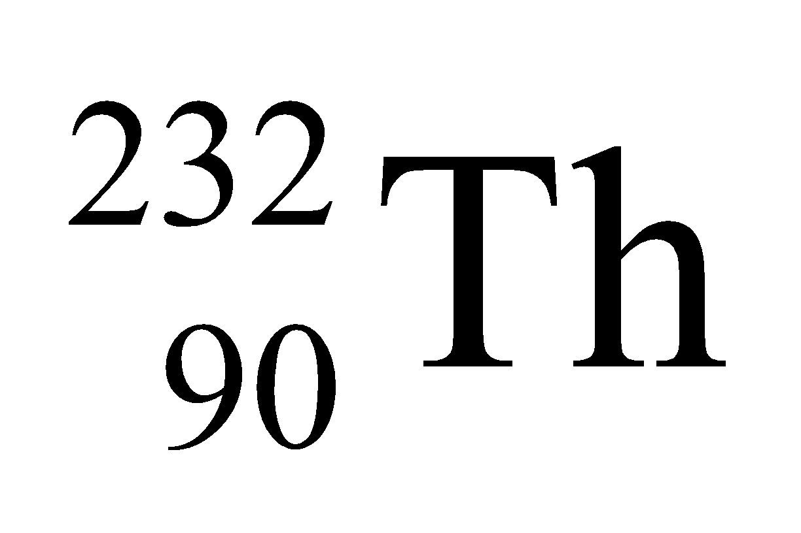 that results in a series of short-lived nuclei. We are to find the third daughter nuclei in the decay series of thorium-232, given the decay mechanism of the second daughter nuclei, and make a chart showing the first three steps in its decay.

**Develop** In *a*-decay, the numbers of neutrons and protons both decrease by two, whereas in 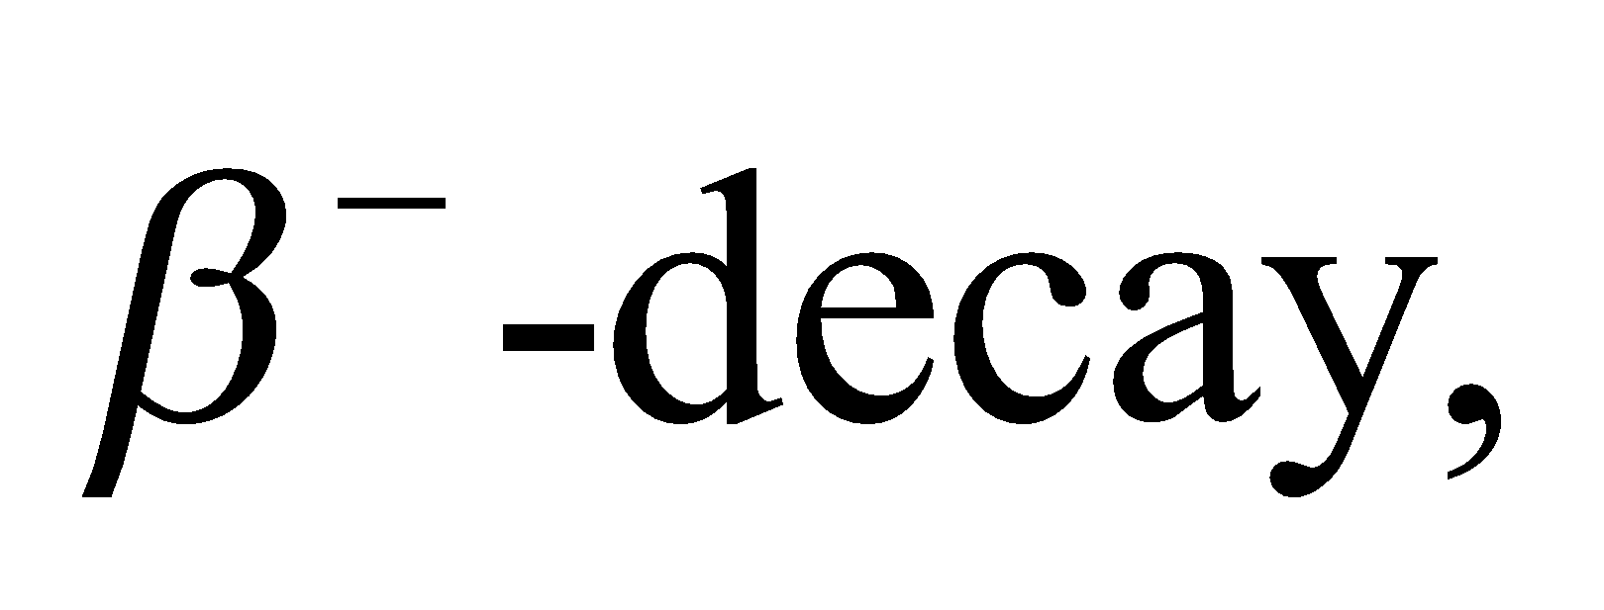 the number of neutrons decreases by one and the number of protons increases by one (see Equations 38.4 and 38.5a). Thus, after one *α*- and two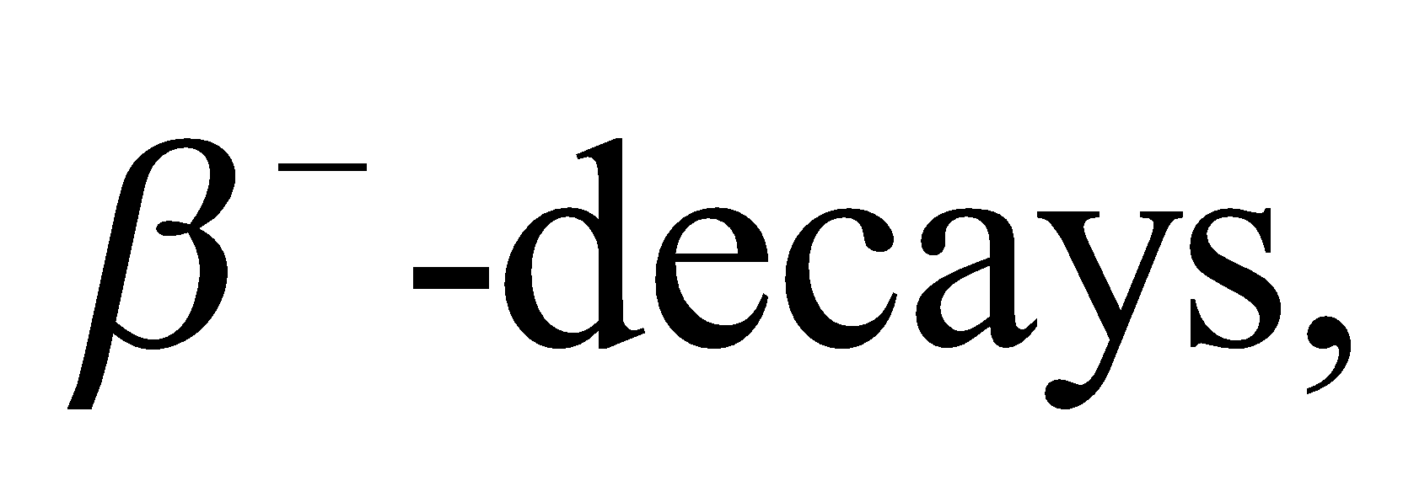 the number of neutrons is decremented by four and the number of protons is unchanged. Given that *A* = 232 and *Z* = 90 for thorium-232, the third daughter nuclei must have *A* = 232 − 4 = 228 and *Z* = 90.

**Evaluate** The third daughter nucleus is therefore 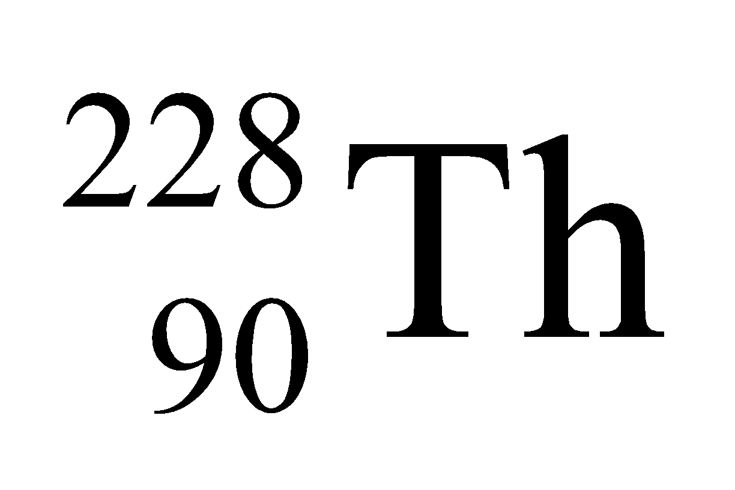, which is another thorium isotope.

**(b)** The chart is shown in the figure below. The half-lives are given in the figure.



**Assess** The reactions shown in the figure are

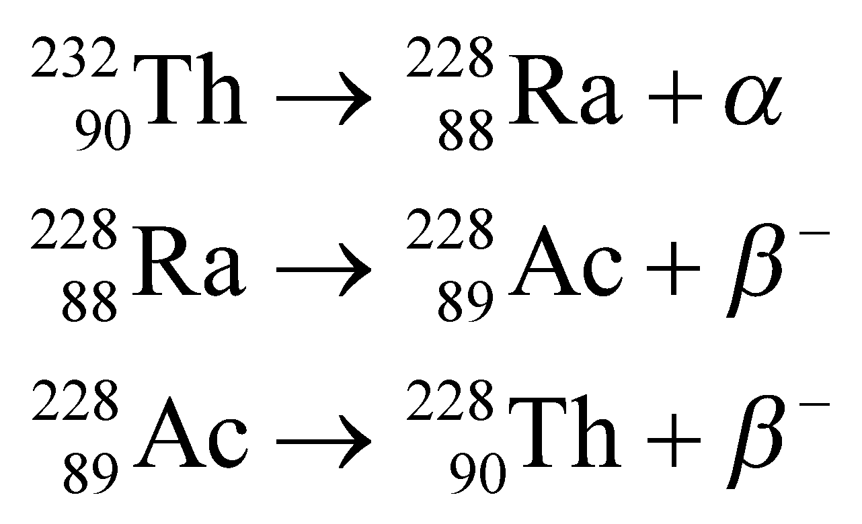

**46. Interpret** For this problem, we are to find the mass of cobalt-60 required to make a source of radioactivity that will exceed the given level for two years, given the half-life of this nucleus.

**Develop** The activity decays with the same time constant as the number of nuclei (see discussion following Equation 38.3b). Thus, we can use Equation 38.3a,

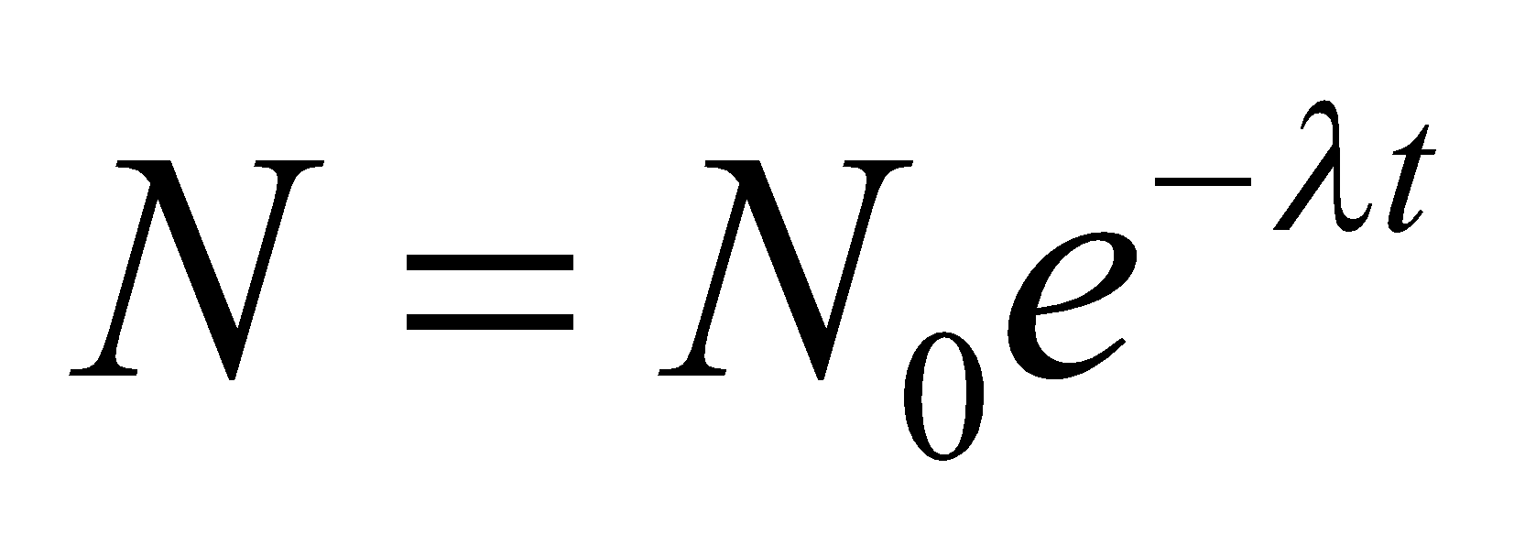

and equate the resulting time constant with the half-life using

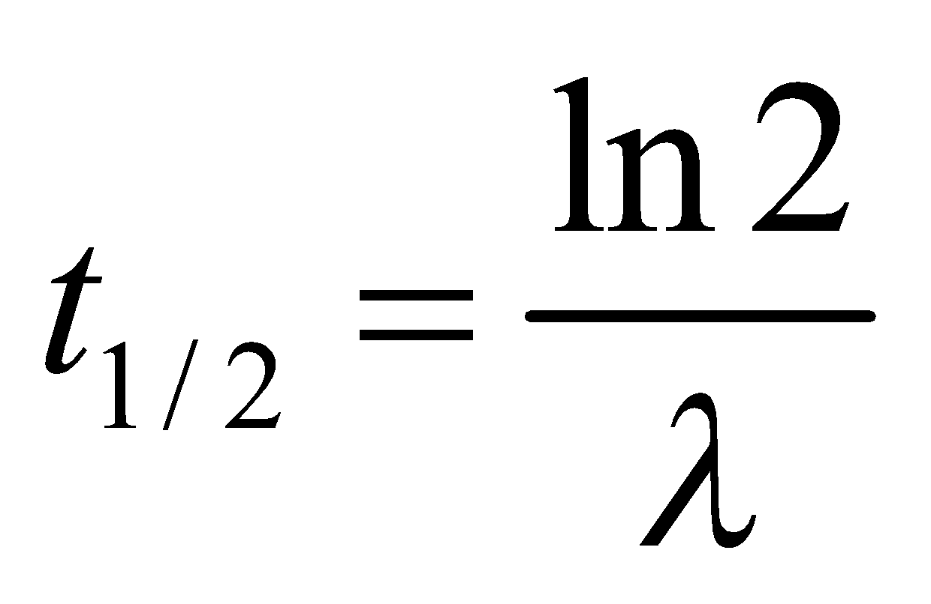

The activity is given by

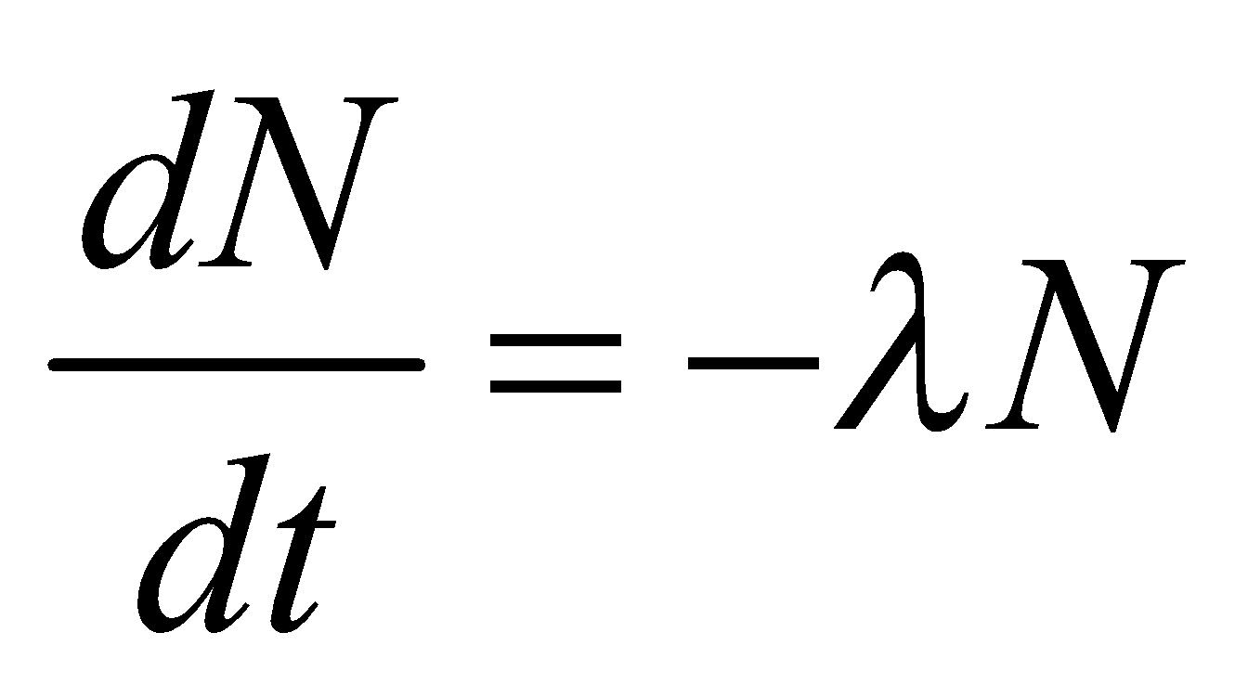

which may be found by differentiating Equation 38.3a. If the activity of 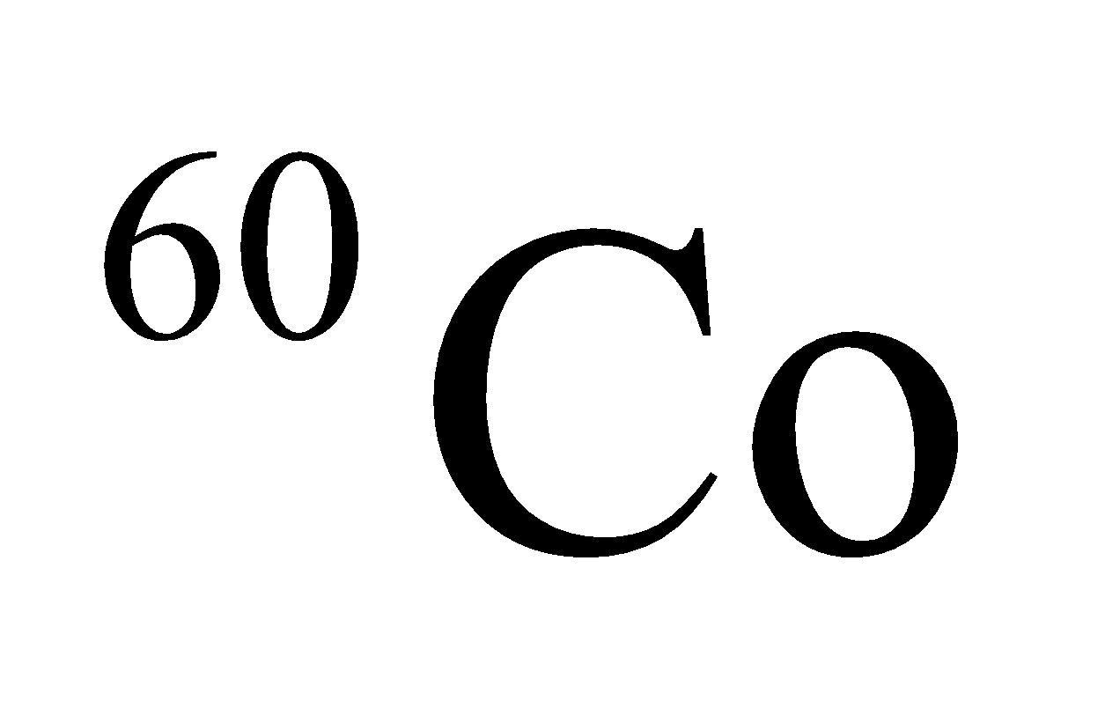 must meet the specified condition after t = 2 y, then

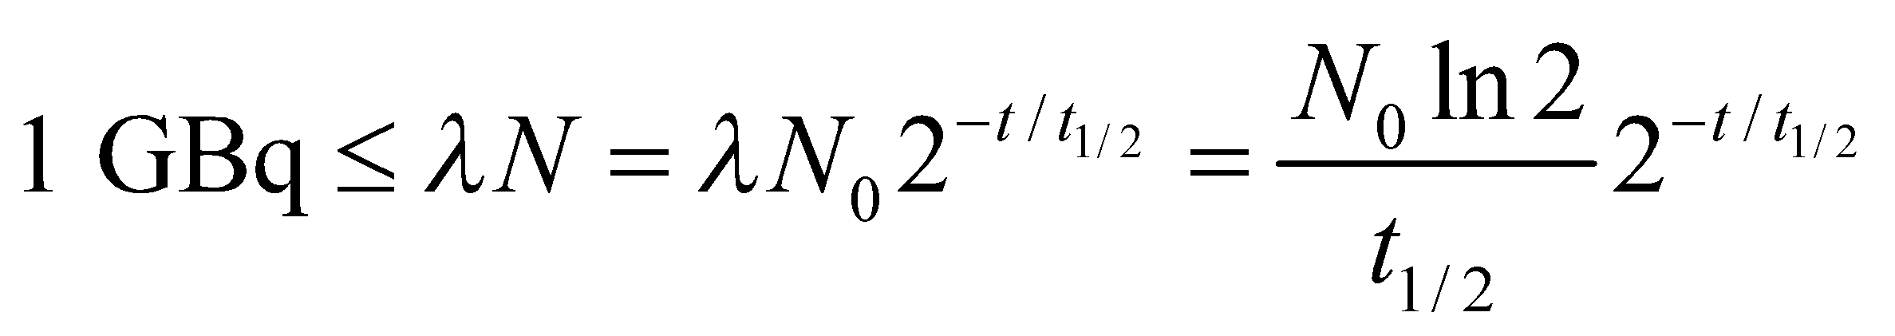

which allows us to solve for the initial number of nuclei *N*0.

**Evaluate** Using , we find that the initial number of cobalt-60 nuclei needed is

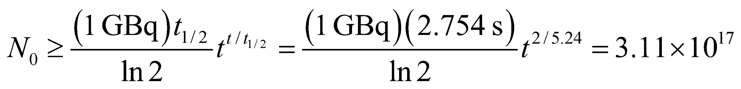

The atomic weight ofis about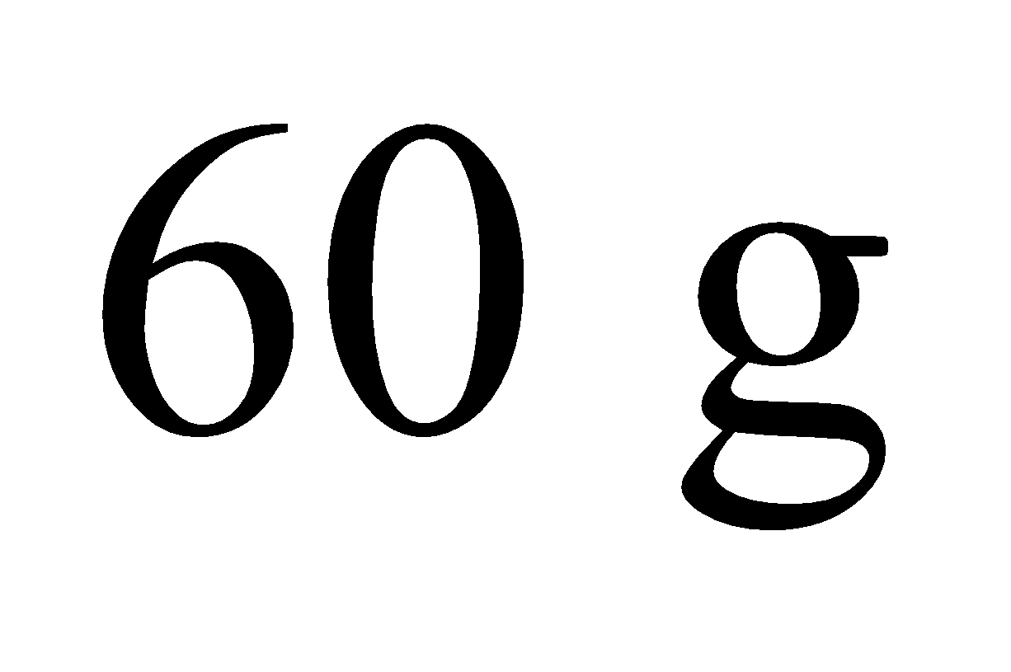and contains Avogadro’s number of atoms, so the sample should have a mass of at least

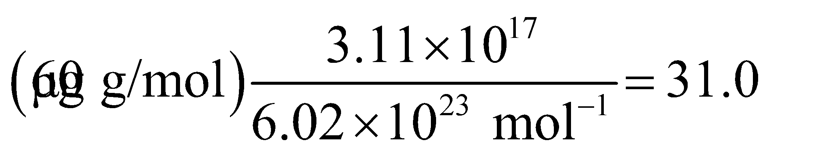

**Assess** Note the time is expressed in seconds in the quotient to accommodate the units Bq, which are SI units and therefore involve seconds for time. In the exponent, the time is expressed in years because the delay time *t* = 2 years is given in years.

**47. Interpret** This is a problem about carbon-14 dating, which we are to use to deduce the age of a bone.

**Develop** Using Equation 38.3b,  the age *t* of the bone is given by



where *N* is the number of nuclei remaining when the bone is unearthed by the archeologists. From Table 38.1, the half-life of 14C is 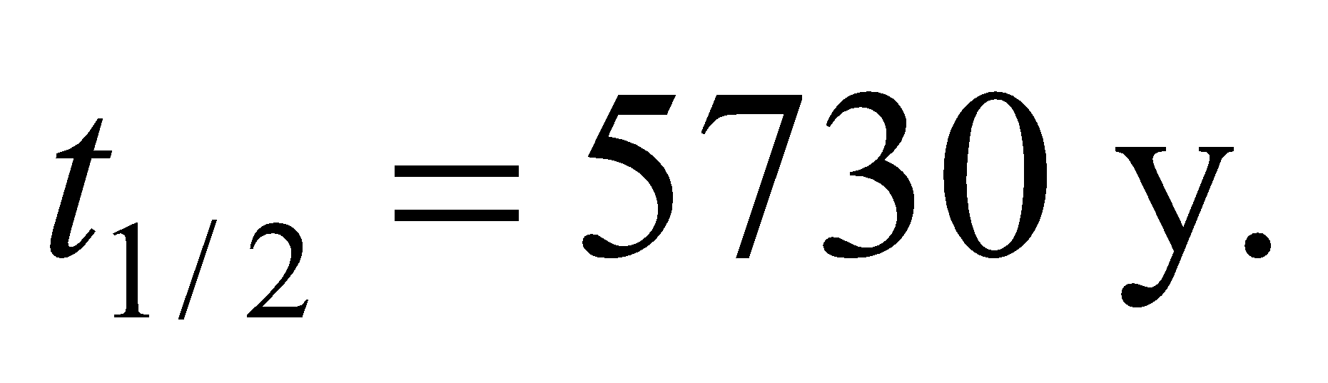

**Evaluate** From the above equation, we determine the age of the bone to be

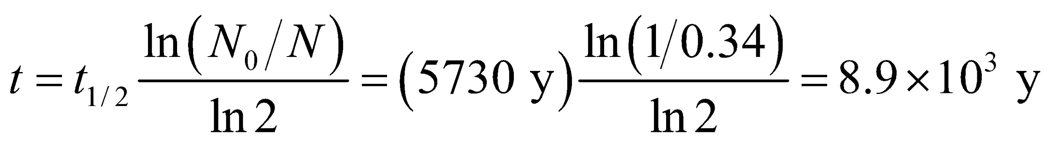

**Assess** As a quick check, we note that one half-life reduces the number to 50% of the original, two half-lives to 25%, three to 12.5%, and so on. In our 14C dating case, we have 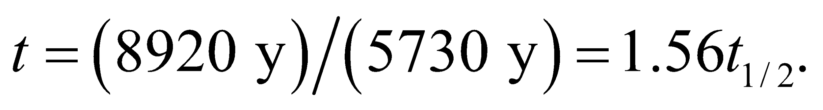 Therefore, we expect the fraction remaining to be between 25% and 50%. This is consistent with the 34% given in the problem statement.

**48. Interpret** This problem is a mathematical exercise in which we are to show that the half-life and the decay constant defined in Equations 38.3b and 38.3a, respectively, are related as given in the problem statement.

**Develop** Because the activity is proportional to the number of nuclei, the ratio *N*/*N*0 from Equation 38.3a should equate to that given by Equation 38.3b for any given time *t*. Thus, we can write

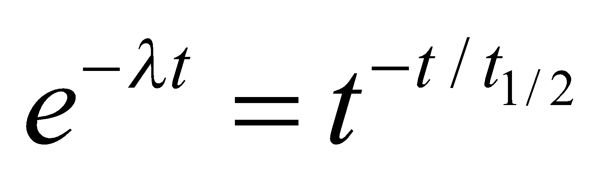

which we can solve for *t*1/2 in terms of *λ.*

**Evaluate** Taking the natural logarithm of both sides, we find

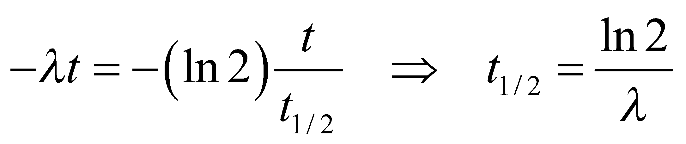

**Assess** This result agrees with that given in the text.

**49. Interpret** This problem is about the decay of 131I in milk. We are given the initial activity per liter of milk, and we want to know how long it takes for the activity to decay to the level provided by the given safety guideline.

**Develop** Using Equation 38.3a, 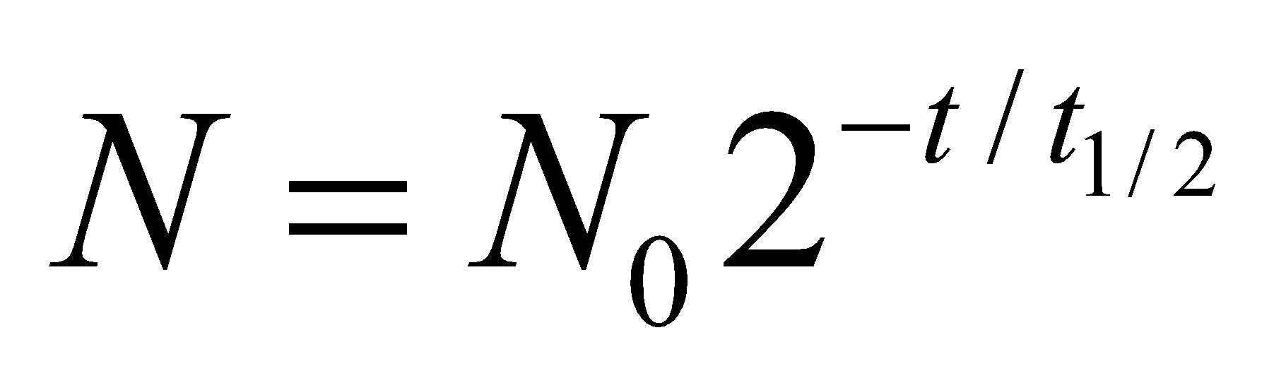 the waiting time *t* required can be written as



where the ratio *N*0/*N* is the ratio of the initial activity to the final activity. The half-life of 131I is 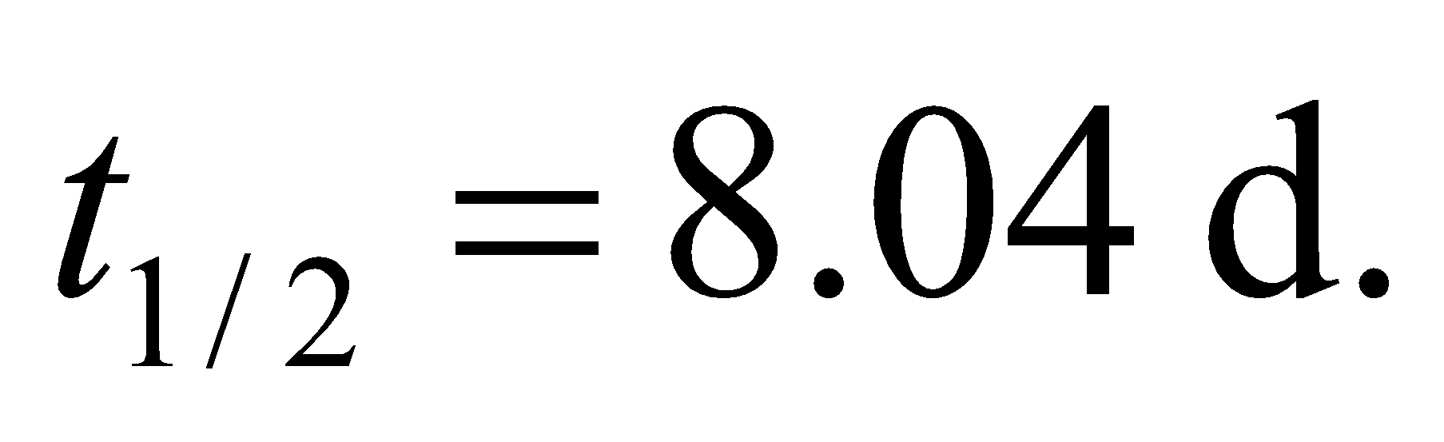

**Evaluate** For Poland, we find

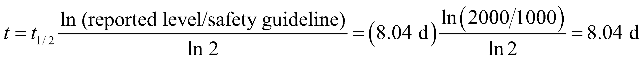

Similar calculations yield 16.2 d for Austria, and 10.0 d for Germany.

**Assess** As a quick check, we note that one half-life reduces the number to 50% of the original, two half-lives to 25%, three to 12.5%, and so on. For Poland, the waiting time is exactly one half-life since the initial reported level is twice the safety guideline. For Austria, 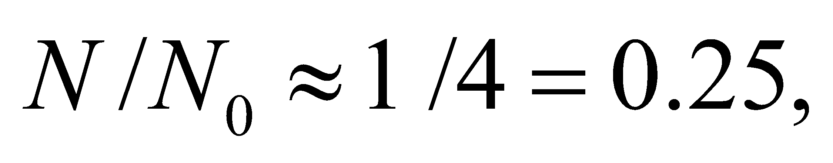 so about two half-lives (16 days) of waiting time are required. Similar reasoning can be applied to the Germany case.

**50. Interpret** Given the activity and the half-life of a sample, we are to find the number of atoms in the sample.

**Develop** Apply Equation 38.3a



The activity of the sample is 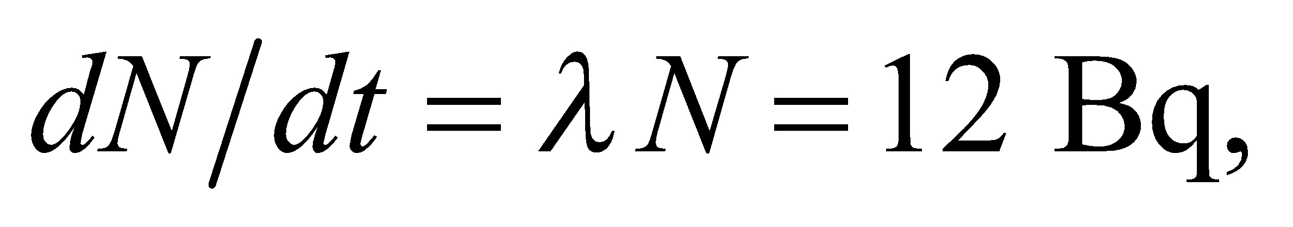 where

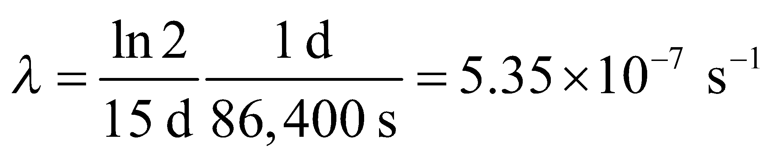

**Evaluate** Solving for *N*, we find

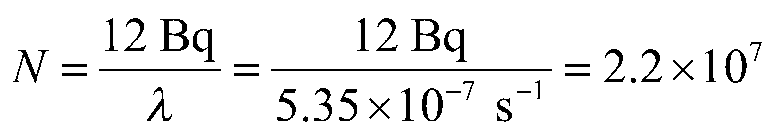

**Assess** Given that atomic masses are on the order of 102 g/mol, this corresponds to a mass *m* of around

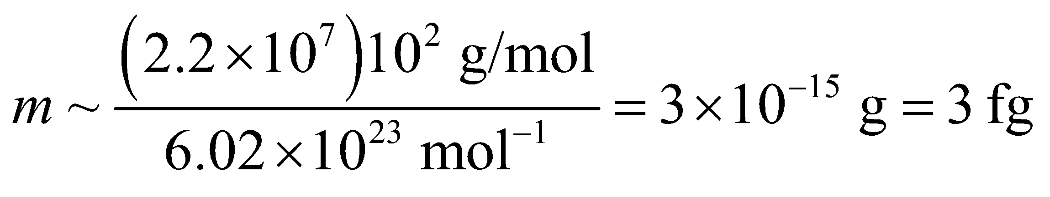

which is a very small sample.

**51. Interpret** This problem involves using the decay rate of 40K to deduce the age of a rock.

**Develop** Using Equation 38.3b, 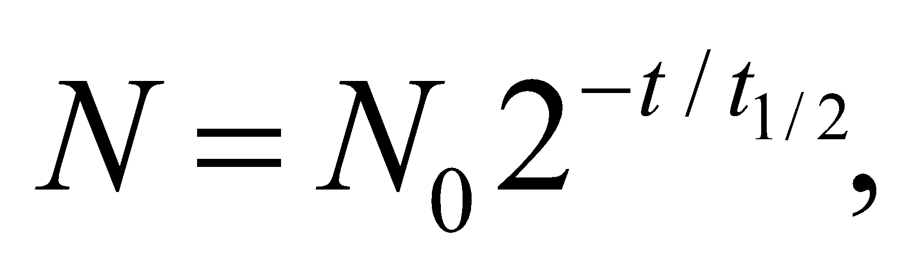 the age *t* of the rock is given by



where *N* is the number of 40K nuclei remaining and *N*0 is the original number of 40K nuclei. The half-life of 40K is 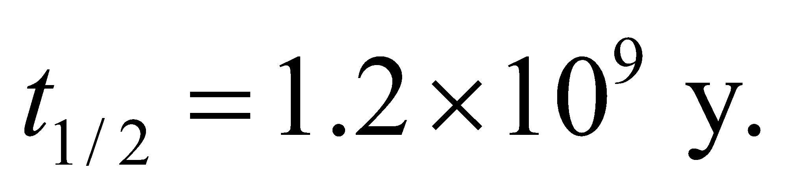 If 82% of the original 40K decayed, then 18% remains in a rock of age *t*, so *N*0/*N* = 1/0.18.

**Evaluate** From the above equation and the given half-life, we get

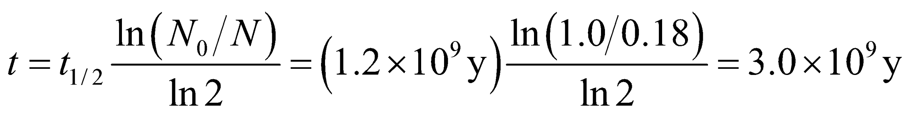

*Note:* A type of lunar highlands rock rich in potassium (K), rare earth elements (REE), and phosphorus (P), is called KREEP norite.

**Assess** The age of the rock is on the same order as the age of the Earth, which is about 4.5 billion years old.

**52. Interpret** Given the half-life of 16N, we are to estimate the time required for the activity of 16N to decrease by a factor of 106.

**Develop** The activity drops by roughly a thousand in ten half-lives (see tip following Example 38.2) and by a factor of 106 in 20 half-lives.

**Evaluate** Twenty half-lives corresponds to

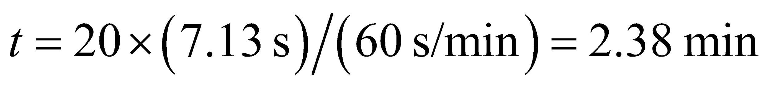

**Assess** The exact calculation from Equation 38.3b gives 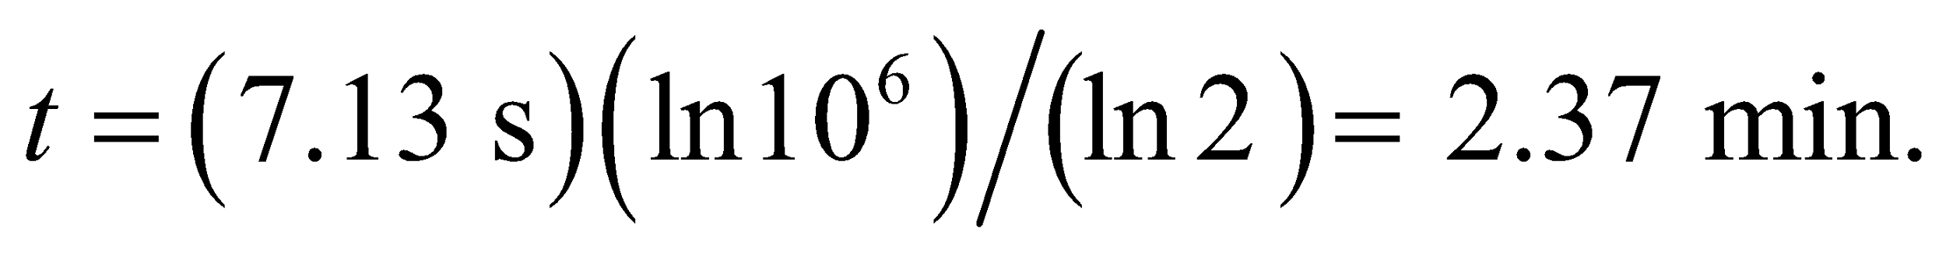

**53. Interpret** The problem asks what fraction of a cancer-fighting agent will remain radioactive one year after the intervention.

**Develop** The number of Ir-182 will drop relative to the initial amount according to 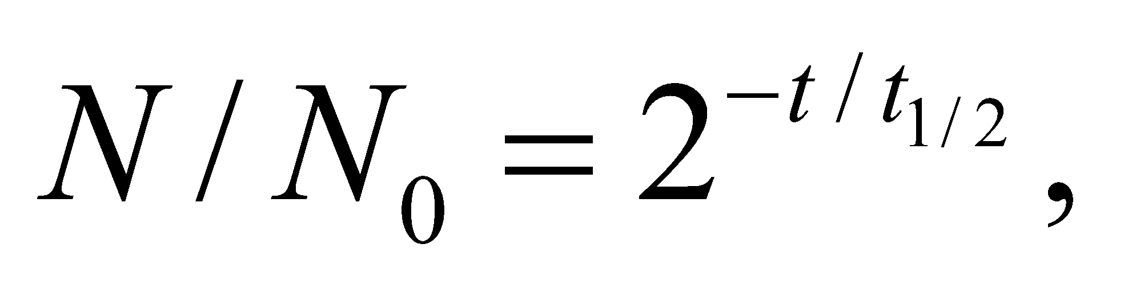where the half-life is 74.2 days.

**Evaluate** The percentage of radioactive iridium left after 365 days is

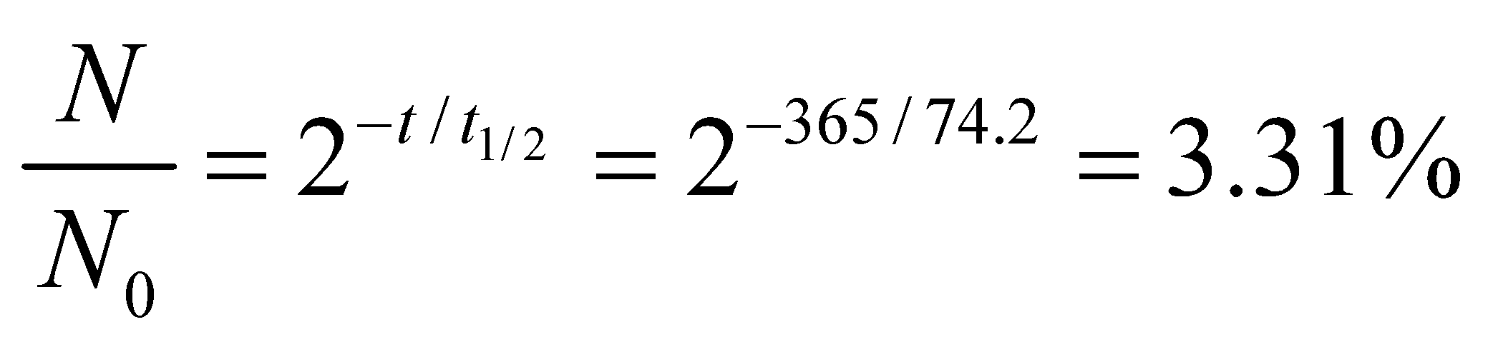

**Assess** Although the seeds remain radioactive for a considerable time, the gamma rays produced only travel a few millimeters through the body, so ideally only the tumor site is irradiated.

**54. Interpret** Uranium-235 and uranium-238 have different half lives. We are given their relative abundance at the present time and asked to find their relative abundance 4.5 billion years ago.

**Develop** Suppose that when the Earth formed at *t* = 0, natural uranium consisted of just the two longest-lived isotopes in Table 38.1 (we ignore 234U which has an abundance of 0.0057%). Then the percentage of 235U today

(*t* = 4.5 × 109 y) is

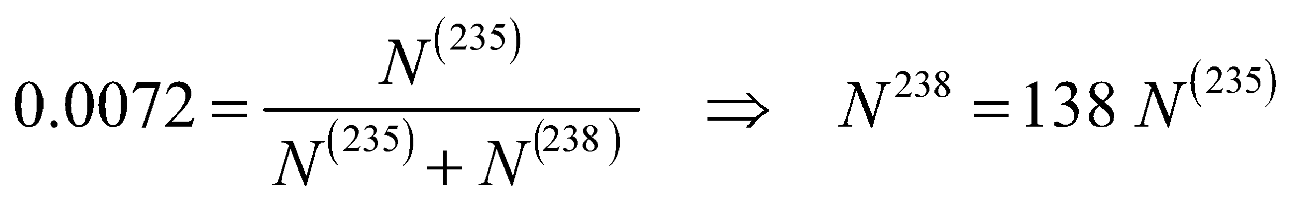

The original amounts of the two isotopes are given by Equation 38.3b,  with half-lives from Table 38.1. The results are



**Evaluate** Thus, the original percentage must have been

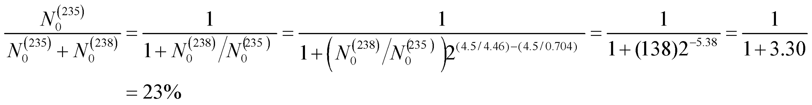

**Assess** Since 235U has a shorter half-life than 238U, we expect the ratio 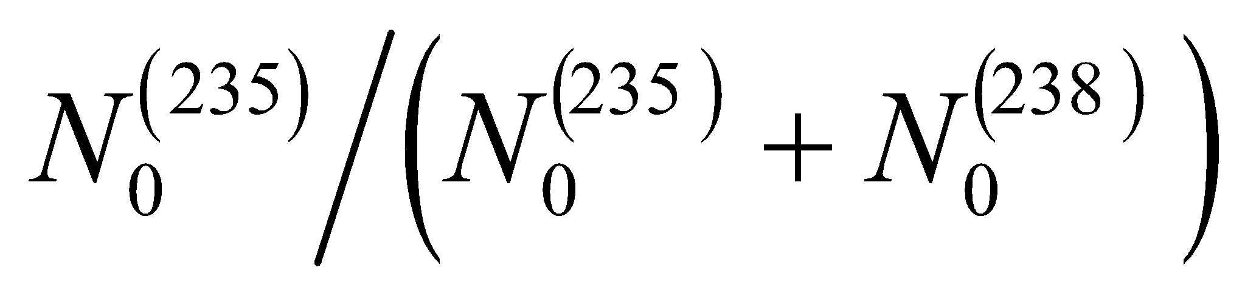 to decrease with time. Note that from current data on nuclear reactions and models of nucleosynthesis in supernova explosions, one can predict the isotopic abundances of 235U and 238U when they were produced. By reversing the above argument, one can then estimate the age of the elements in the nebula from which the solar system formed.

**55. Interpret** You're asked what is the long-term radioactivity of plutonium in terms of nuclear waste storage.

**Develop** The amount of plutonium will decrease by 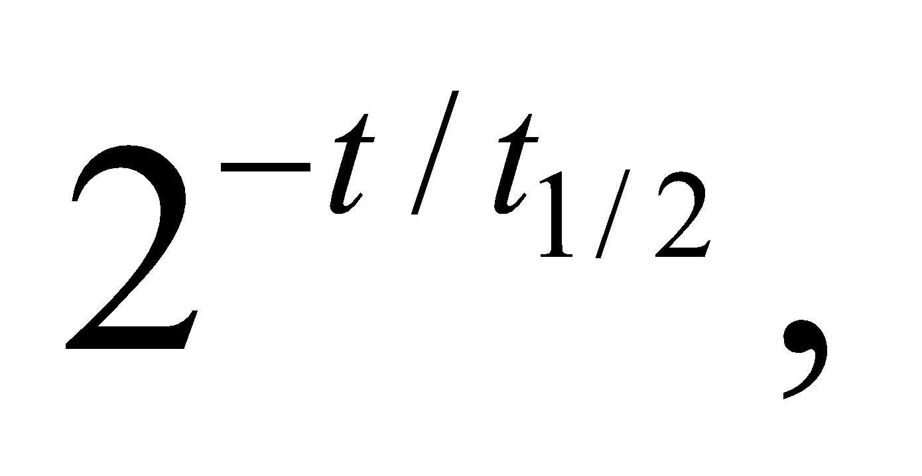where the half-life is 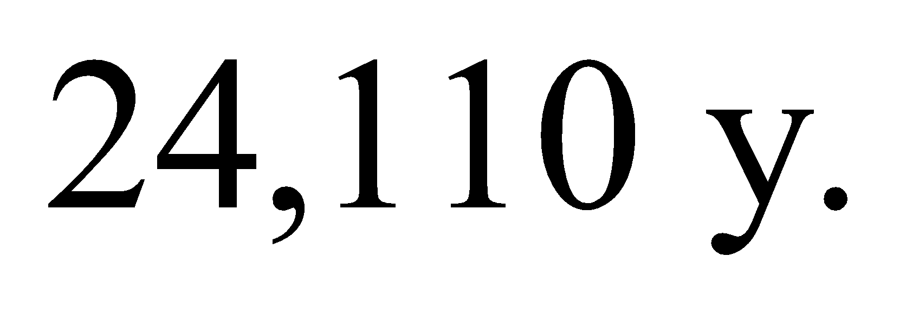

**Evaluate** The fraction of Pu-239 after 1 million years is

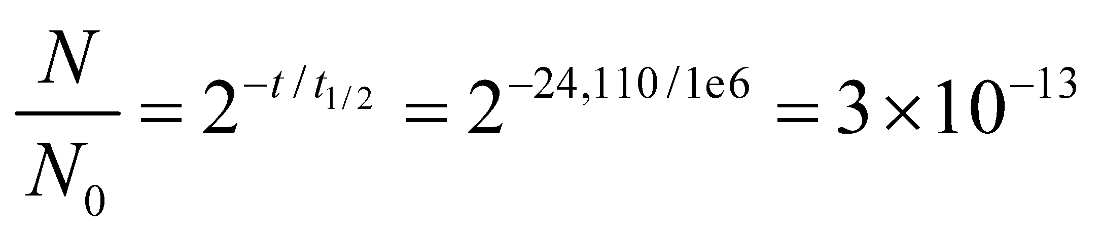

**Assess** This is almost nothing, as we'd expect after 41 half-lives of plutonium. However, the plutonium itself is only part of the problem, since it's decay products will be radioactive as well. Notably, Pu-239 decays to U-235, which has a half-life of 704 million years.

**56. Interpret** This problem concerns the decay rate of 15O. We are given its activity concentration at time *t* and asked to find its initial activity concentration.

**Develop** From the derivation of Equation 38.3a, we see that the activity concentration dN/dt = lN. Combining this with Equation 38.3b, we may write

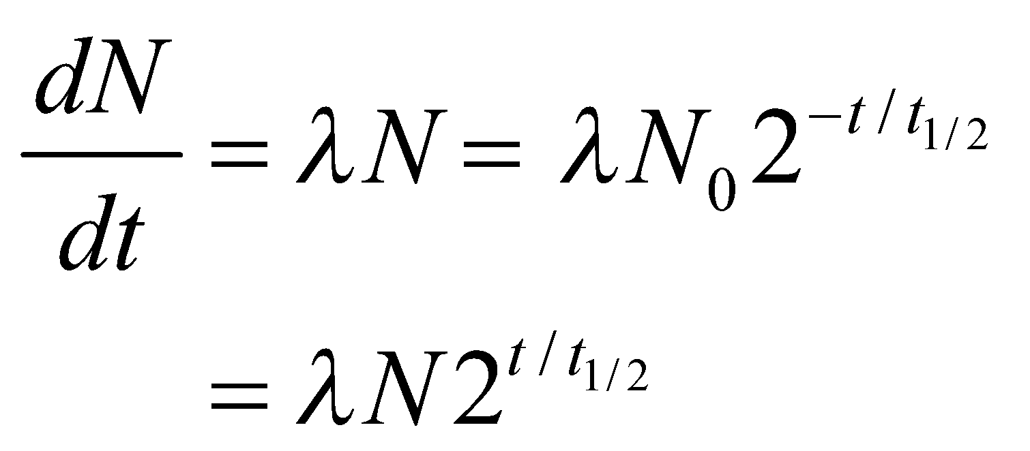

where *λN* is the activity concentration at t = 3.5 min.

**Evaluate** With 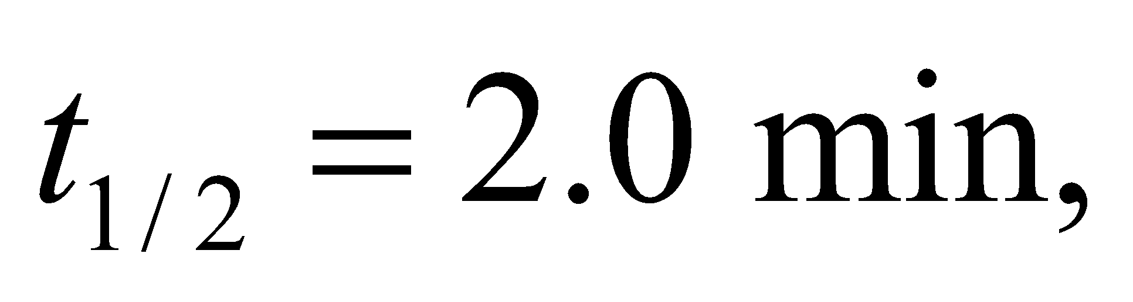 we get

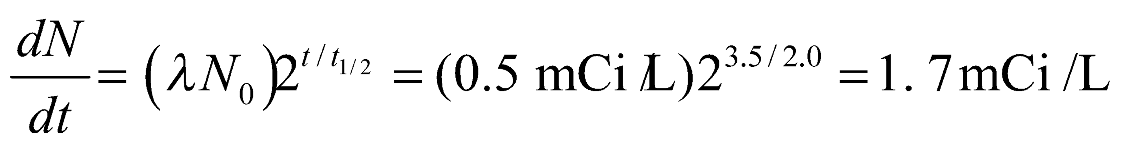

**Assess** As a quick check, we note that one half-life reduces the activity to 50% of the original, two half-lives to 25%, three to 12.5%, and so on. In our case, 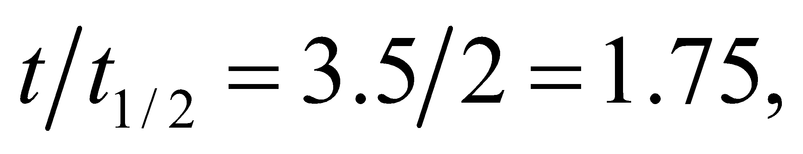 which is less than 2. So we expect the activity to be between 25% and 50% of the original. Indeed, we have 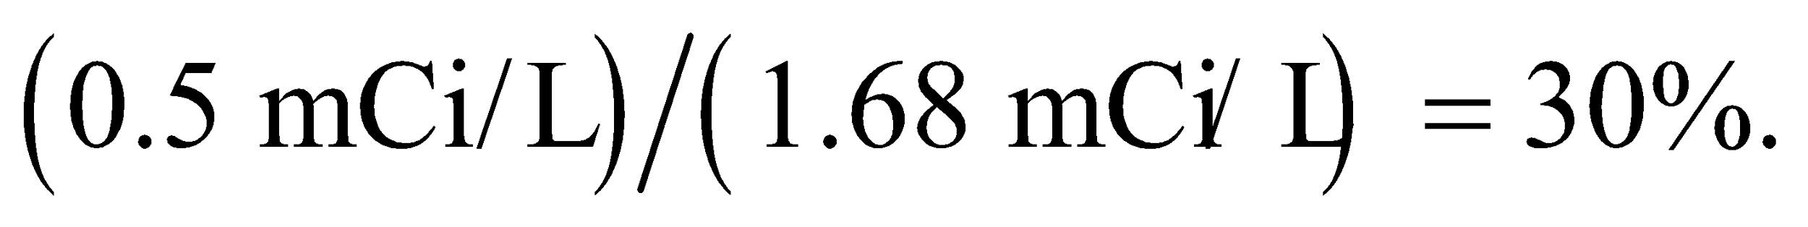

**57. Interpret** For a 3.2-GW reactor, we are to determine how much 235U would be needed to fuel the reactor for one year.

**Develop** The energy content of 235U is (see Appendix C) 2.3 × 107 kWh/kg. Thus, we can calculate the amount needed to power a 3.2-GW reactor for one year.

**Evaluate** Letting the units guide us, we find that the mass *m*U of 235U needed to power the reactor for one year is

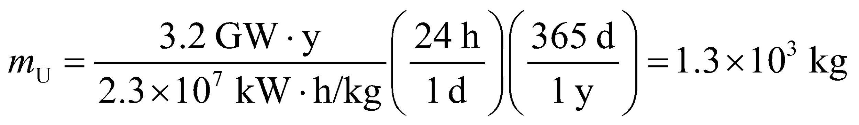

**Assess** How much natural uranium do we need to obtain this amount of 235U? Because natural uranium contains about 0.7% 235U, we would need (1.3 × 103 kg)/(0.007) ~ 2 × 105 kg of natural uranium. If we estimate the ratio of the densities of natural uranium (i.e., 238U) and water by the ratio of their atomic masses, we can estimate that the volume of 238U to be

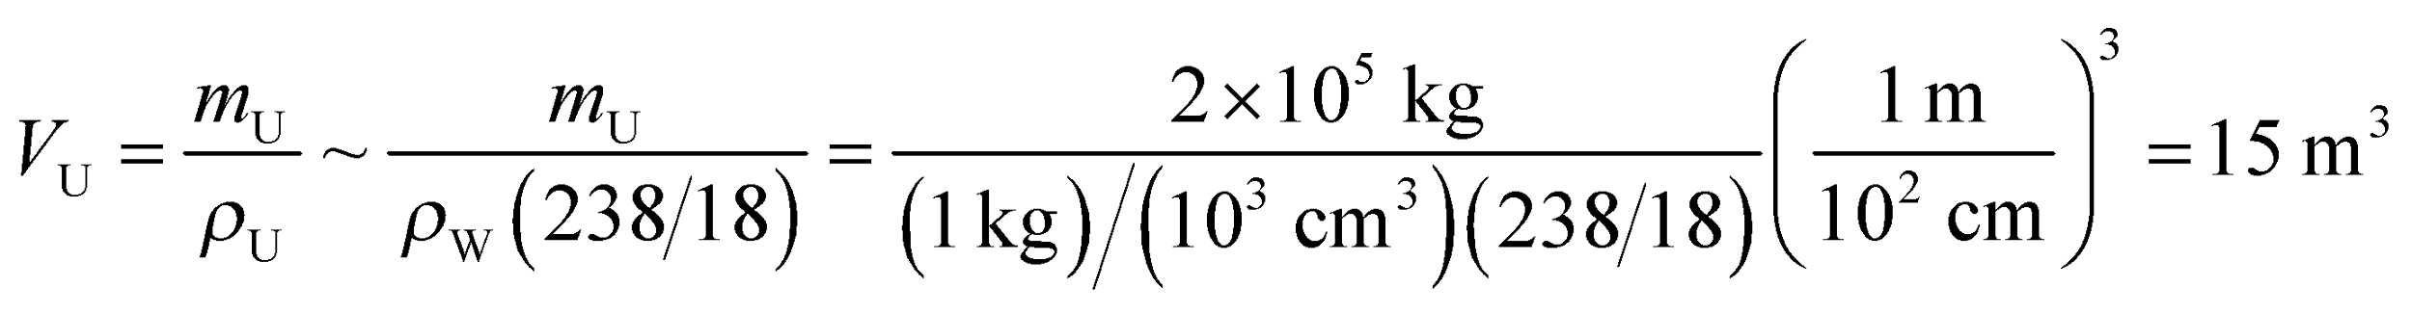

This would fit nicely into an average-sized truck, in agreement with Example 38.5.

**58. Interpret** We are to calculate the amount of uranium-235 needed for a fission bomb with a 20-kt explosive yield.

**Develop** Using the data in Appendix C, we find that a 1-kt explosive yield is about 4.18 × 1012 J. The fission of 235U yields 8.2 × 1013 J/kg. Therefore, 1 kt is equivalent to the energy released in the fission of about

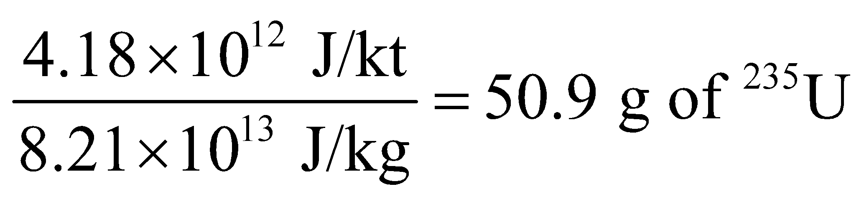

**Evaluate** A 20-kt yield is equivalent to the fission energy of 20 × 50.9 g = 1.0 kg of 235U.

**Assess** The bomb “Little Boy” was a uranium-235 fission bomb which had a yield of about 12–15 kt.

**59. Interpret** This problem concerns a nonrelativistic collision between a neutron and a stationary deuteron, so conservation of momentum and energy are involved. We are to find the fraction of the kinetic energy that is transferred from the neutron to the deuteron.

**Develop** The particles involved in the fission reactions discussed all have nonrelativistic energies, so Equations 9.15a and 9.15b, for a head-on elastic collision between a neutron (mass *m*n) and a deuteron initially at rest (*v*d,i = 0) gives

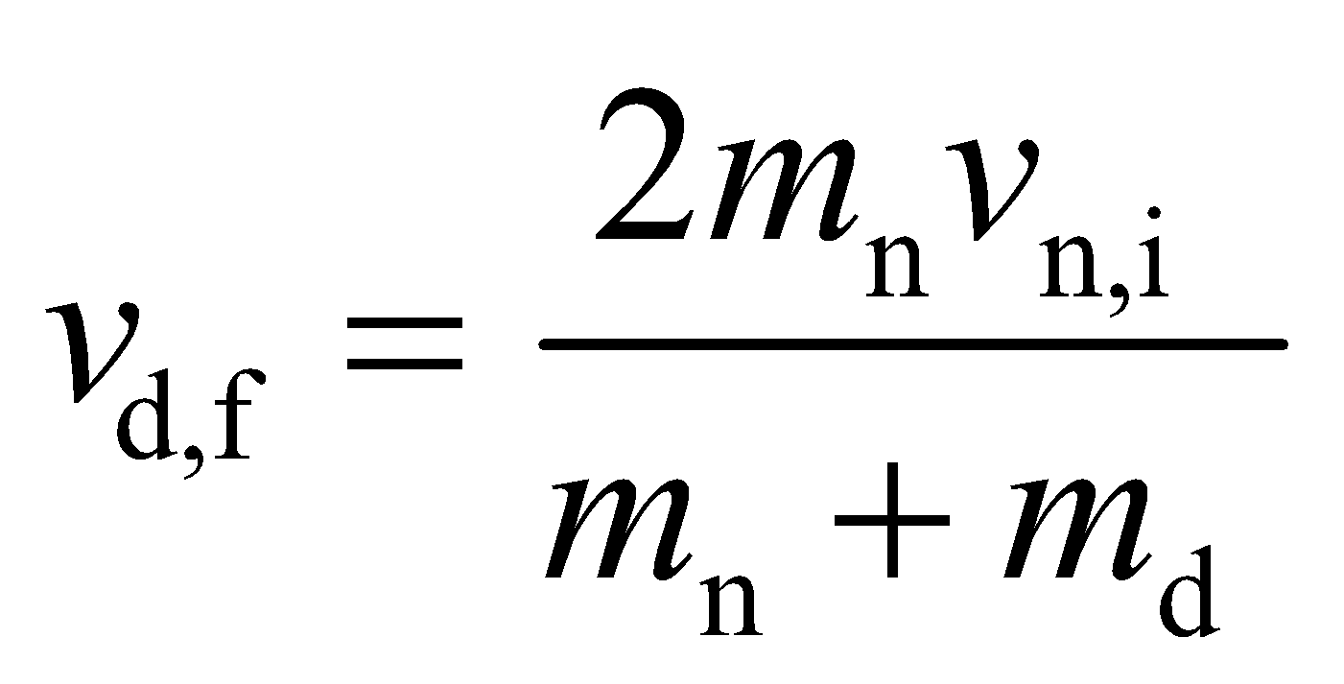

The ratio of the initial to final kinetic energy is

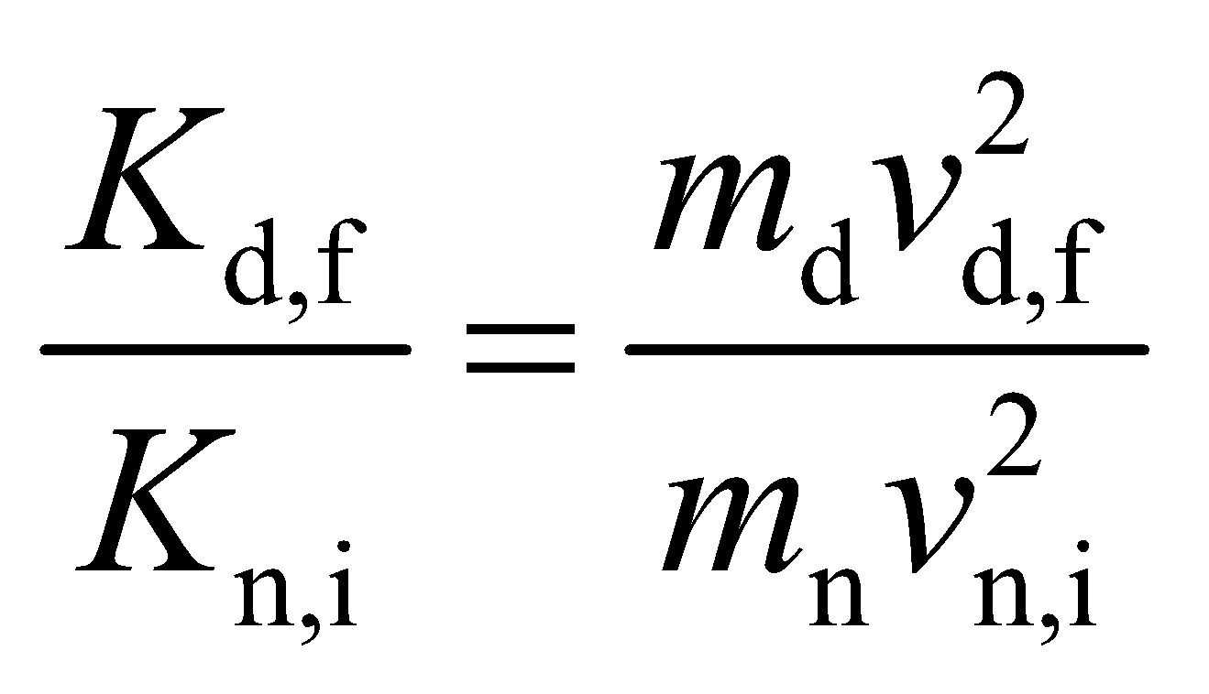

Using the expression above for *v*d,f and the fact that *m*d = 2*m*n allows us to calculate this ratio.

**Evaluate** The fraction of the neutron’s initial kinetic energy transferred to the deuteron is therefore

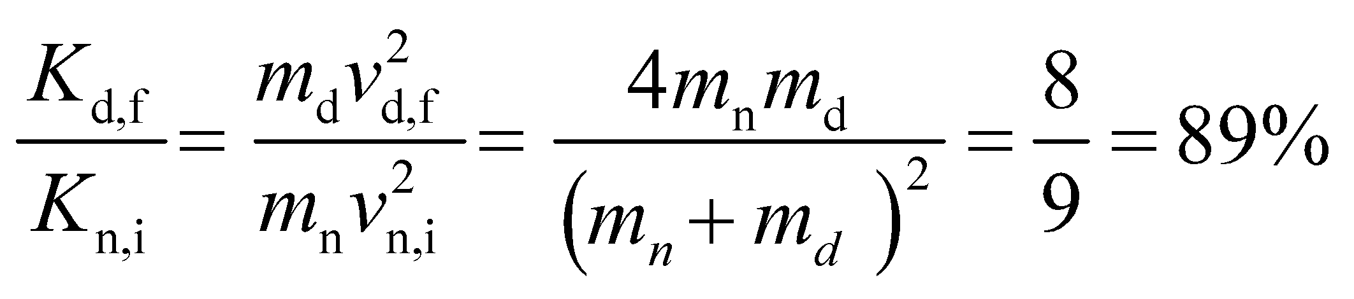

**Assess** The remainder of the kinetic energy is retained by the neutron.

**60. Interpret** This problem is about a reactor in a subcritical state with multiplication factor *k* < 1. We’re asked to calculate the time it takes for the power to be reduced by half, given the generation time.

**Develop** As outlined in Example 38.6, the multiplication factor *k* means that the fission rate is multiplied by a factor *k* with each generation time. The reactor power changes by a factor of 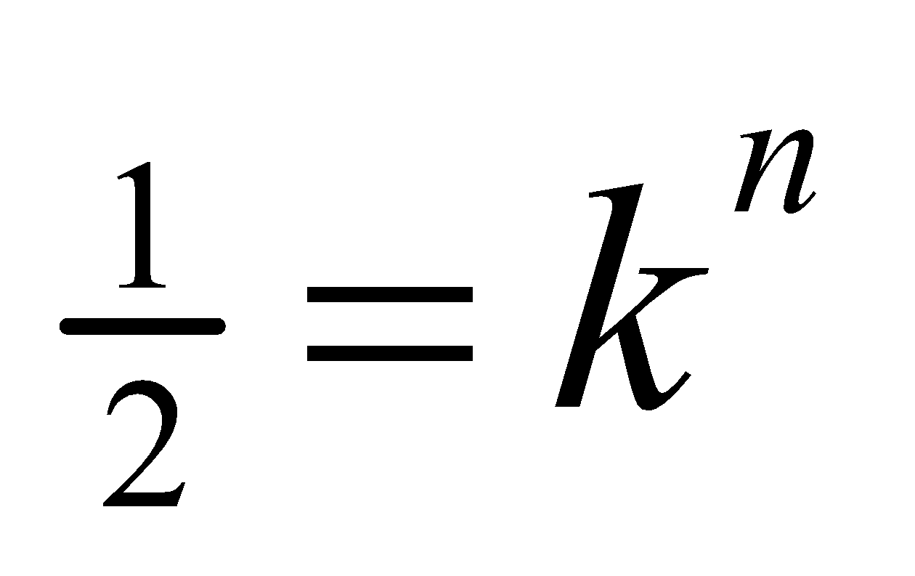 in *n* generations. The time *t* elapsed during this process is *t* = *nτ*, where *τ* is the generation time.

**Evaluate** Taking the logarithm on both sides of  gives

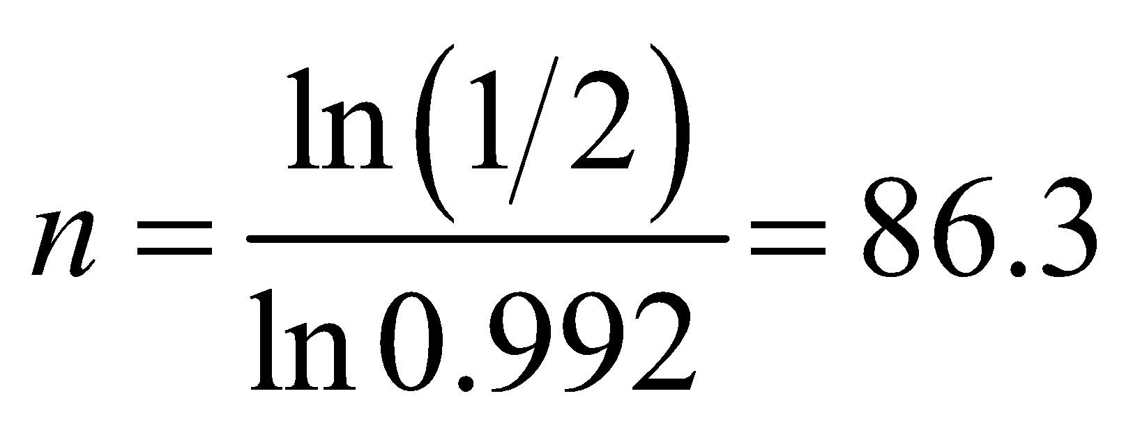

If the generation time is *τ* = 0.10 s, this process takes *t* = *nτ* = (86.3)(0.10 s) = 8.6 s.

**Assess** The power output decreases rather rapidly. A fission reactor with *k* < 1 produces fission without achieving criticality, and thus no sustaining chain reaction.

**61. Interpret** We are to calculate the amount of 235U consumed in one year in a reactor that produces 1.5 GW of power.

**Develop** This problem is similar to Problem 38.57, except that we are asked to find the amount of 235U required for the reactor instead of the amount of 238U. From Appendix C, we find that the energy content of pure 235U is 2.3 × 107 kW·h/kg. The energy required for the reactor for a full year’s operation is 1.5 GW·y, so we can calculate the mass of 235U required.

**Evaluate** The amount of 235U required is

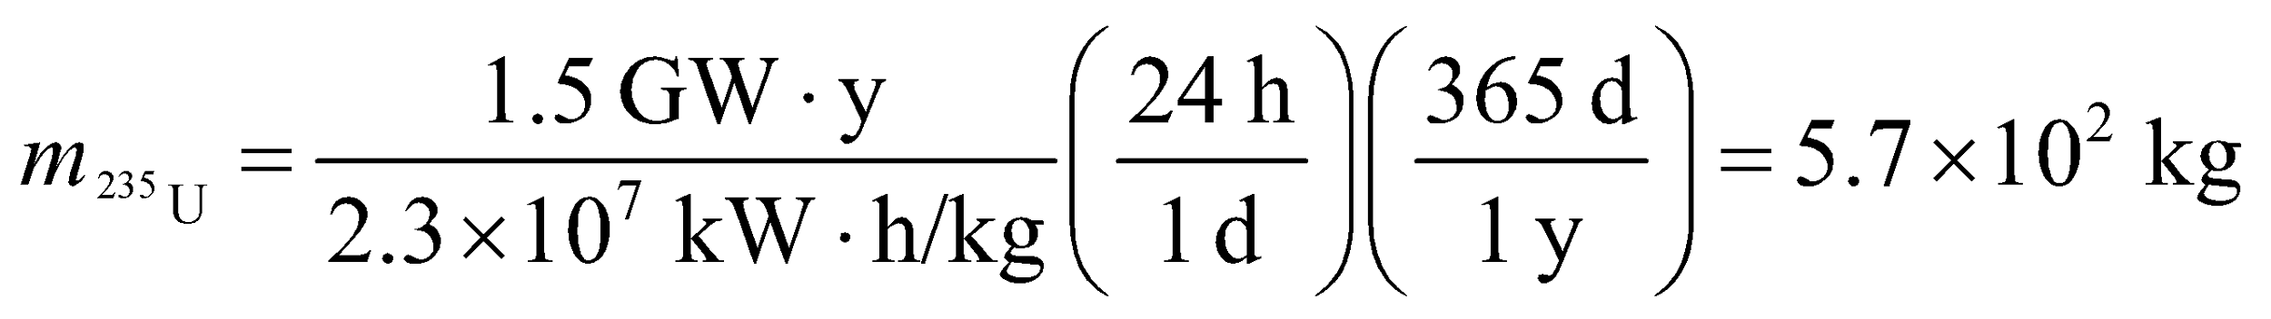

**Assess** As expected, this is much less than the amount of natural uranium required (cf. Problem 38.57).

**62. Interpret** This problem is about the power output and efficiency of a nuclear plant. We are given its power output and are to calculate the power output and efficiency.

**Develop** To compute the power output, we note that the energy content of 235U is 8.2 × 1013 J/kg (see Appendix C).

**Evaluate** **(a)** If all the 235U consumed fissions to produce heat, the thermal power output would be



**(b)** The efficiency is

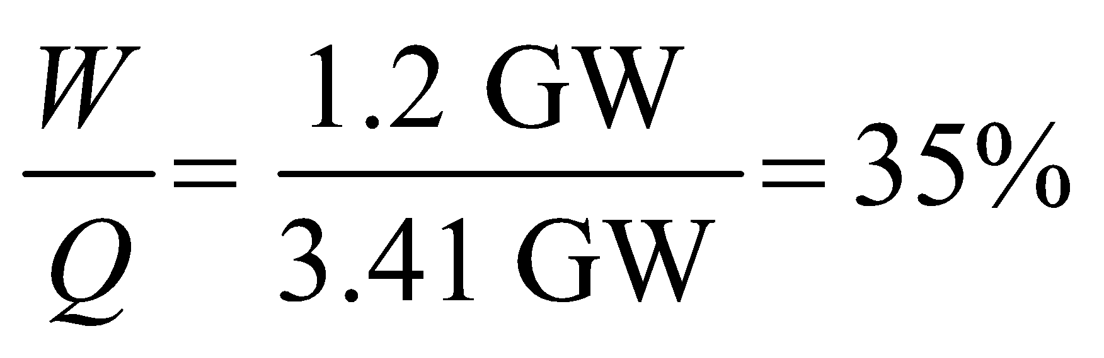

**Assess** An alternative way to calculate the power output is to follow the procedure used in Example 38.6. Since each fission produces about 200 MeV of energy, the power output is

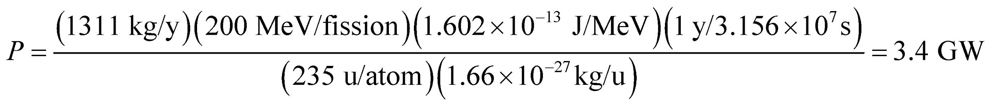

As illustrated in Example 38.6, only 0.35g of 235U is required to provide the same amount of energy as 1000 kg of coal. That’s why a nuclear power plant is more efficient.

**63. Interpret** This problem involves fission reactor dynamics. We are to find the time it takes for a 100-fold increase in power for a reactor that goes prompt critical.

**Develop** This problem is similar to Example 38.6. Similar reasoning leads in this case to the equation 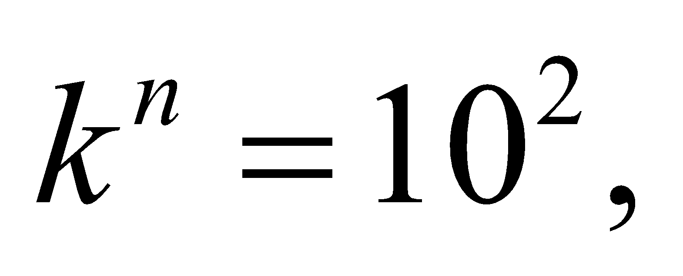 or 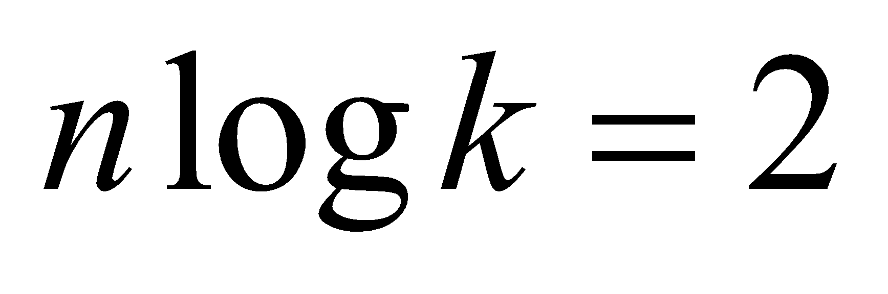, where *n* is the number of generations. The time *t* required for this increase in power is the number of generations *n* multiplied by the generation time *τ*:

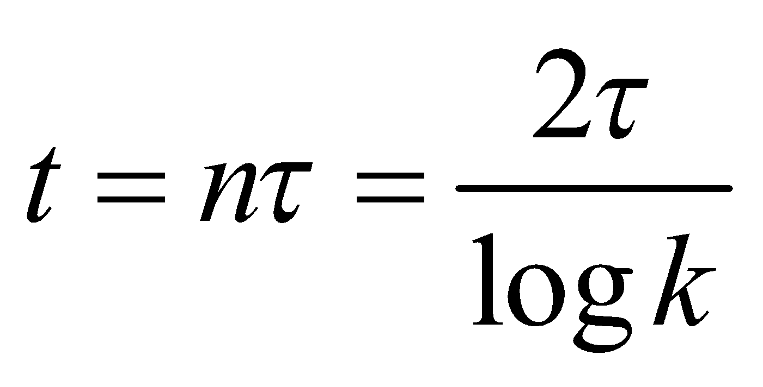

**Evaluate** Inserting *τ* = 100 μs and *k* = 1.001 gives

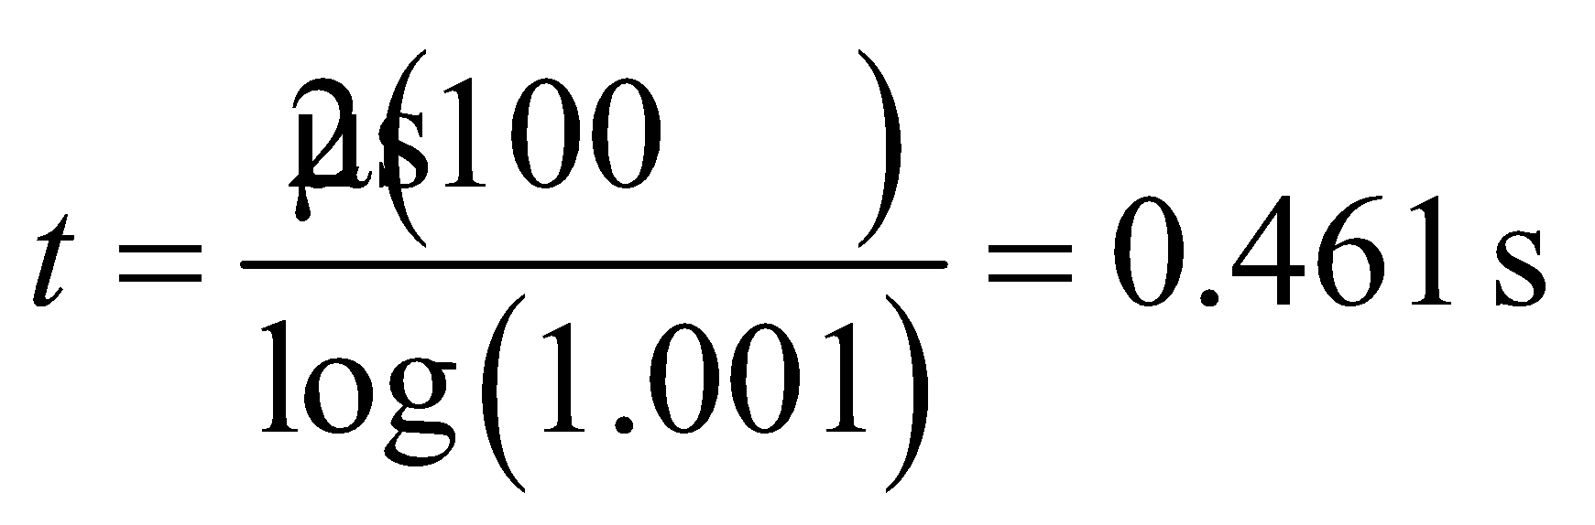

**Assess** This is a very fast increase in power, which gives an indication of the care that must be taken to prevent the reaction from going prompt critical.

**64. Interpret** This problem is similar to Problems 38.57 and 38.61, except that the material powering the power plant in question is now deuterium oxide instead of uranium. We are to find the amount of deuterium needed to give the desired annual energy output in D-D fusion.

**Develop** In one year (= 3.156 × 107 s), the amount of energy produced by a 1.000-GW power plant is



We shall use 7.20 MeV/deuteron as the average energy release in a D-D reactor (note that the D-D reactions of Equations 38.10b and 38.10c produce 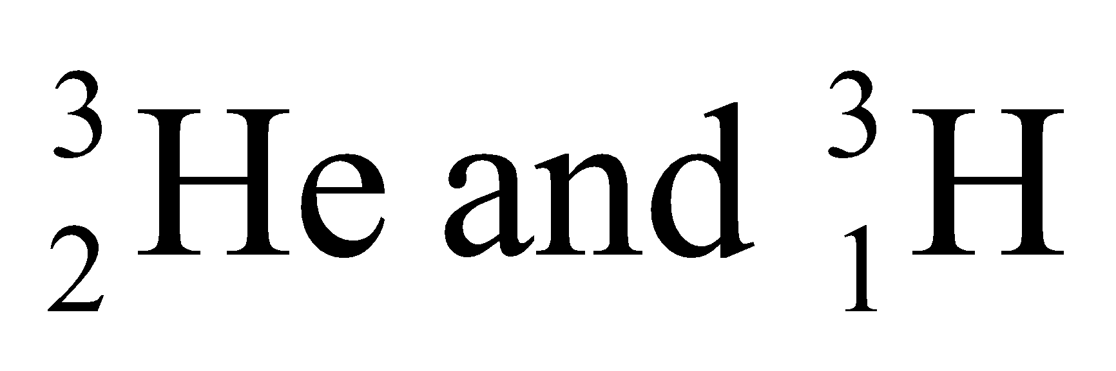 that can undergo further fusion reaction). Thus,

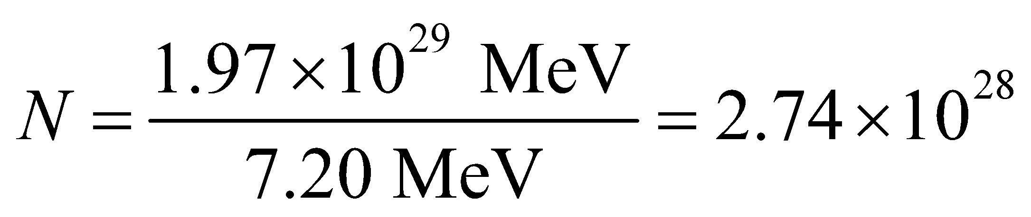

deuterons are required.

**Evaluate** The molecular weight of D2O is about 20 u, so about

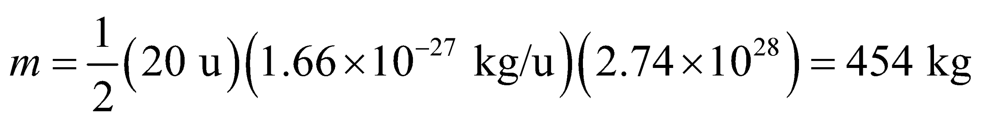

of heavy water (each molecule of which contains two deuterium atoms) would be needed.

**Assess** About 0.015% of hydrogen nuclei in seawater molecules are deuterium. They can be used to produce heavy water. Note that heavy water plays the role of moderator and coolant in certain reactors (e.g., the Canadian CANDU design).

**65. Interpret** This problem involves calculating the rate at which the Sun consumes protons given that 4 protons must combine to give 27 MeV. We are also to find how long the Sun’s current proton-consuming phase will last.

**Develop** The number of protons consumed per second is the power output divided by the energy release *E* per proton, where *E* = (27 MeV)/4 because 4 protons are required for each reaction that produces 27 MeV. The amount of hydrogen originally contained by the Sun is (0.71)(2 × 1030 kg)/(1.67 × 10−27 kg/proton) = 8.5 × 1055 protons, so we can find how long it takes to consume 10% of this by dividing by the consumption rate.

**Evaluate** (a) The proton consumption rate *dN*p/*dt* is about

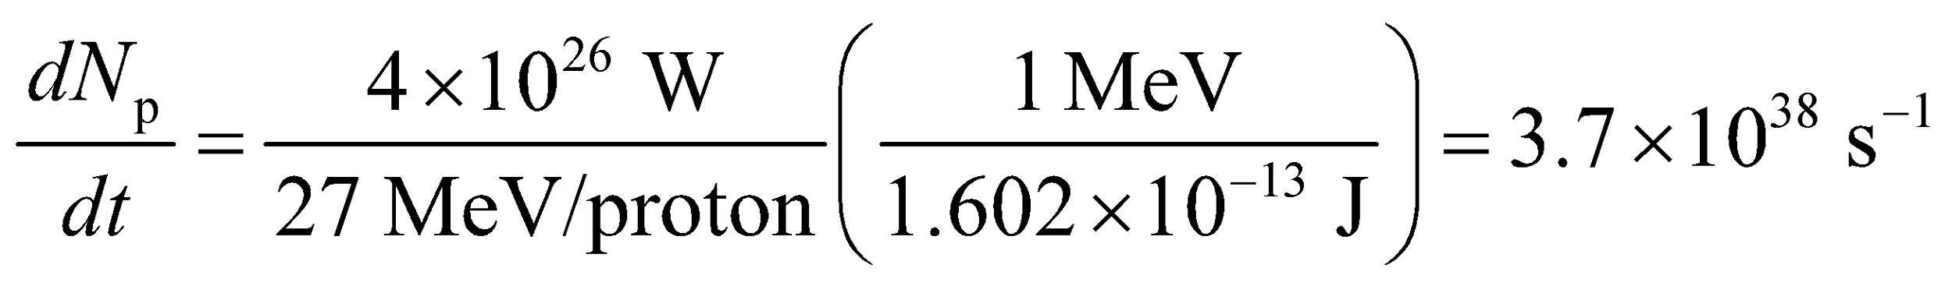

(b) The consumption of 8.5 × 1055 protons at the rate found in part **(a)** would take about

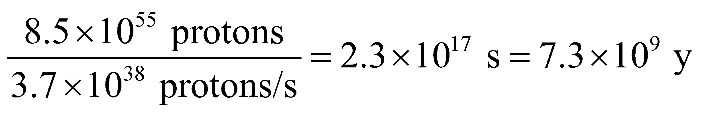

**Assess** The present age of the Sun is about 4.5 billion years.

**66. Interpret** You want to convince others of the potential of nuclear fusion by estimating how much energy is in a gallon of seawater, due to its concentration of deuterium nuclei.

**Develop** The number of deuterium 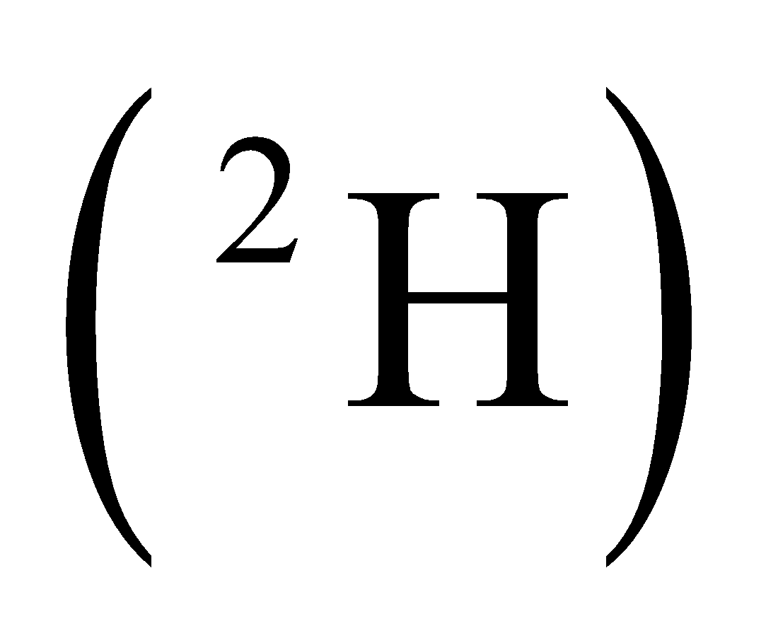 is a small fraction of the number of hydrogen 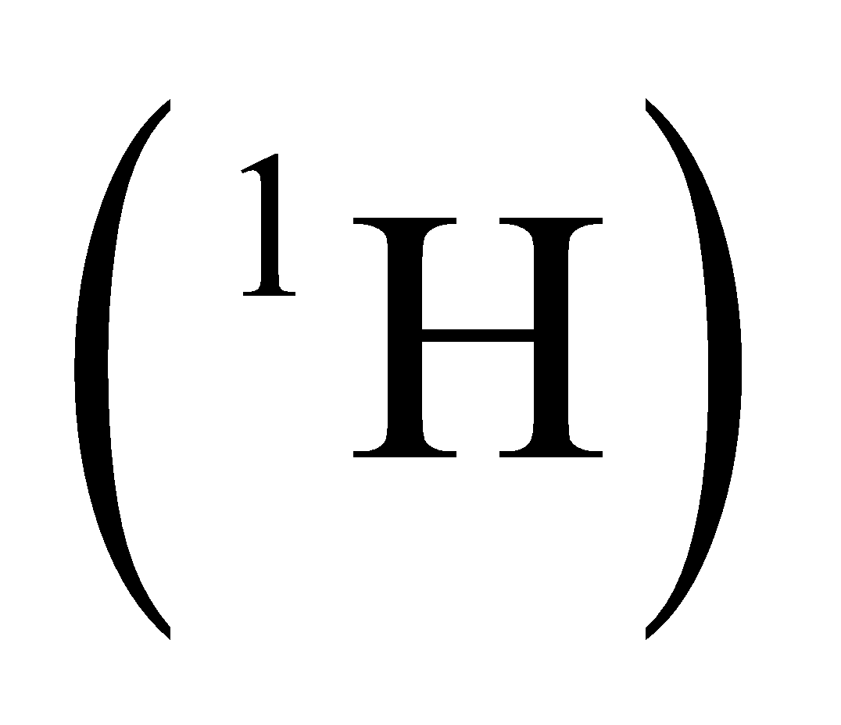in a given sample: 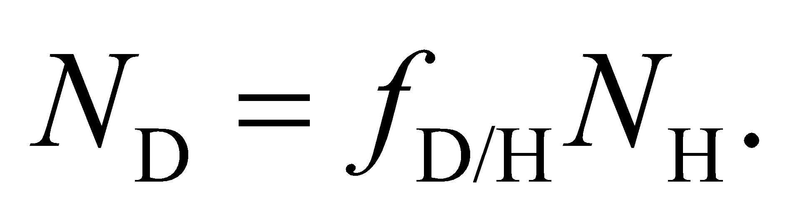 In water, the number of hydrogen is twice the number of water molecules: 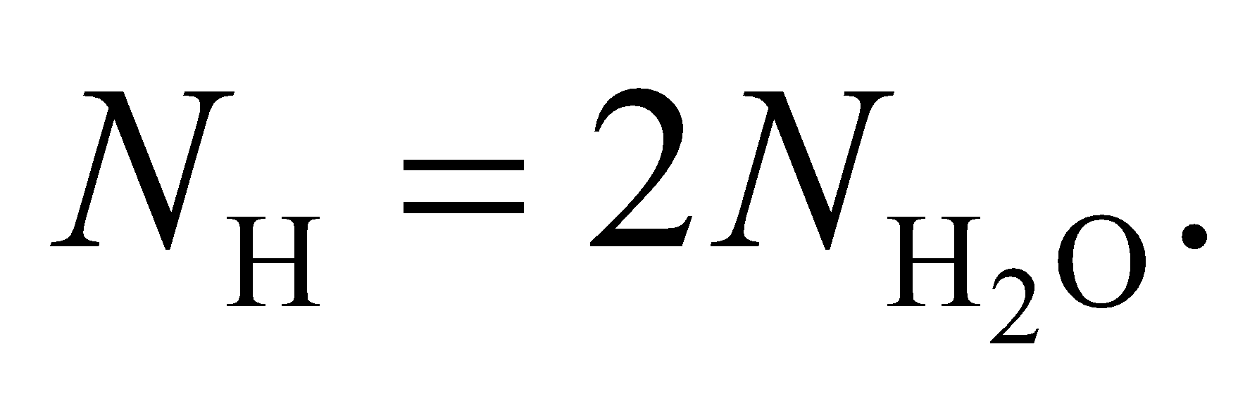 If you assume seawater is pure water, the number of water molecules is the ratio of the total mass and the mass of a single molecule: 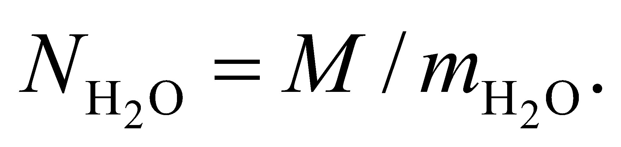 Since the density of water is 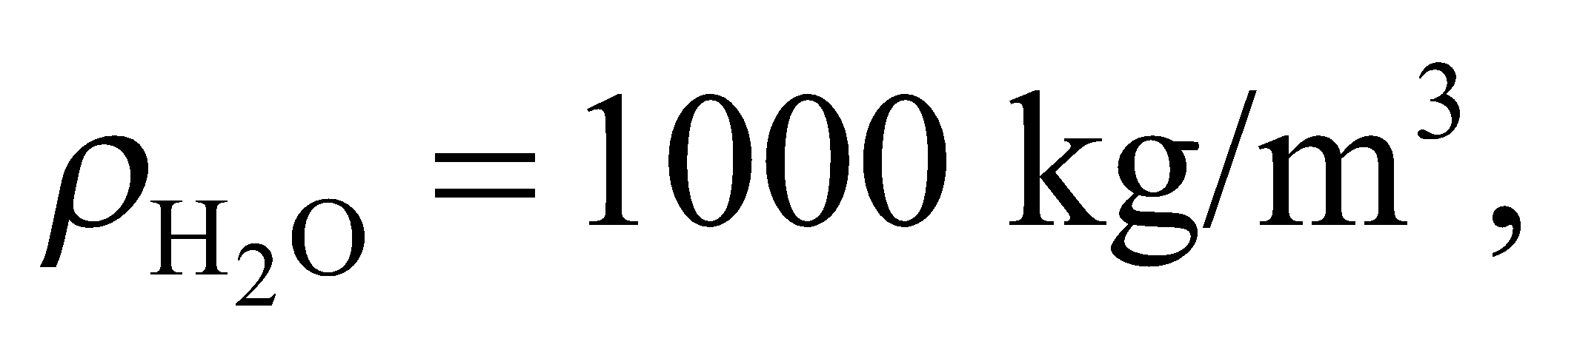 the mass of one gallon of water is

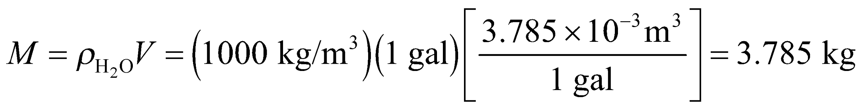

The mass of a single water molecule is the sum of two hydrogen and one oxygen:

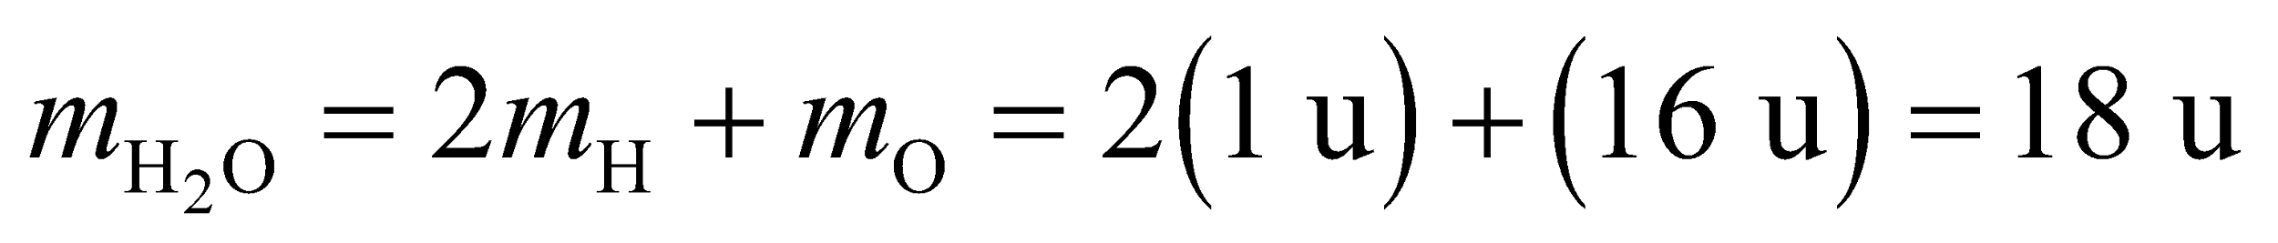

**Evaluate** Combining the information from above, the number of deuterium in a gallon of seawater is

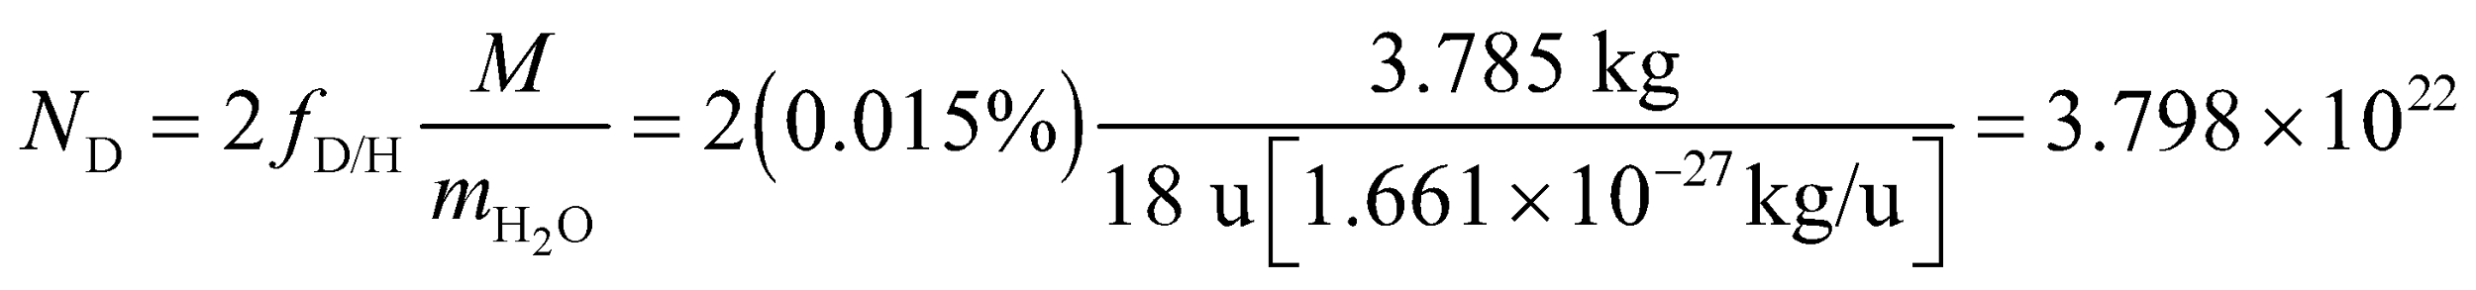

Assuming 7.2 MeV per deuterium, the available fusion energy in a gallon of seawater is

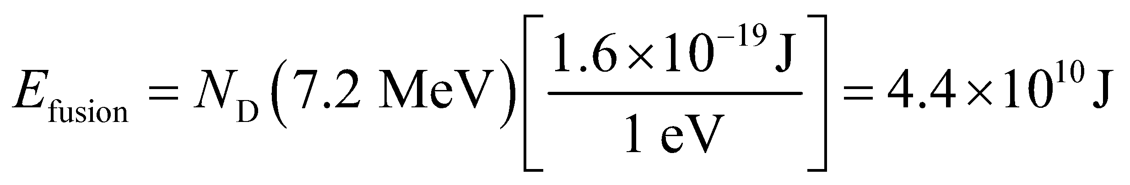

Thus, the energy density of seawater is about 12,000 kWh/gal, compared to 36 kWh/gal for gasoline (see Appendix C). In other words, the energy in a gallon seawater is equivalent to 340 gallons of gasoline.

**Assess** Although there is reason to be enthusiastic about nuclear fusion, the technology is not there yet for harnessing this powerful source.

**67. Interpret** To continue the argument of the previous problem, you want to estimate how long nuclear fusion could supply the human population with energy it demands.

**Develop** Since you have already calculated the energy density of seawater in the previous problem 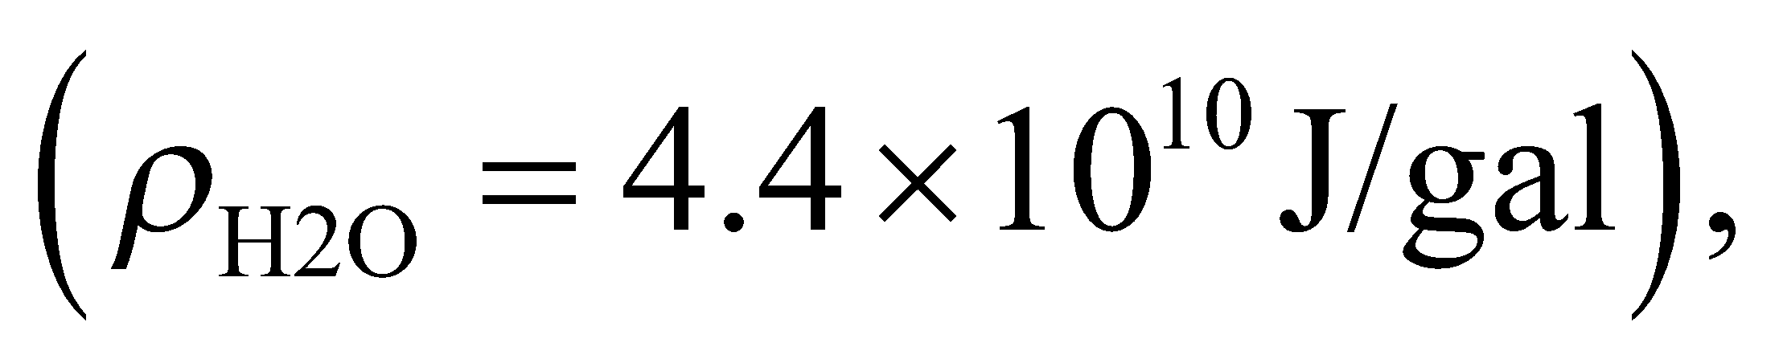 you need now only estimate the number of gallons in the world's oceans. Assuming that 70% of the Earth's area 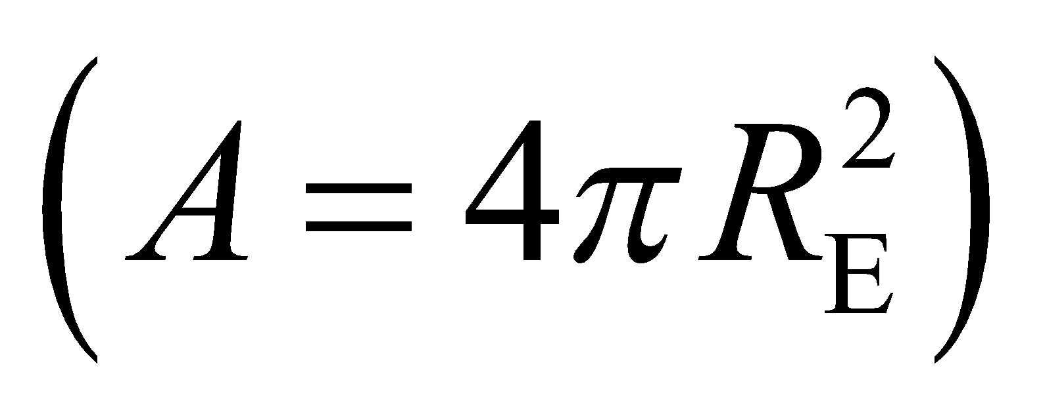 is covered with water to an average depth of 3 km, the volume of water is



**Evaluate** Using the planet's water supply, the total energy available from fusion is



Assuming humans continue to consume energy at the current rate of 15 TW, fusion energy could last for

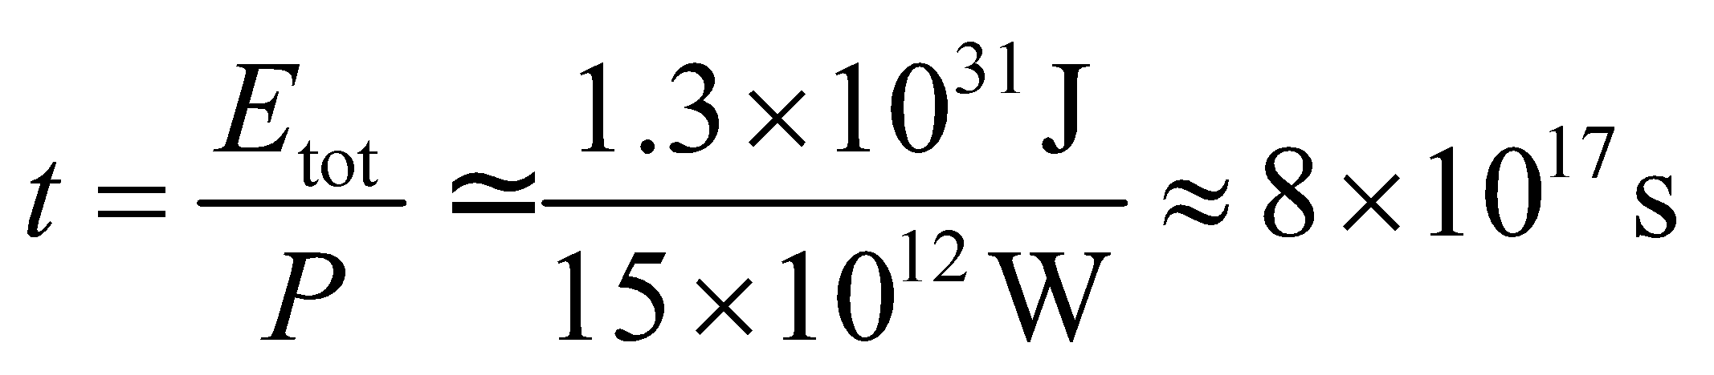

This is about 26 billion years, or roughly 20 billion years longer than the Sun will shine.

**Assess** This is a very rough calculation, but even so it should make it clear that fusion energy is effectively limitless once the technological hurdles can be overcome.

**68. Interpret** We are asked to find the energy released in the *α*-decay of 238U.

**Develop** The energy released in the decay is the difference in the mass-energy of the initial nucleus and that of the decay products. Rewriting Equation 38.7 gives

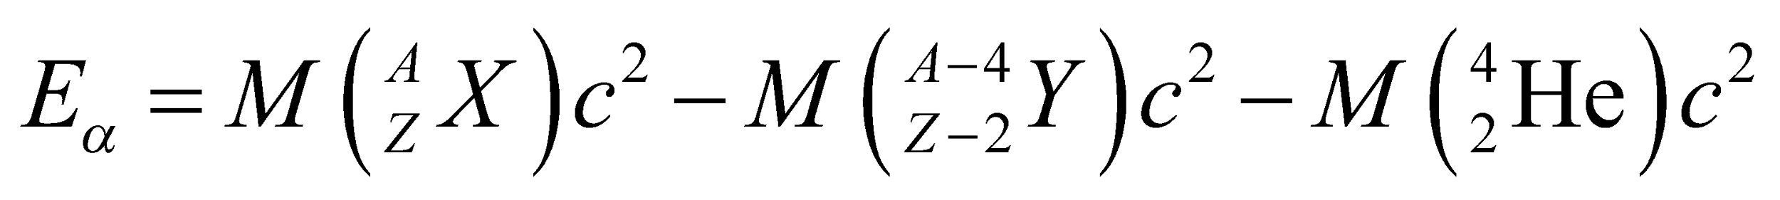

Note that atomic or nuclear masses can be used to calculate 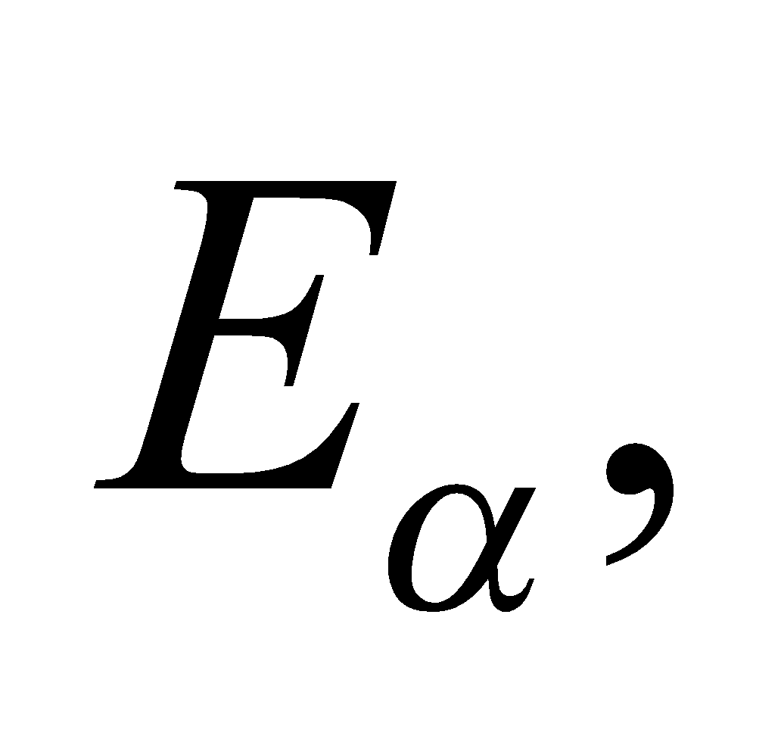 since in *α*-decay, the mass of the *Z* electrons cancels. The neglect of atomic binding energies is also less serious here than in Equation 38.7 because only differences enter. For 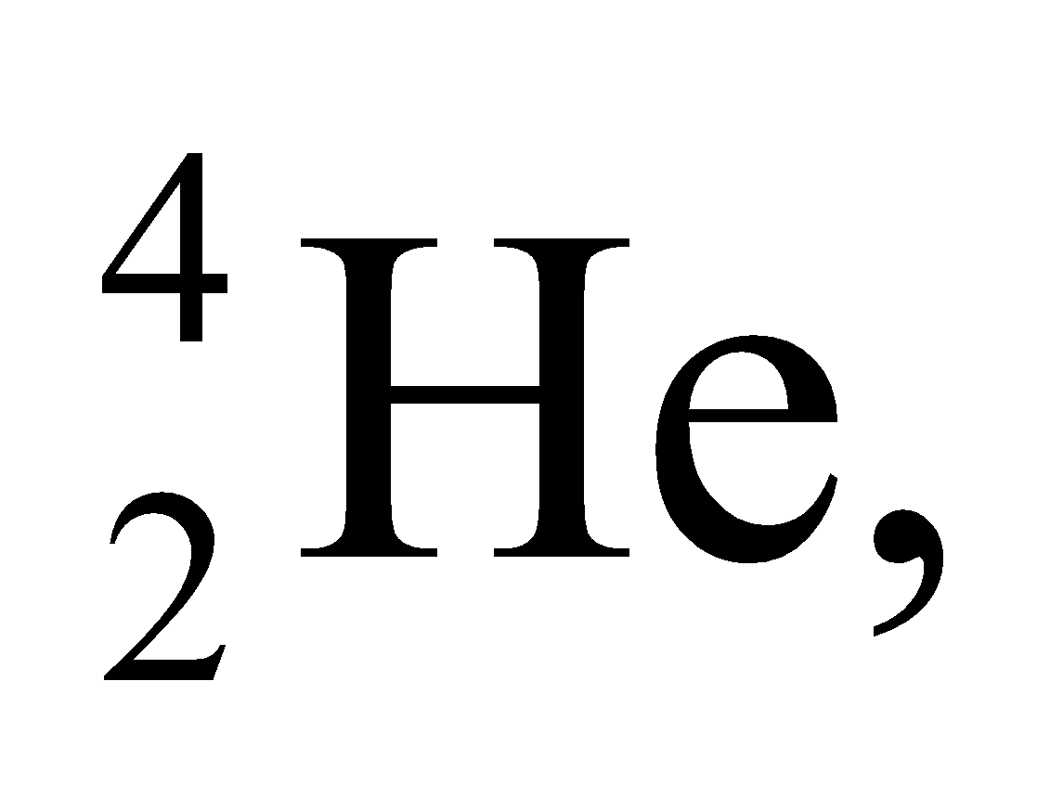 from Table 38.2, we have 4.001506 u + 2(0.000548579 u) = 4.002603 u; the atomic masses of 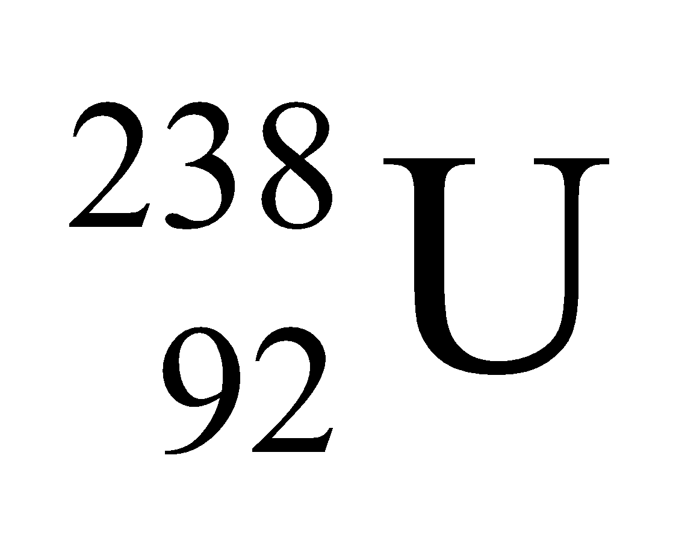 and 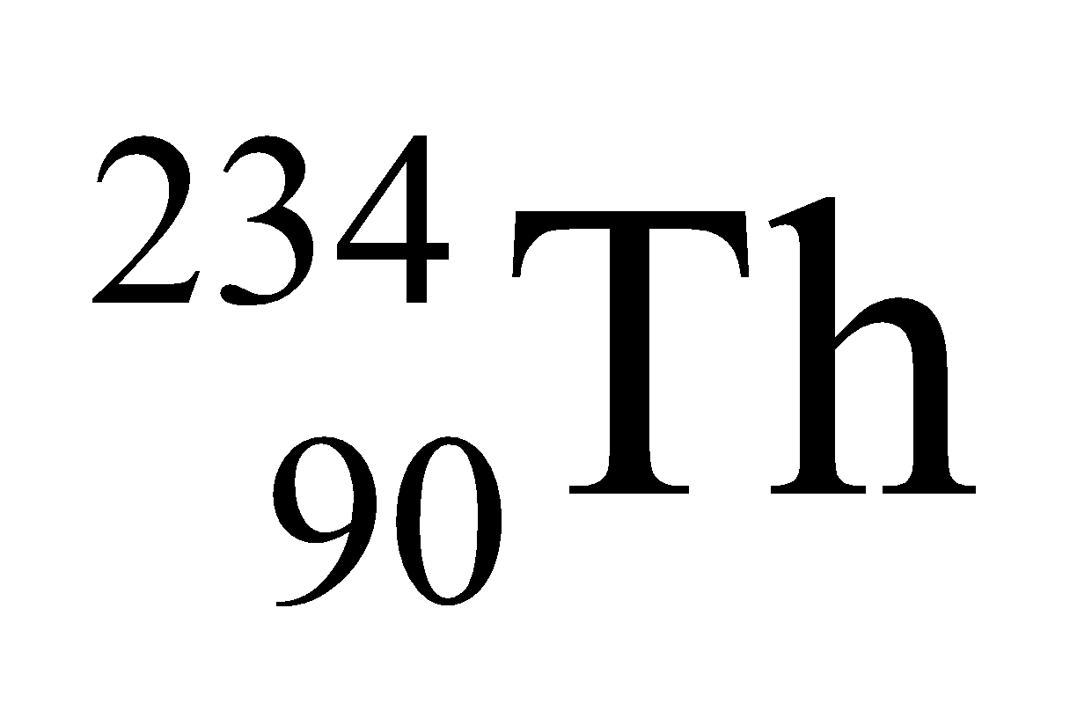 are given.

**Evaluate** Substituting the values obtained, we get

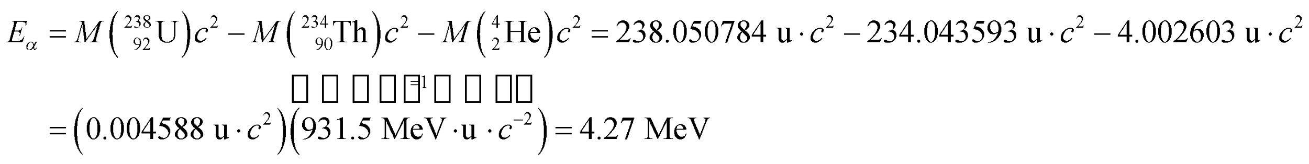

Thus, the energy released during the *α*-decay is 4.27 MeV. Note that the half-life of this decay process is about

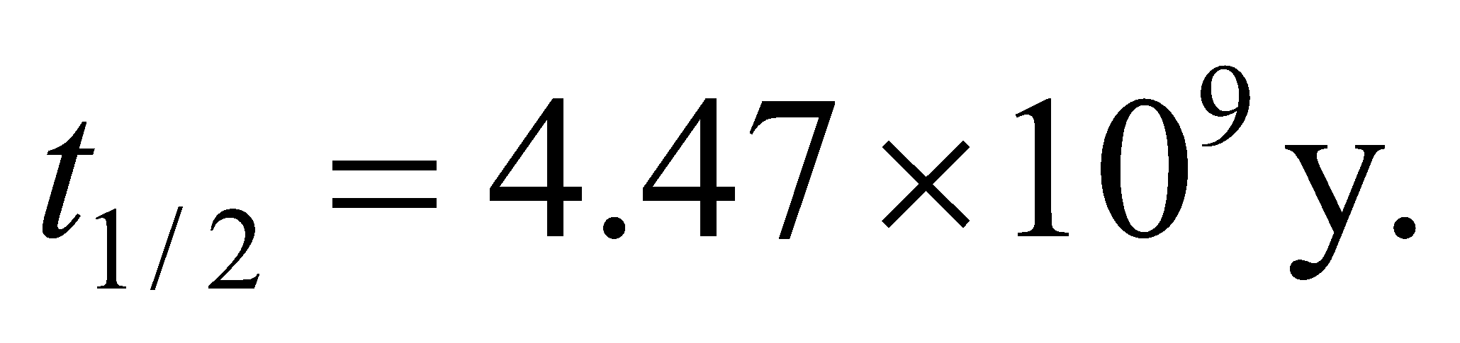

**Assess** The energy released in the decay is analogous to the binding energy for a stable nucleus, which has the opposite sign. In nuclear reactions, the difference in mass-energy between the initial and final reactants is called the Q-value, which is positive for exothermic (energy releasing) and negative for endothermic (energy absorbing) reactions.

**69. Interpret** We want to identify the product of a nuclear fusion reaction.

**Develop** Bismuth has atomic number 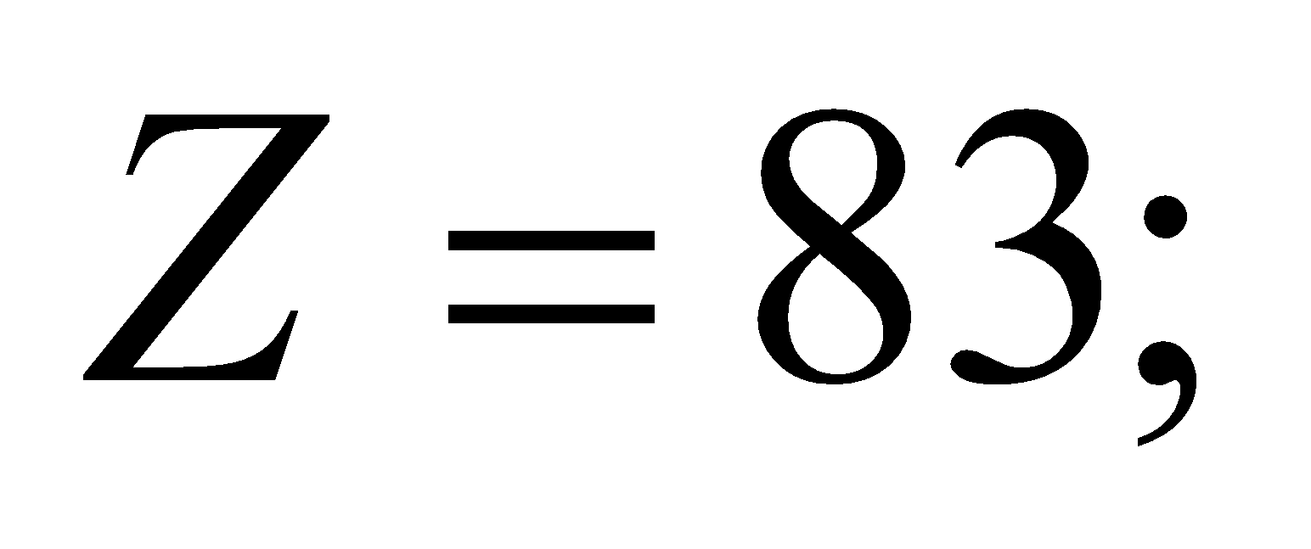chromium has atomic number 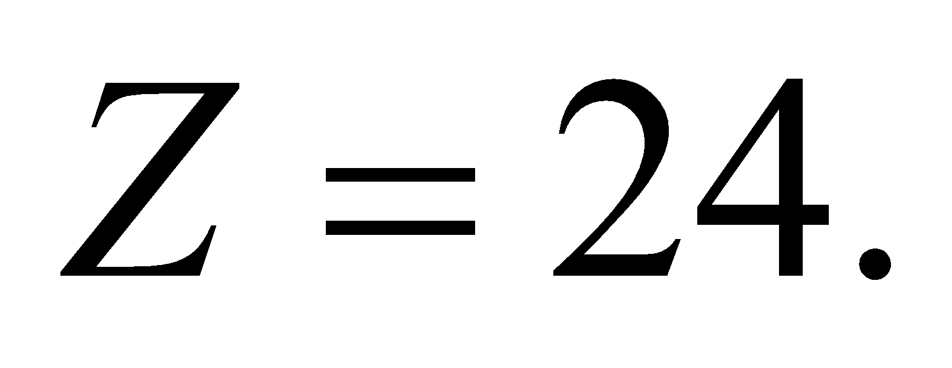 Since the nuclear reaction does not produce any beta particles, we can assume that the number of protons and the number of neutrons are both conserved separately.

**Evaluate** To conserve the proton number, the final product must have an atomic number equal to the sum of reactants' atomic numbers:

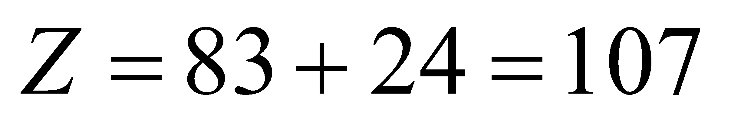

Looking in the periodic table, this corresponds to the element bohrium (Bh). To find its mass number, we need to account for the extra neutron produced in the reaction:

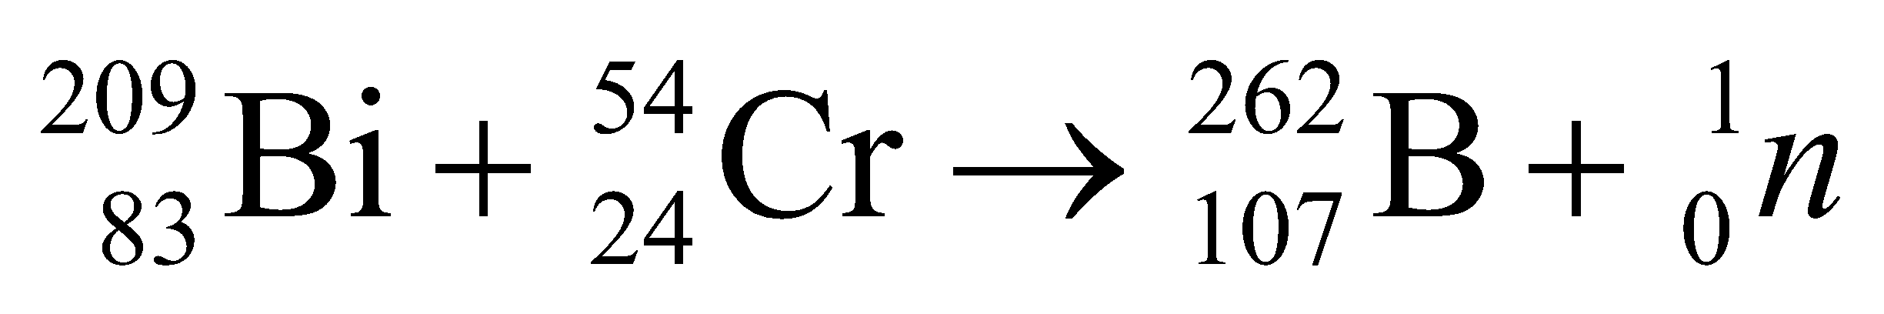

So the heavy nucleus is borhium-262 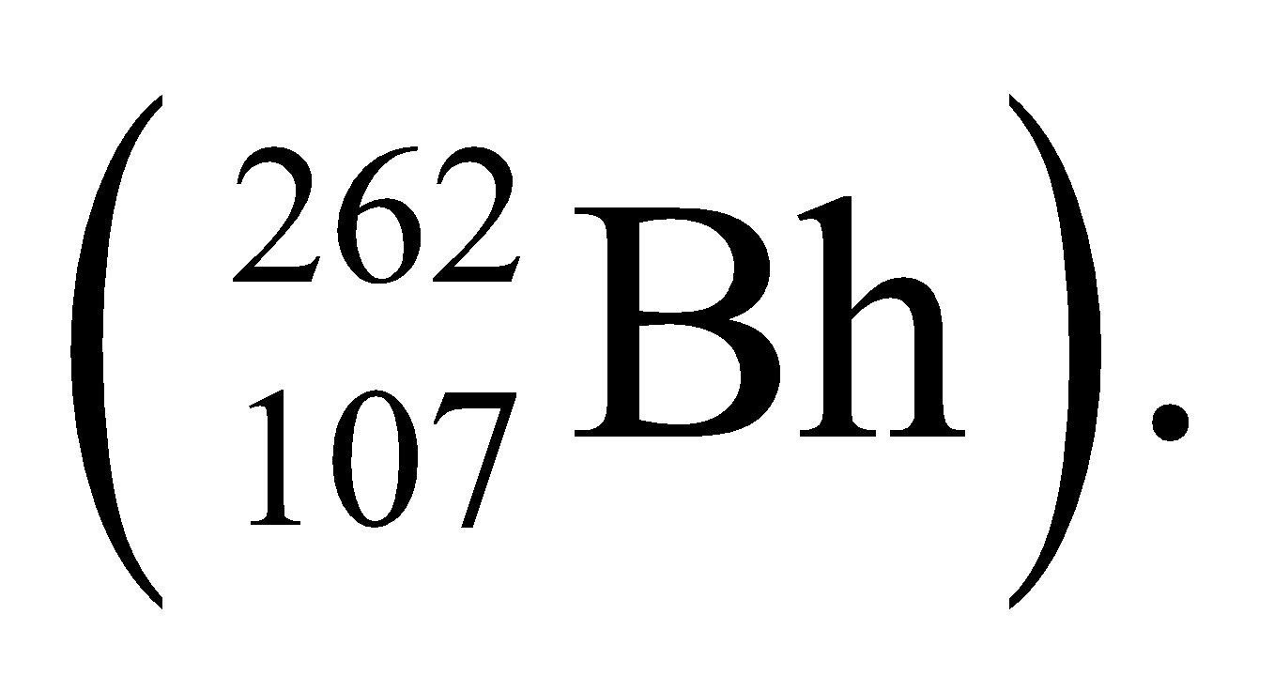

**Assess** This isotope of borhium has a half-life of only about a tenth of a second. There are no stable forms of this element, so it is not found naturally in the environment. It was first synthesized in a laboratory in the 1980s.

**70. Interpret** We are to write the reaction for producing a gold nucleus from bombarding mercury with neutrons.

**Develop** If we assume only one unknown product, the reaction will be of the form

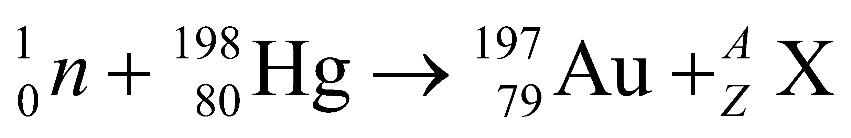

Conservation of charge and mass number implies that 80 = 79 + *Z* and 1 + 198 = 197 + *A*, so *Z* = 1 and *A* = 2.

**Evaluate** Thus, the unknown product is a deuteron, 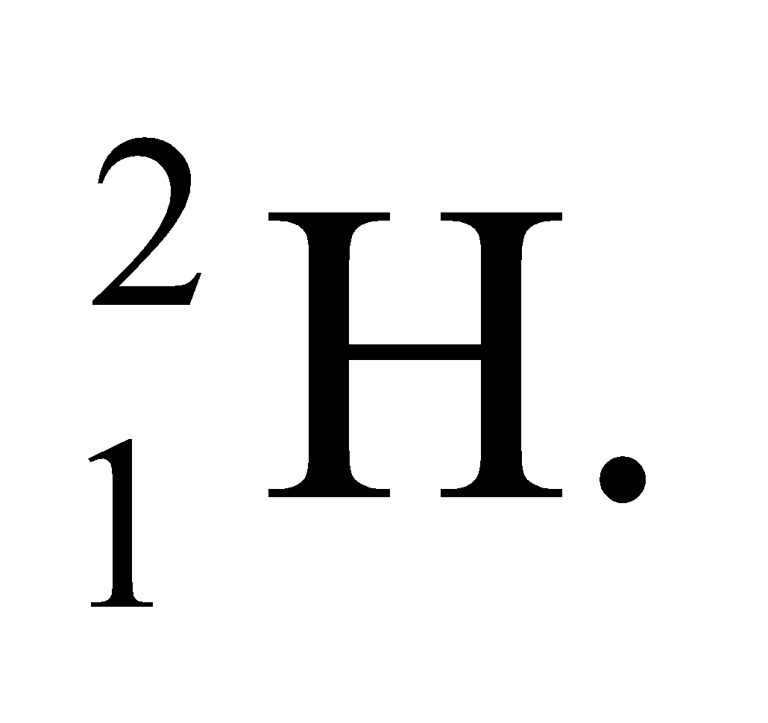 The reaction can be written as

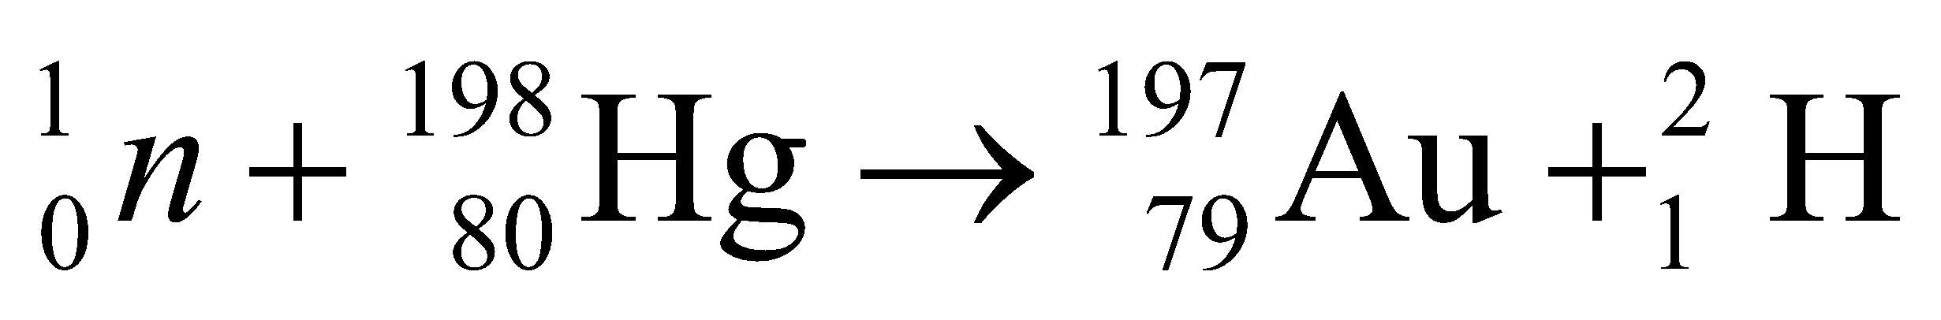

or symbolized by 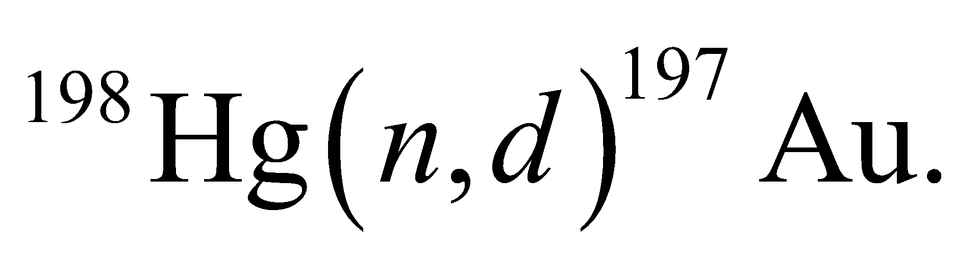

**Assess** The production of gold is an age-old dream of alchemists. While it is possible in nuclear reactors, the expense of the procedure far exceeds the financial gain!

**71. Interpret** This problem involves finding the products of a nuclear decay reaction. In addition, given the decay constant, we are to find the time required for the daughter nuclei to outnumber the parents by 2 to 1.

**Develop** In a  the atomic number of the parent nucleus increases by one while the mass number stays the same (i.e., 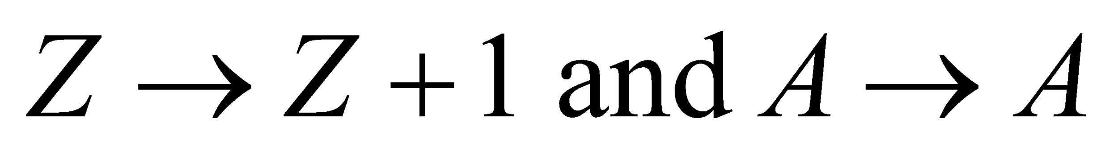). Given the Ni has *Z* = 28 and *A* = 65, we can identify the daughter nucleus. The number of parent nuclei at time *t* (in a sample that was pure at t = 0) is  (see Equation 28.3a) which, when we solve for *t*, gives

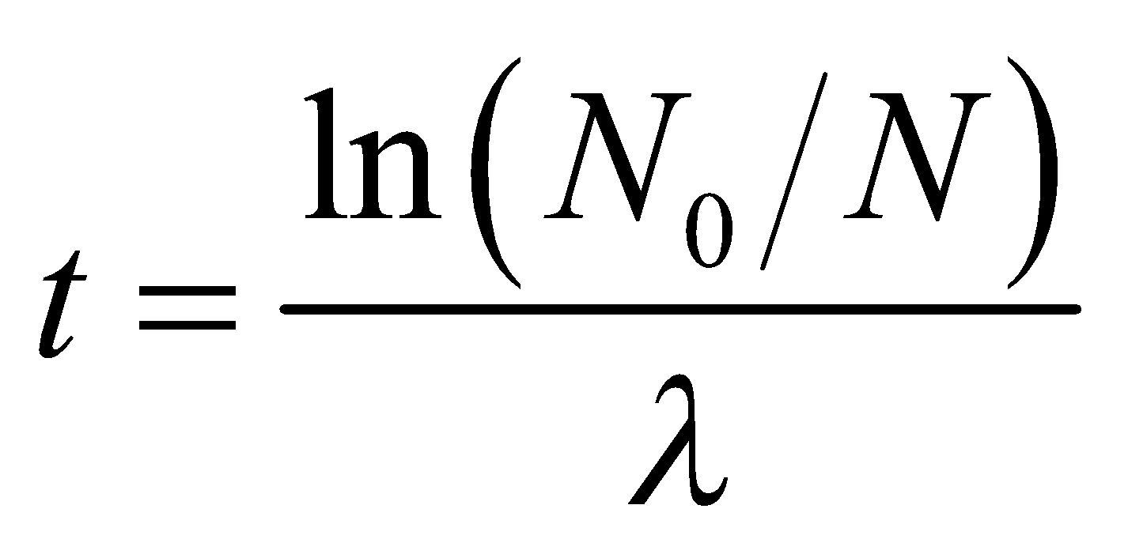

Since a single daughter nucleus is produced each time a parent nuclei is consumed in the reaction, the number of daughter nuclei is *N*d = *N*0 − *N*, which allows us to find the time *t* when *N*d = 2*N* (recall that *N* is the number of parent nuclei).

**Evaluate (a)** The daughter nuclei is 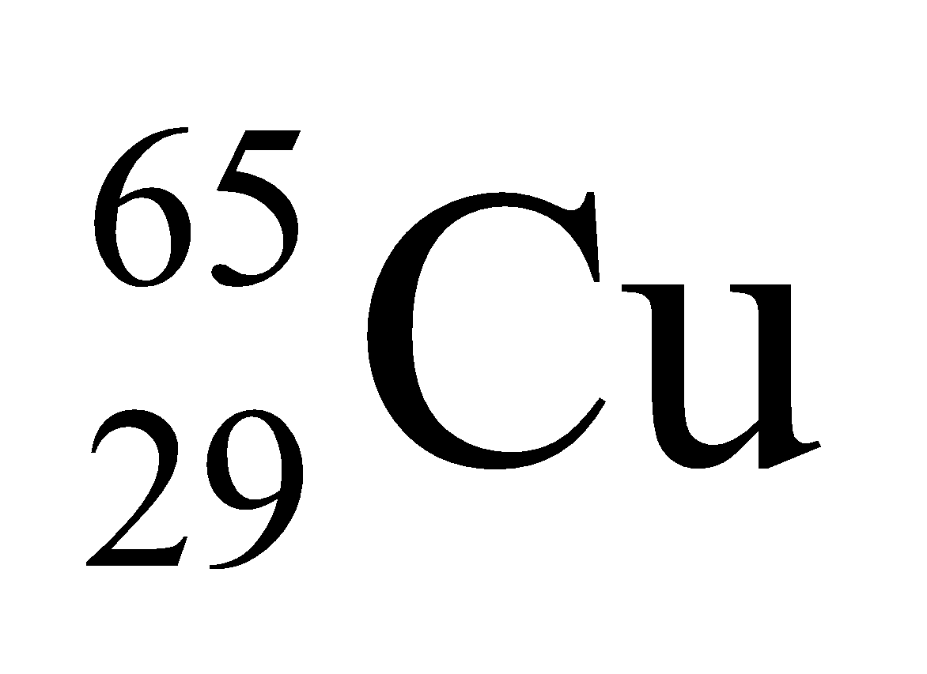.

**(b)** When *N*d = 2*N*, N0/N = 3, so the time required is

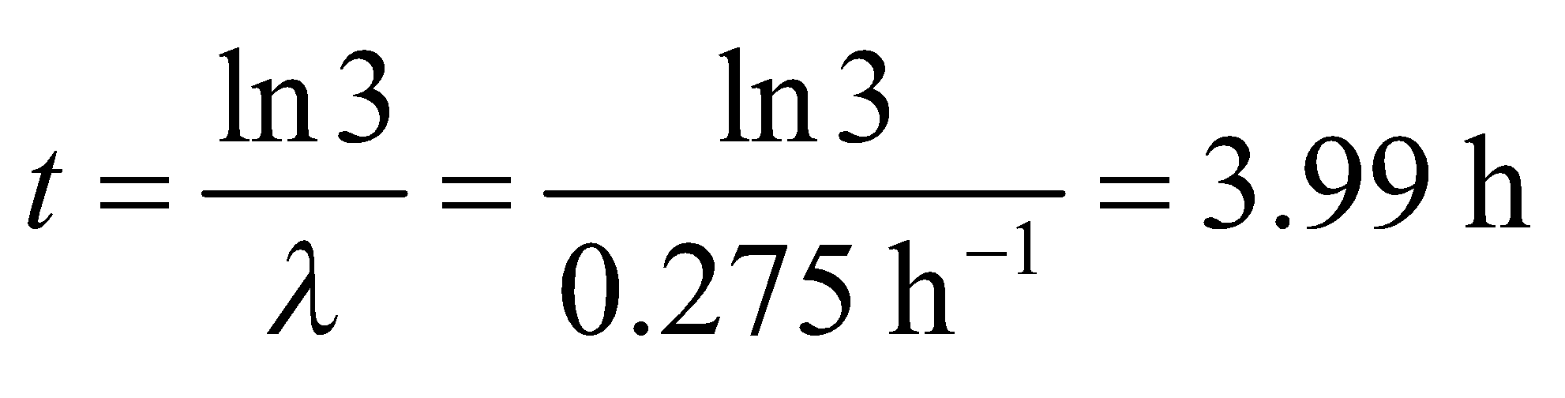

**Assess** The reaction may be written as

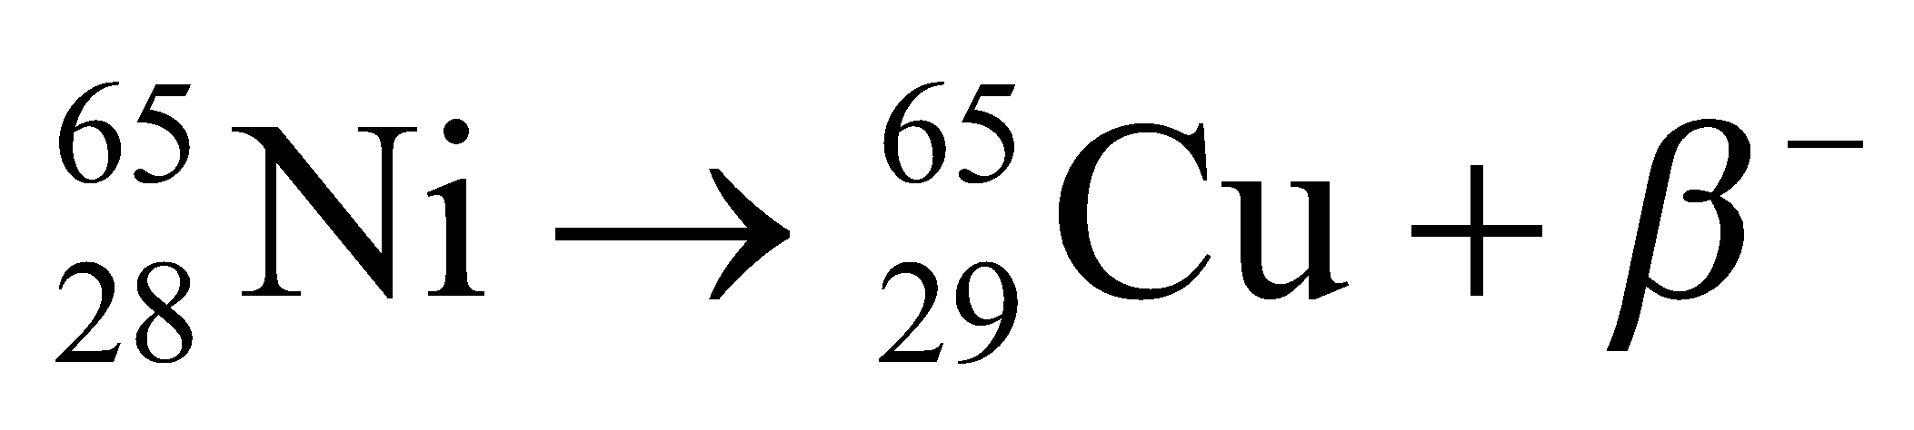

**72. Interpret** We're asked to estimate the human body's natural radioactivity, given the mass of the dominant radioactive elements in the body.

**Develop** For a given element, the radioactivity is the number of decays per unit time given by 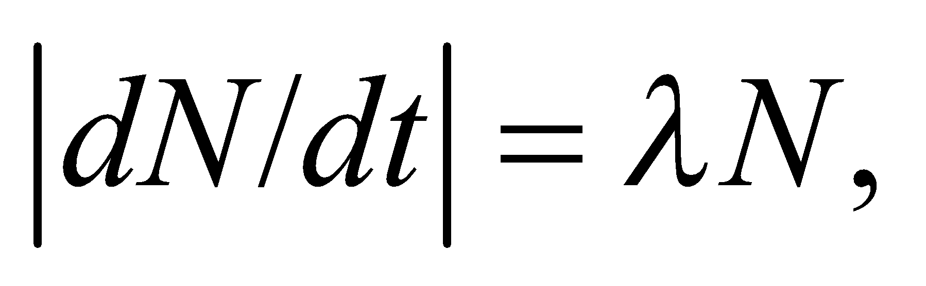where 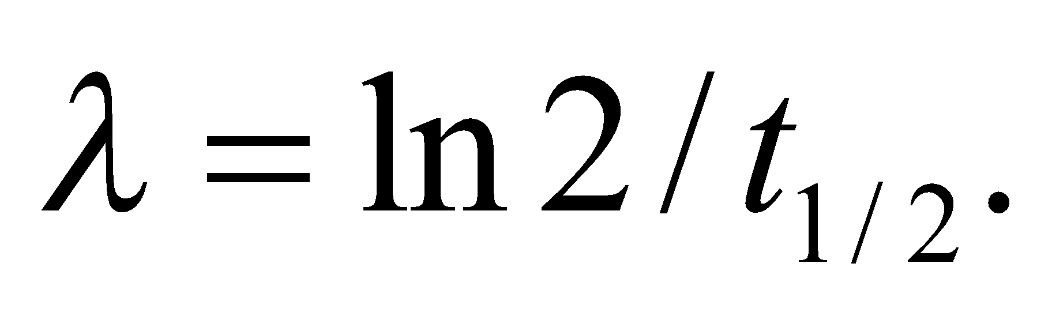 The half-life of potassium-40 is 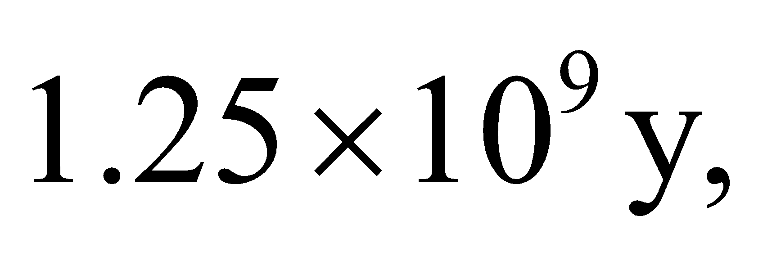 while that of carbon-14 is 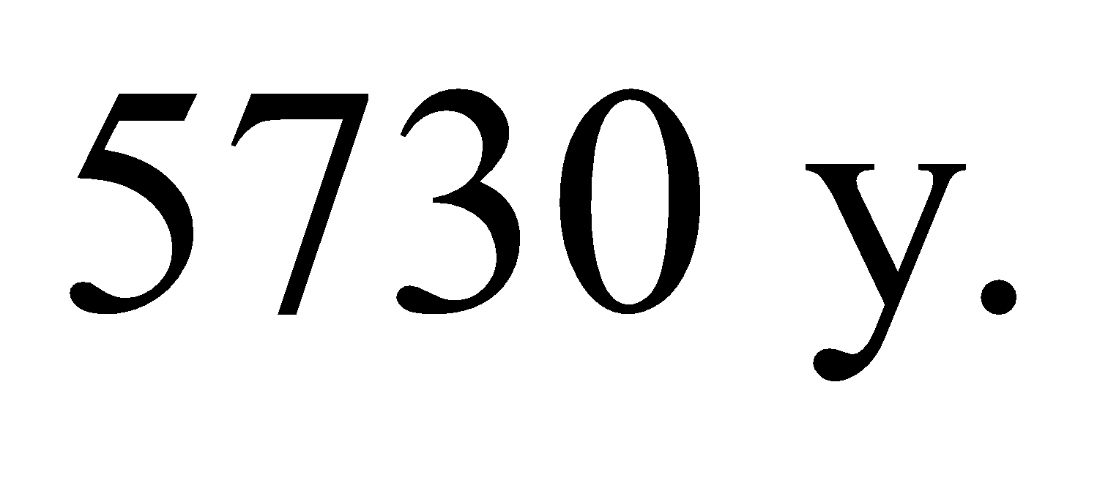The number of each element is 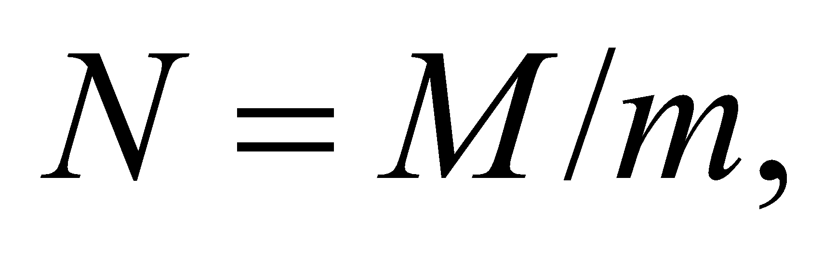 where *M* is the total mass found in the body and *m* is the mass of a single nuclei, which is just the mass number multiplied by the atomic mass unit, u.

**Evaluate** We will use as our unit of radioactivity the becquerel (Bq), which is defined as one decay per second. For K-40, the radioactivity is

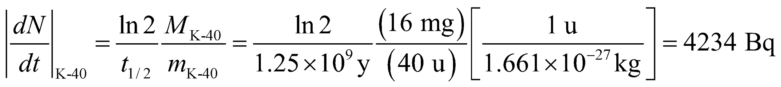

For C-14, the radioactivity is

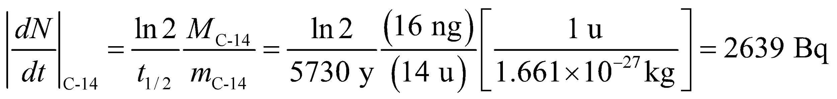

Adding these two results together gives the body's total radioactivity

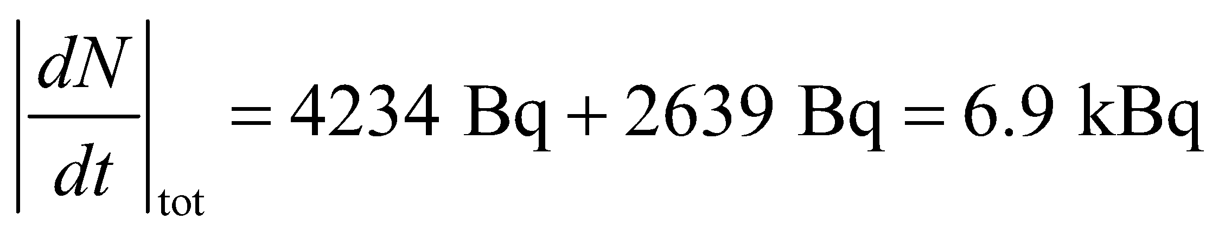

**Assess** The answer agrees with Problem 38.22, where we were told that the human body's natural radioactivity is about 7 kBq.

**73. Interpret** This problem is about the energy released in D-T fusion. We also want to compare the fusion energy with the energy produced by a coal-burning power plant.

**Develop** Half of the number of deuterons in one fuel pellet is

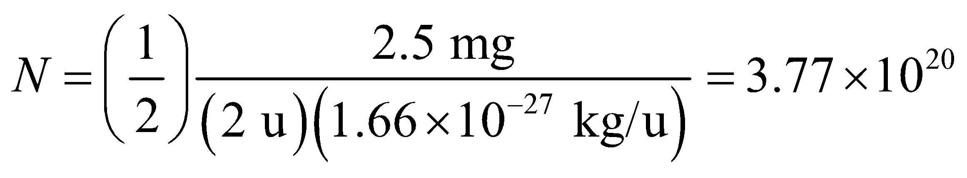

since there is 2.5 mg of deuterium in a pellet and the mass of a deuteron is approximately 2 u. As given in Equation 38.10a, each D-T reaction releases *E*1 = 17.6 MeV of energy.

**Evaluate** **(a)** The total amount of energy released in the D-T fusion reaction is



**(b)** The thermal power output, 3.000 GW, is equal to the energy release per pellet times the rate that pellets are consumed, hence this rate *dN*pel/*dt* of pellet consumption is

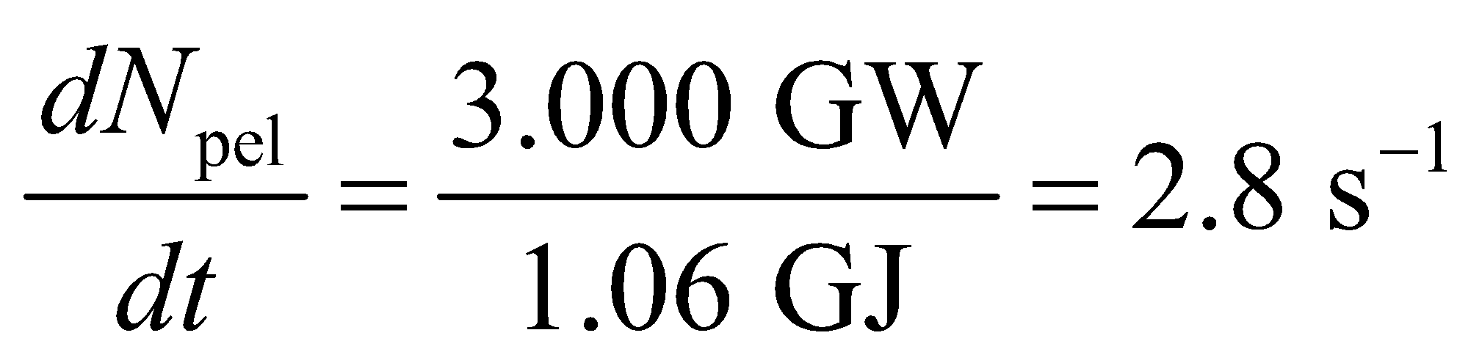

**(c)** 5.0-mg pellets, consumed at this rate for a year, have a total mass of



A comparable coal-burning power plant uses more than 7 million times this mass for its fuel.

**Assess** The amount of energy released by D-T fusion is enormous compared to the energy content of coal fuel. Controlled fusion devices could play a key role in future energy production.

**74. Interpret** This problem involves calculating the amount of 239Pu produced in a uranium power plant. We are also to estimate the number of potential plutonium bombs that could be produced by such a plant.

**Develop** In one year, the number *N* of fission events in a power plant whose thermal output is (0.30)(1.0 GW) = 3.33 GW is

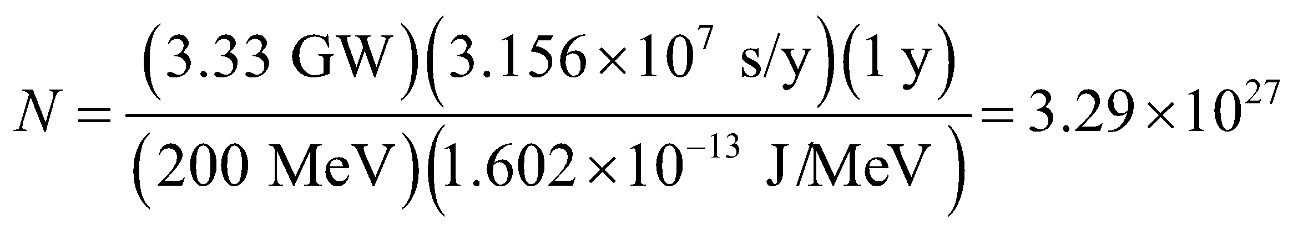

is the total energy released in a year divided by the energy release in one fission event, as in Example 38.6. The number of 239Pu nuclei produced is the number of fission events times the neutron absorption probability (= 0.6), from which we can find the mass of 239Pu produced. Since it takes 5 kg of 239Pu to produce a single bomb, we can divide the mass of 239Pu produced by 5 kg to find the total number of potential bombs that can be produced from this reactor.

**Evaluate** **(a)** The amount of 239Pu formed (atomic weight approximately 239 u) is



**(b)** This is enough to make (783 kg)/(5 kg) = 157 bombs, if all of the 239Pu could be extracted from the spent reactor fuel.

**Assess** This is another reason nuclear energy is controversial.

**75. Interpret** We are to find the value of *Z* within the liquid-drop model that gives the minimum nuclear mass as a function of *A*. This value of *Z* will be the most stable of the nuclei for that atomic mass.

**Develop** The formula given us for the liquid-drop model is

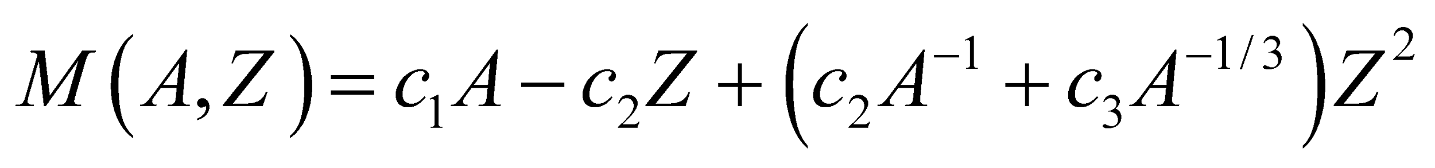

We shall take the partial derivative 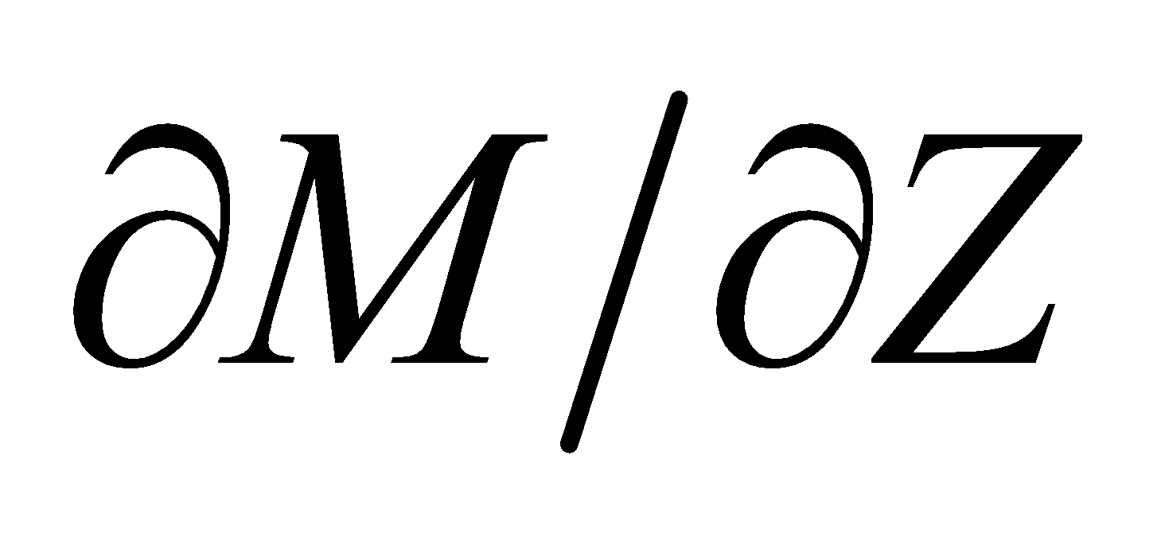 and set it equal to zero to find 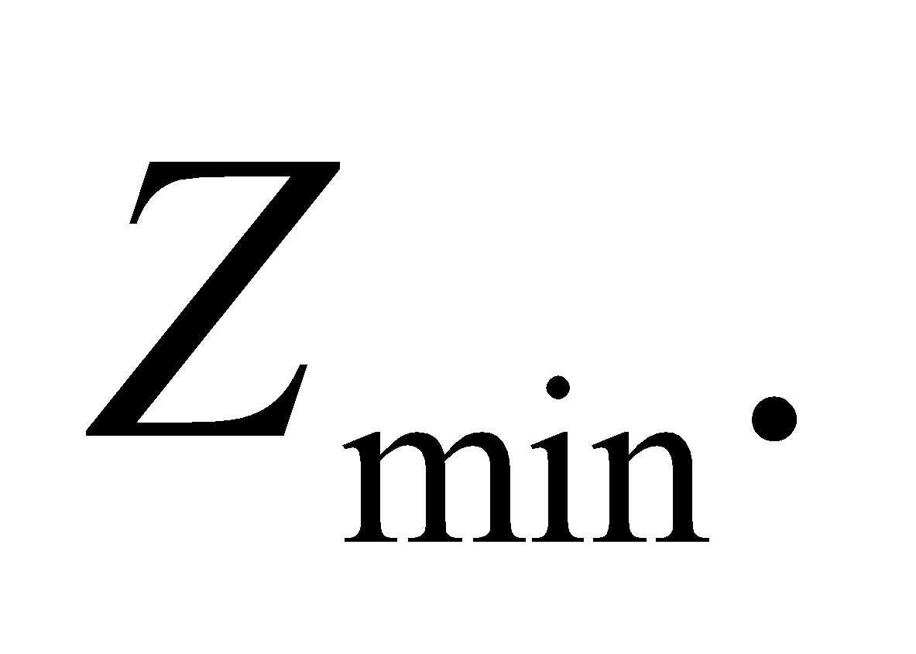

**Evaluate** Taking the derivative gives

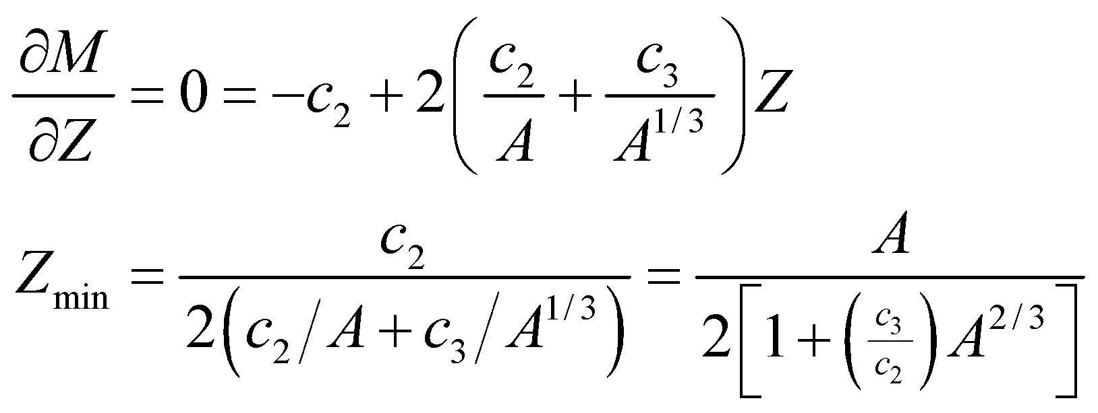

**Assess** To check that this is a minimum, we take the second partial derivative, evaluate it at *Z*min, and verify that the result is positive:

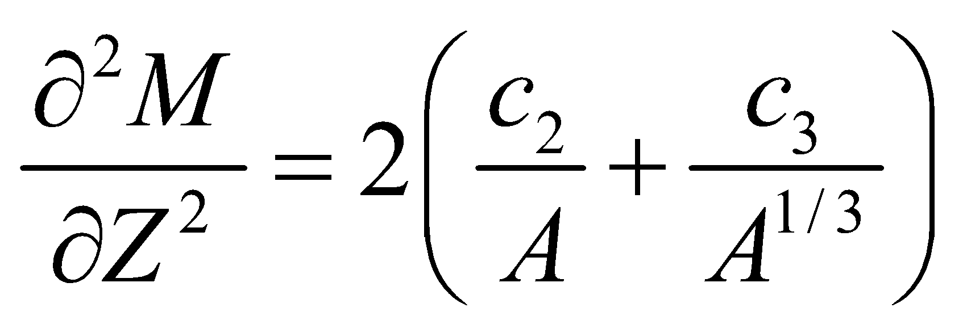

which is positive if 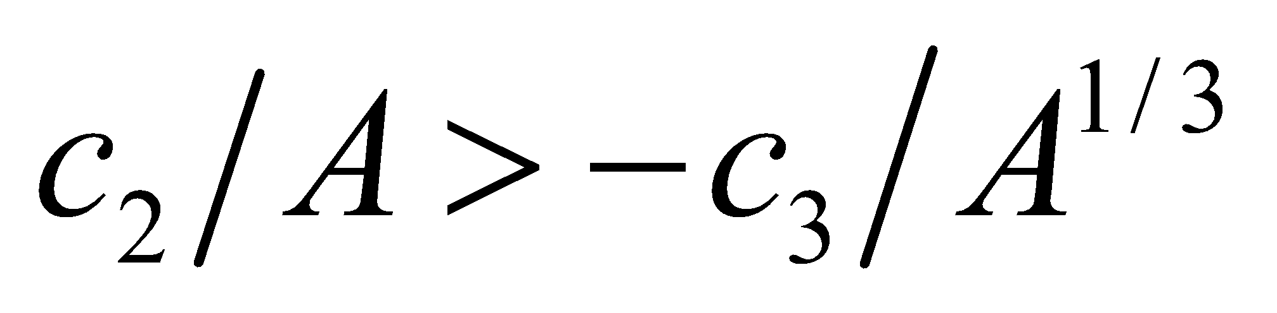.

**76. Interpret** We are to find the average lifetime of a radioactive nucleus using the approach outlined in the problem statement, and show that the result is the inverse of the decay constant of Equation 38.3a.

**Develop** The number of nuclei that will decay in a given time interval *dt* is 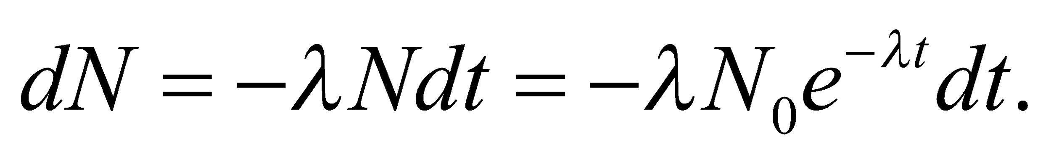 To find the average lifetime of a nucleus, we sum number of nuclei that survive to time *t* and divide by the total number of nuclei:

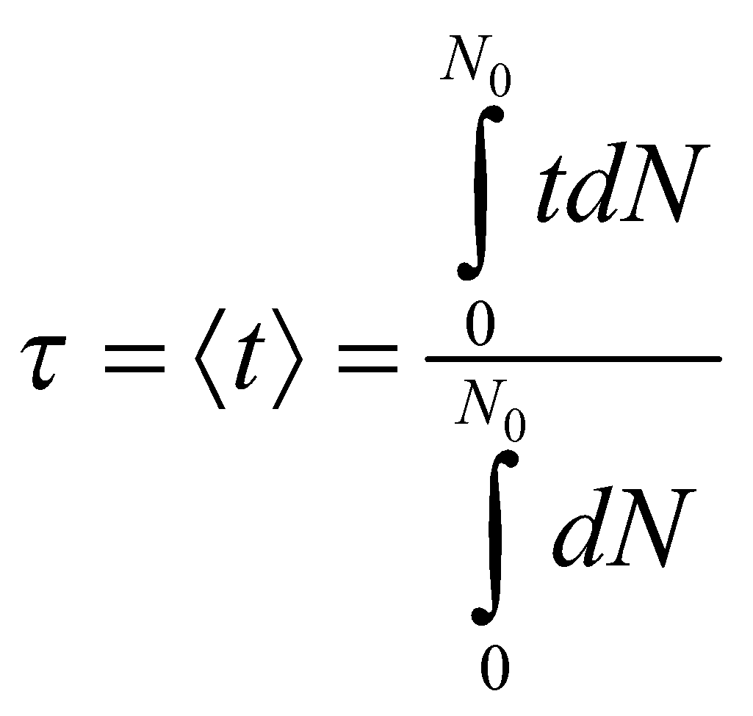

**Evaluate** We can evaluate the integrals with the help of the integral table in Appendix A. The result is

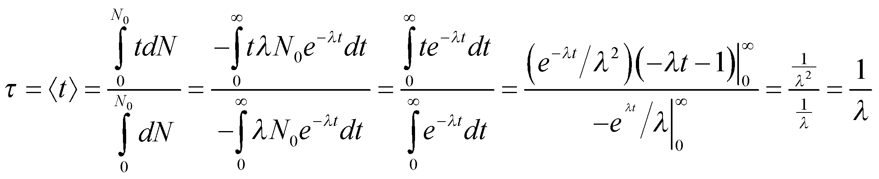

**Assess** We find that the average lifetime of a nucleus is the inverse of the decay constant *λ*.

**77. Interpret** When one radionuclide decays into another radioactive nucleus, the total activity of the sample becomes somewhat complicated. Here we will calculate the total activity for a two-step decay reaction, starting with the differential equations that define activity.

**Develop** The activity of a sample is 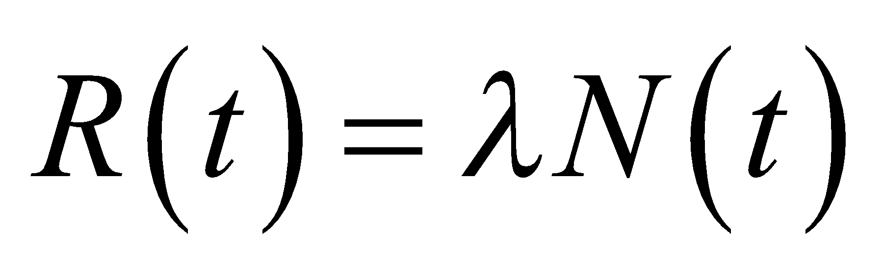 so if we find *N*(*t*) for each radionuclide, we can find the activity

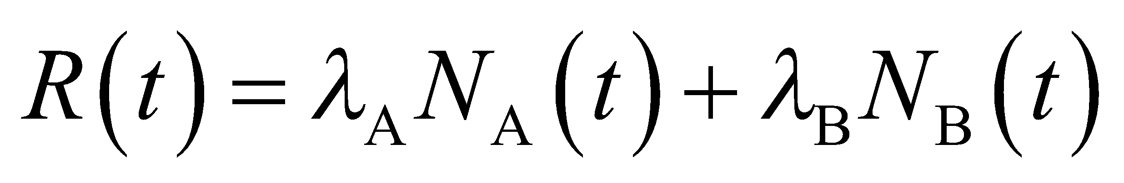

The equation for the parent nuclide is found in the usual way—it does not depend on the daughter at all. Thus, it is given by Equation 38.3a:

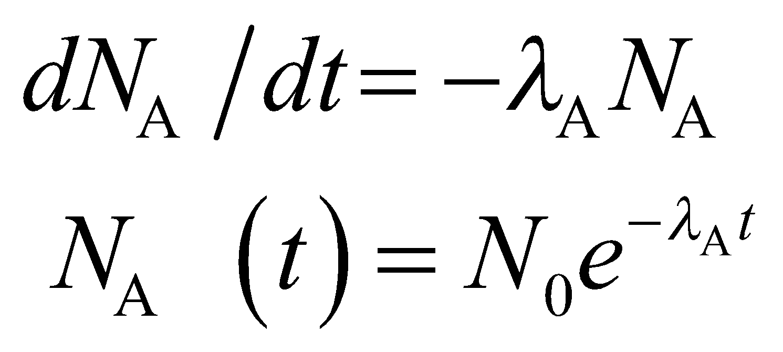

The differential equation for the daughter nuclide has the usual decay term, but it also has a growth term since each decay of a parent nucleus creates a daughter nucleus. Thus,

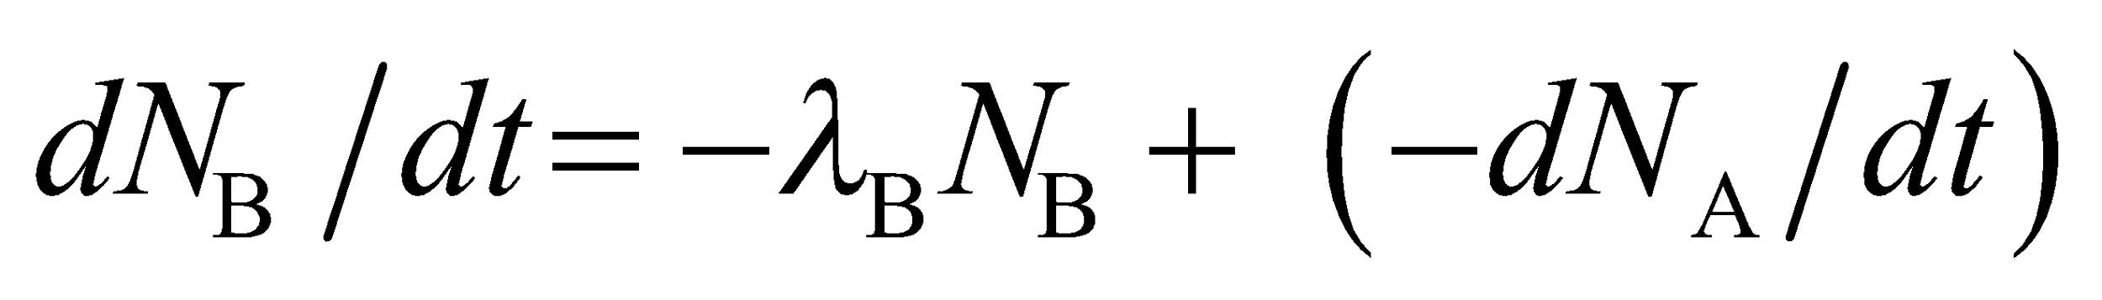

where we *subtract* the rate of change in the number of parent nuclides because a decrease in the parent (i.e., *dN*A/*dt* < 0) count is an increase in the daughter count. We will solve this second differential equation for 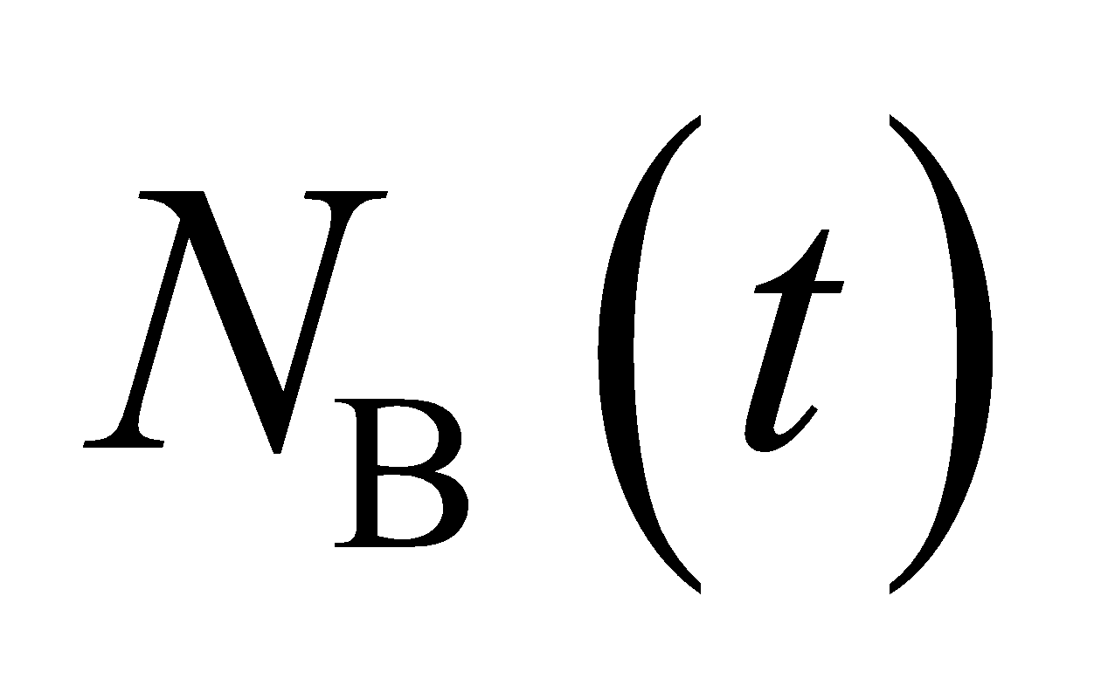 and then find the activity *R*(*t*).

**Evaluate** The rate of change in the daughter nuclide is

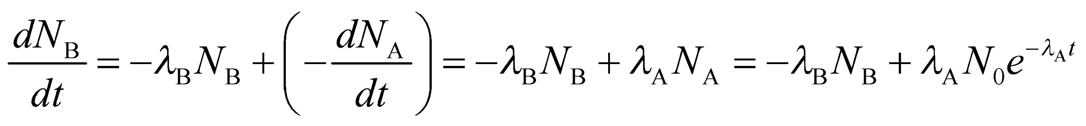

Try a solution of the form 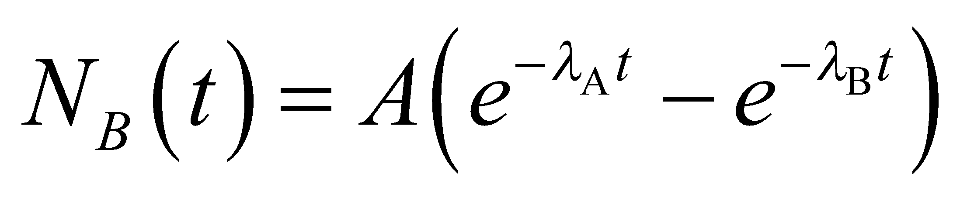. Inserting this into the differential equation for *N*B(*t*) to find the coeficient *A* gives

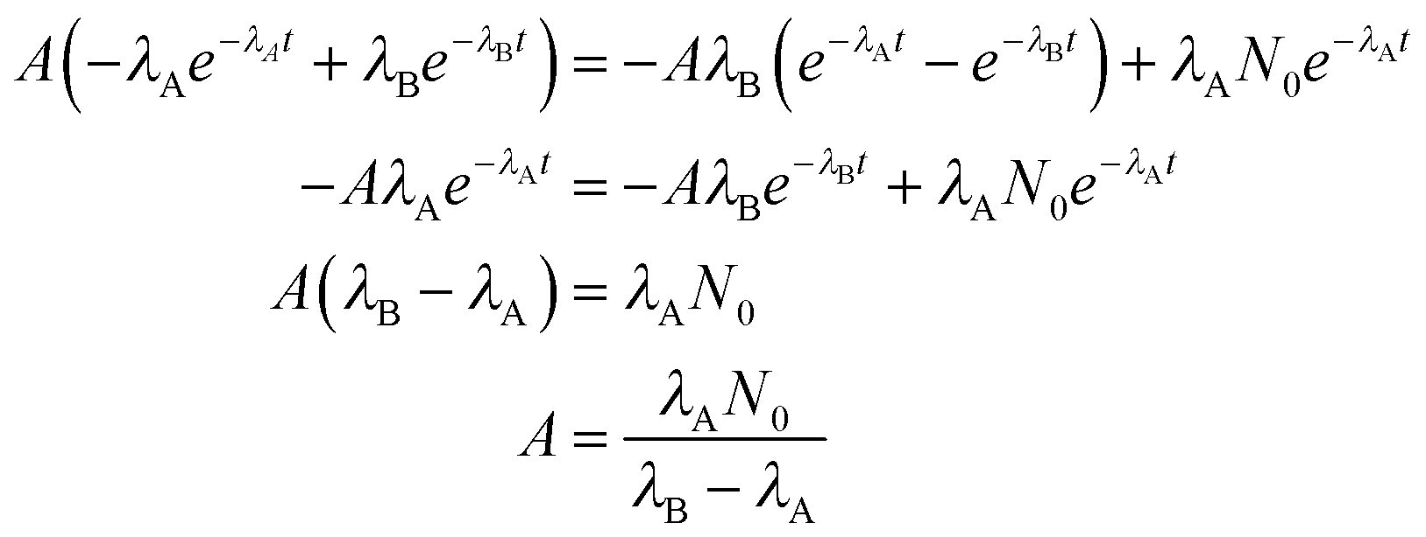

so

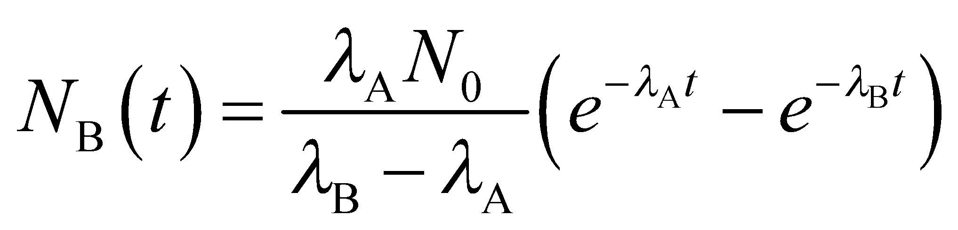

Combining this with *N*B(*t*) to get the total activity *R*(*t*) gives

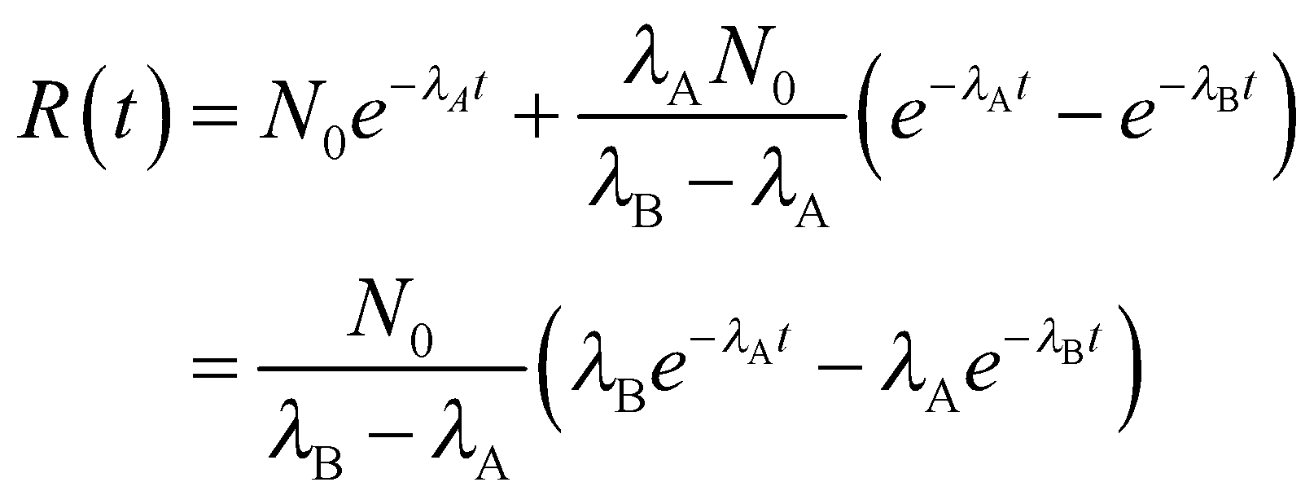

**Assess** Interestingly, the activity can actually *increase* with time! This is a serious problem right now with some of the radioactive holding tanks left over from the production of bomb-making material during WWII—their activity is increasing, and is expected to continue increasing for several more decades.

**78. Interpret** We are to find the total number of fission events that occur in *n* generations when the *k*-factor is greater than unity. We are to use this result to determine the time it would take for all nuclei in 10 kg of uranium to react.

**Develop** In part **(a)**, we shall show that 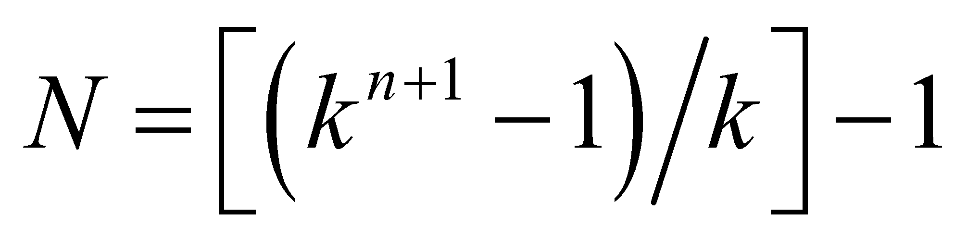 by summing the atoms that react each generation:

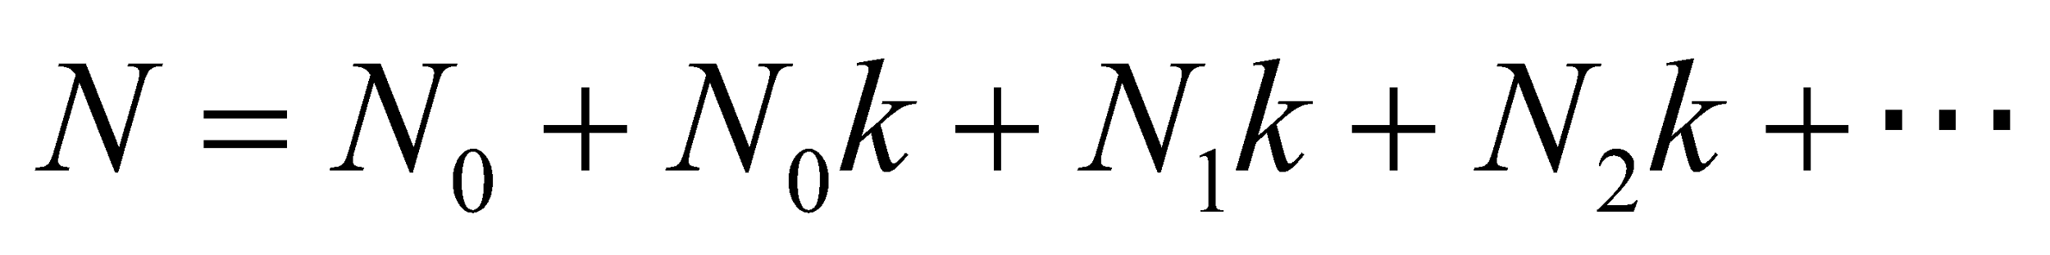

In part **(b)**, we shall use the sum from part **(a)** to find the time it takes to split 10 kg 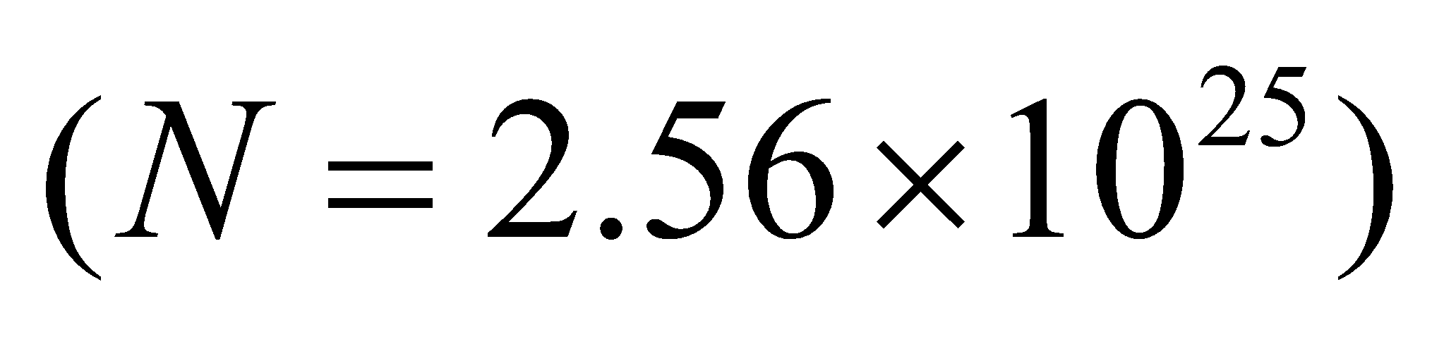 of 235U atoms, given that the time between generations is *τ* = 10 ns and *k* = 1.5. We will solve for the number of generations and multiply by *t* to find the total time to fission all the nuclei.

**Evaluate**

**(a)** Take *N*0 = 1 and let each subsequent *N* be equal to the previous *N* times *k*. This gives

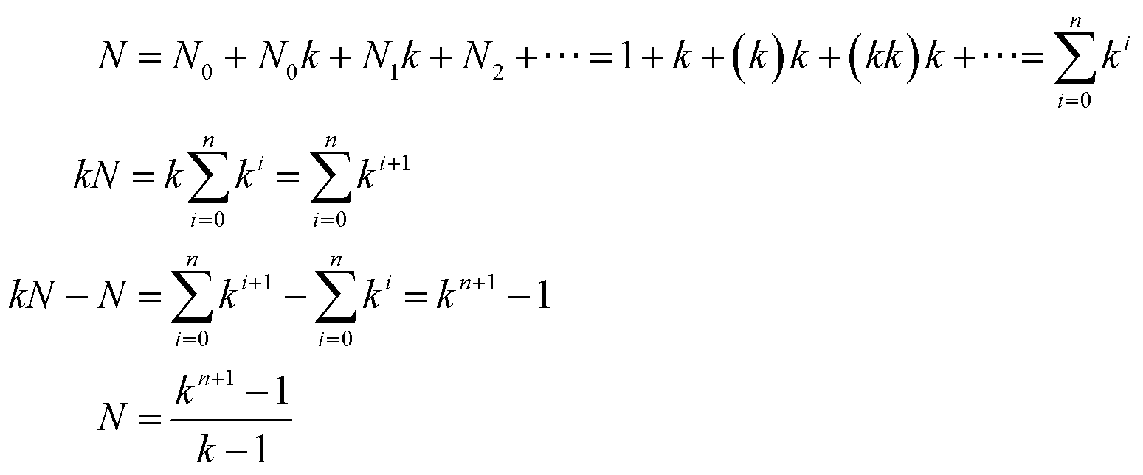

**(b)** Solving for the number of generations *n* yields

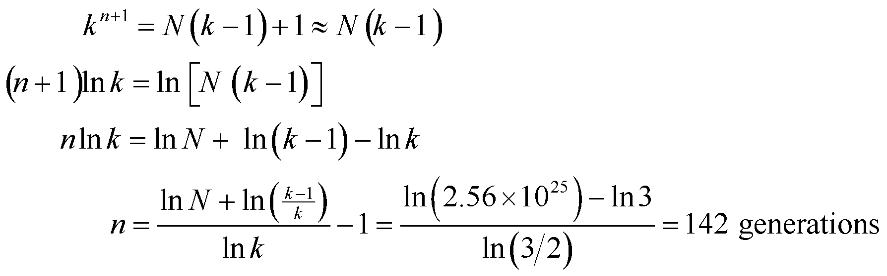

where we have neglected unity compared to *N*(*k* − 1) in the first line. Thus, the total time for all fission events is

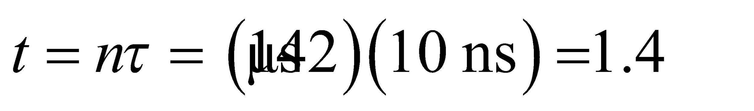

**Assess** For a *controlled* nuclear reaction, the value of *k* must be kept very close to unity. Large values such as *k* = 1.5 are impossible to control mechanically.

**79. Interpret** You're curious whether enough of a short-lived radioisotope is being made for a medical scan planned for one of your family members.

**Develop** The initial mass of Tc-99* will be reduced to 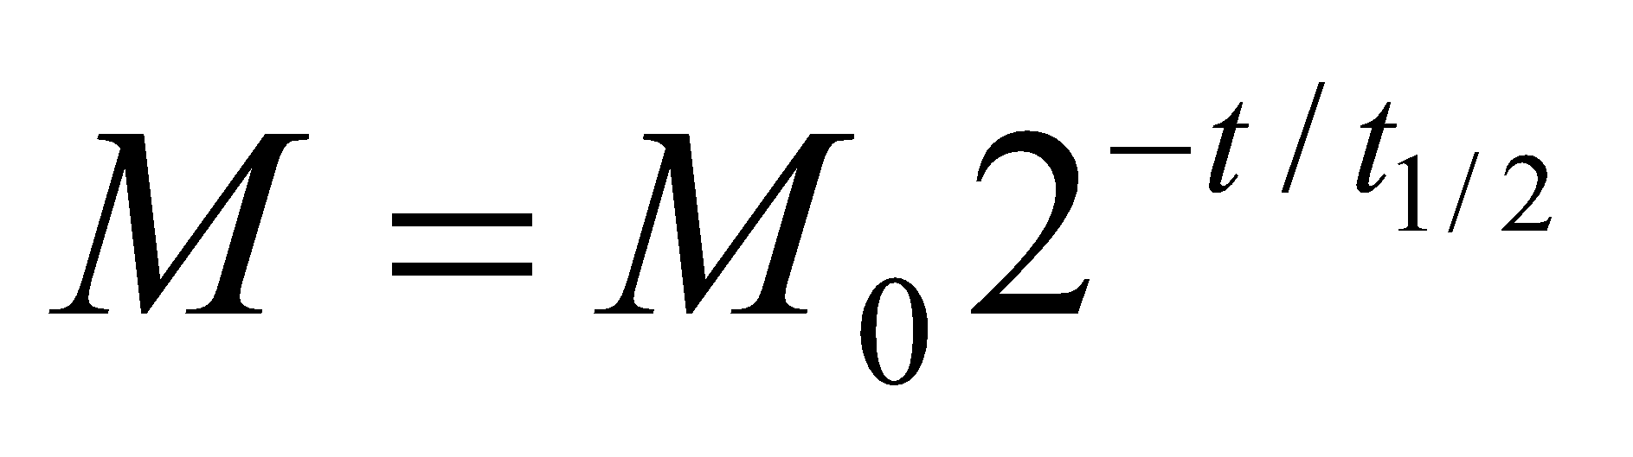 (a variation on Equation 38.3b) during the 90 minutes that it takes to transport it to the nuclear medicine department. Although you are given the half-life of the parent isotope, molybdenum-99, the only relevant half-life is that of the excited state of technetium-99, 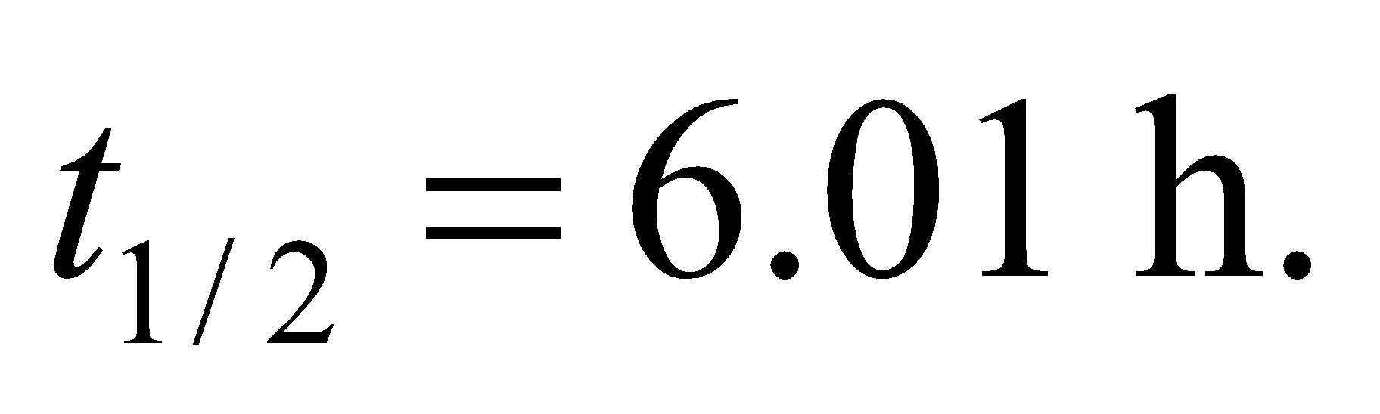

**Evaluate** Writing 90 min as 1.5 h, the amount of the initial 12 mg of Tc-99* that remains is

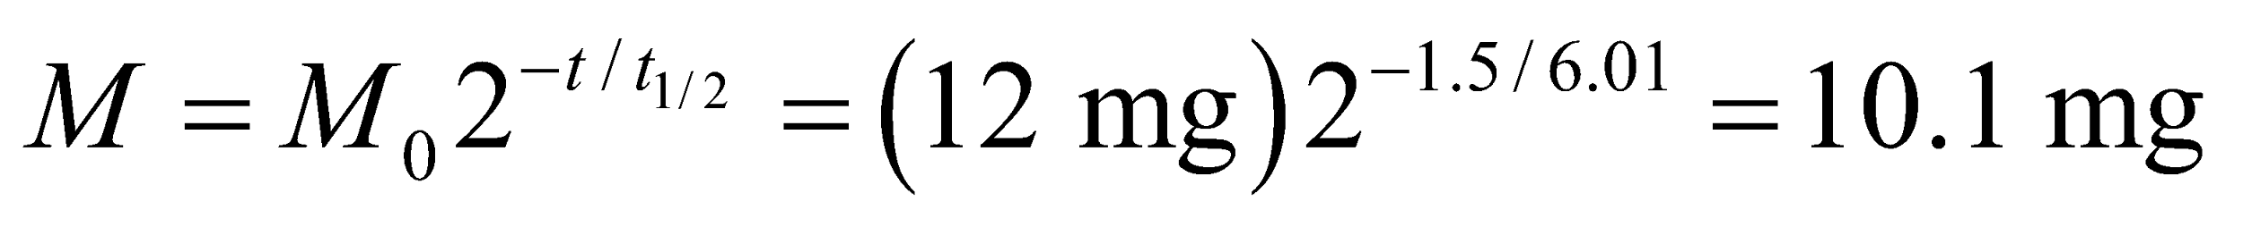

This is (barely) above the required 10 mg, so yes, the initial amount will be enough.

**Assess** It might seem like the hospital staff is not leaving themselves much room for delay, but they presumably do not want to over-produce the amount of Tc-99*, since that would increase costs, as well as increase the risks from handling this radioactive material.

**80. Interpret** We will explore the circumstances surrounding a natural nuclear fission reaction that occurred 2 billion years ago.

**Develop** Since the Oklo fission reaction, there have passed several half-lives of U-235, more precisely

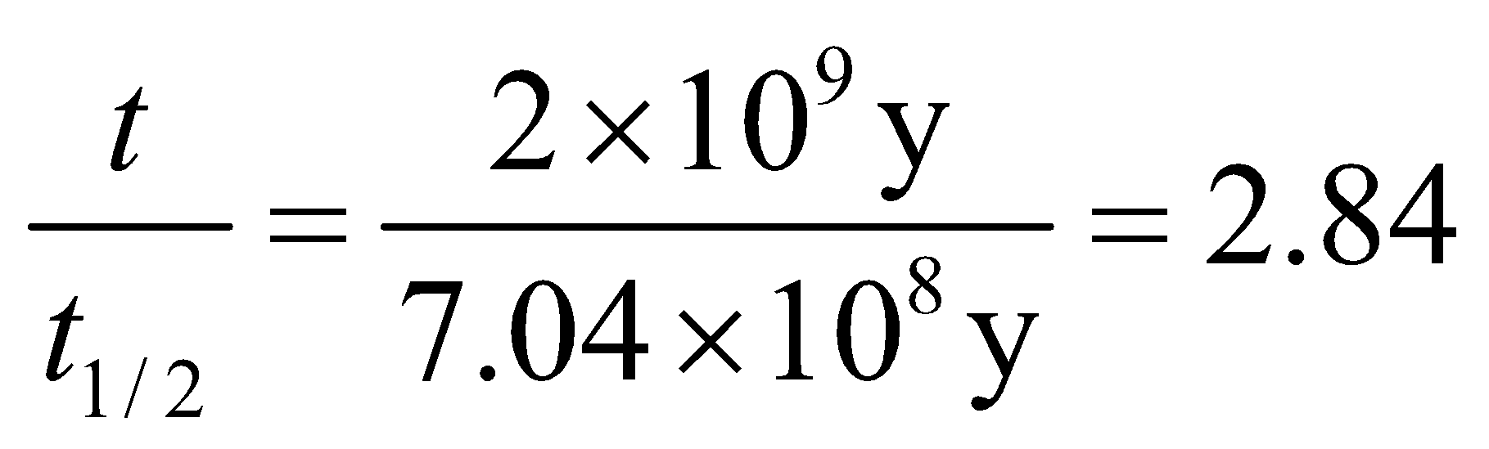

**Evaluate** Two billion years ago, the number of U-235 at the Oklo site relative to now was

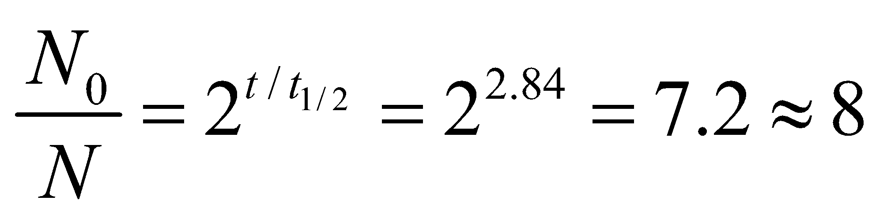

The answer is (d).

**Assess** Notice that this result is completely general. The amount of U-235 here or anywhere in the solar system was 8 times greater 2 billion years ago.

**81. Interpret** We will explore the circumstances surrounding a natural nuclear fission reaction that occurred 2 billion years ago.

**Develop** We want to know what the ratio between U-235 and U-238 was two billion years ago in natural uranium. In the previous problem, we showed that 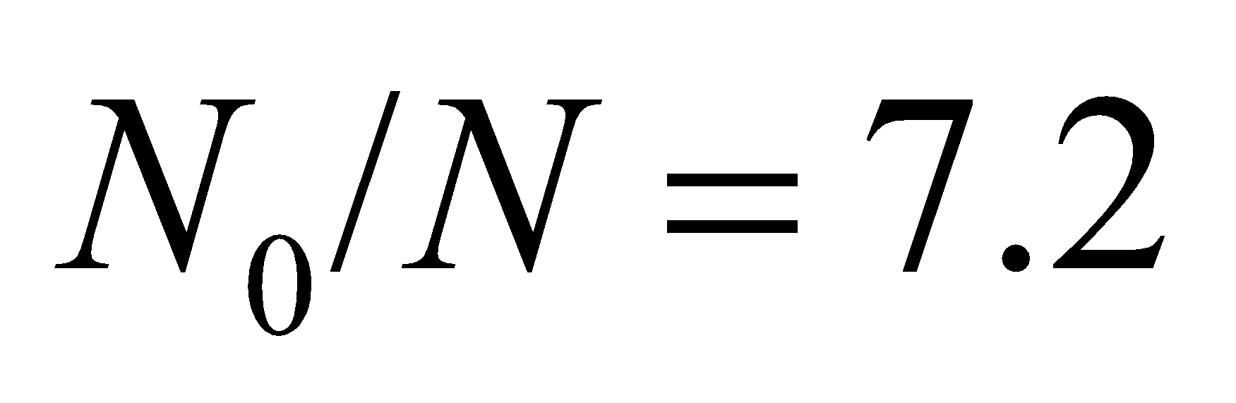 for U-235. For U-238 with 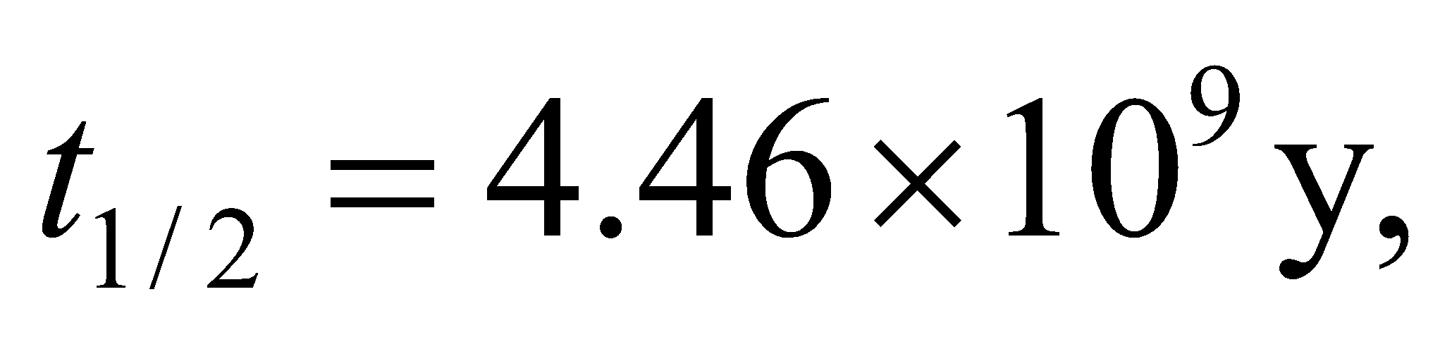

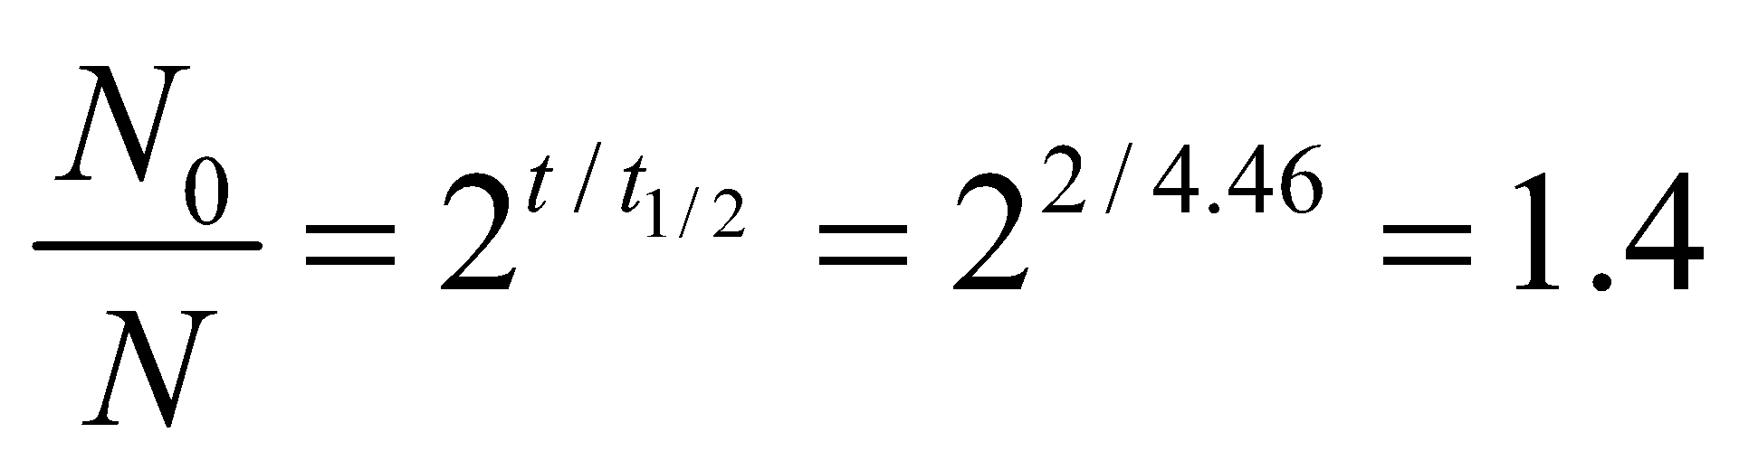

**Evaluate** Two billion years ago, a typical sample of uranium would have as its ratio of U-235 to U-238:

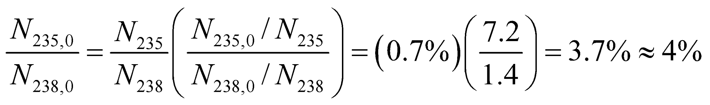

The answer is (b).

**Assess** Since U-235 decays 6 times faster than U-238, there had to be relatively more of U-235 in the past.

**82. Interpret** We will explore the circumstances surrounding a natural nuclear fission reaction that occurred 2 billion years ago.

**Develop** The water at Oklo served as the moderator. It slowed down neutrons created in the fission reaction. These slow neutrons were vital to the chain reaction, as they were what initiated the next generation of fission reactions.

**Evaluate** In the description of nuclear reactor types, the text makes it clear that a loss of moderator will cause the chain reaction to halt. Therefore, if the water boiled away at Oklo, the fission reaction would cease.

The answer is (a).

**Assess** We can think of this in terms of the multiplication factor, *k*, which is the average number of neutrons from a fission event that cause additional fission. We can assume that Oklo when it was working had 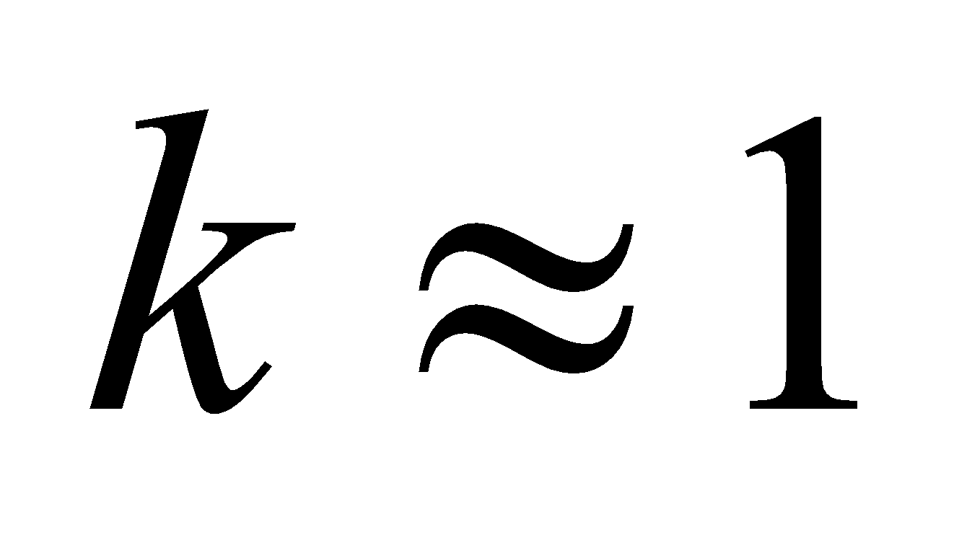 (critical mass), since the supercritical case with 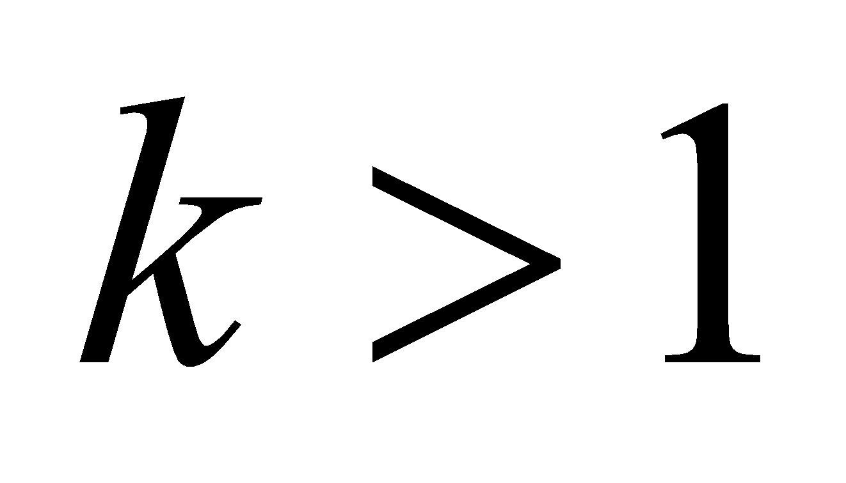 would have resulted in the fuel being burned up in a very short time, which is inconsistent with the estimated 100,000-year-lifetime of this natural reactor. If the water evaporated, then there would no longer be anything to slow down the neutrons. Although fast neutrons can still induce further fission reactions, they are less effective than slow neutrons, so the factor *k* would certainly fall below 1. As such, the chain reaction would no longer be able to sustain itself.

**83. Interpret** We will explore the circumstances surrounding a natural nuclear fission reaction that occurred 2 billion years ago.

**Develop** There are many radioactive products from nuclear fission, and so we might expect small amounts of the three given isotopes were created at Oklo.

**Evaluate** The half-lives of Sr-90, C-14 and Pu-239 are, respectively, 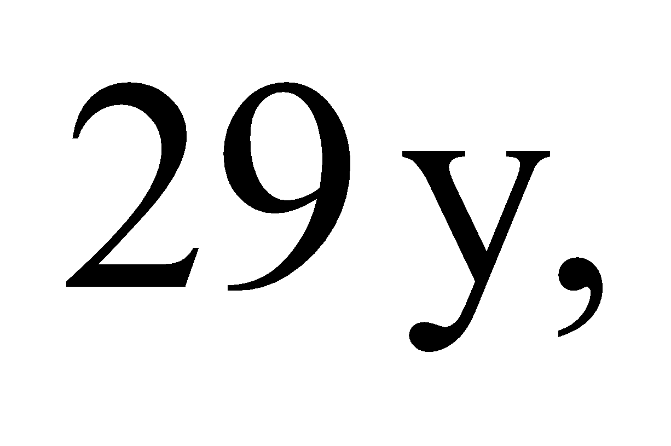 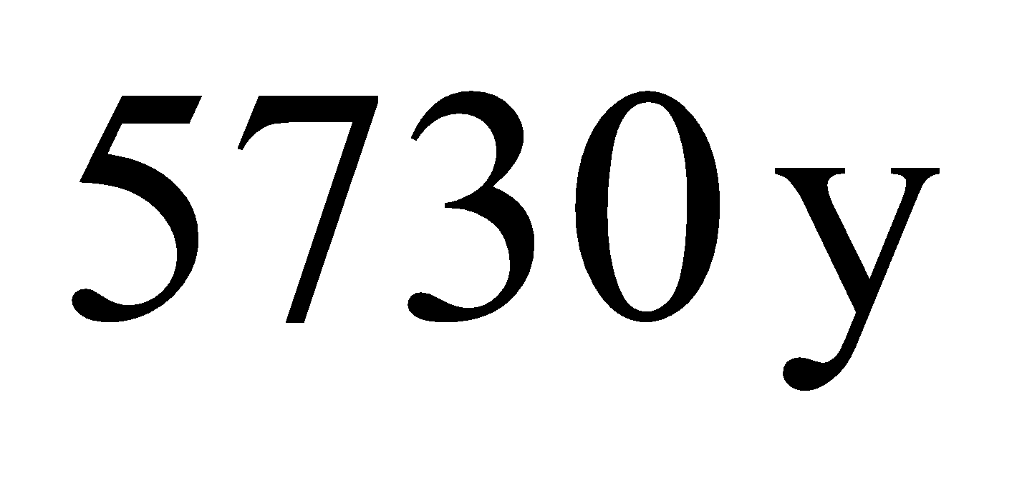 and 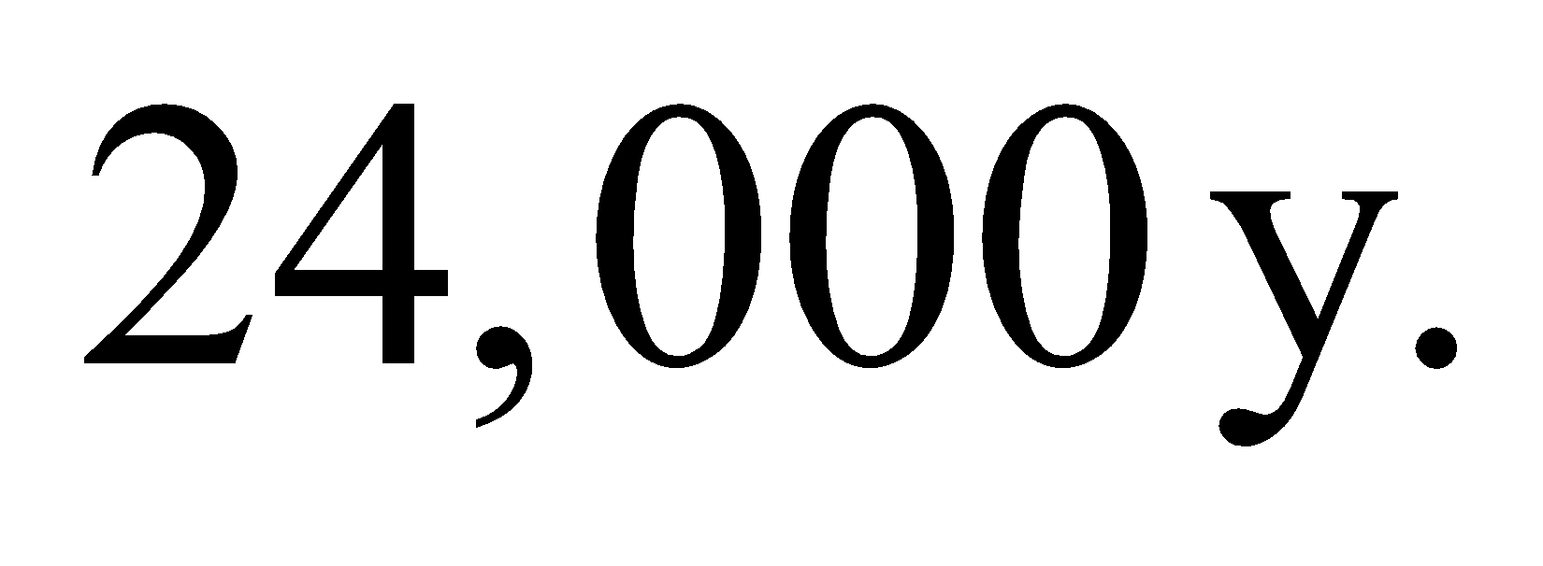Over the 2 billion years since the fission reactions ended, there have been over 60 million lifetimes of strontium-90, 350,000 lifetimes of carbon-14, and over 80,000 lifetimes of plutonium-239. Clearly, there will no longer be any trace of these elements.

The answer is (d).

**Assess** Scientists have found measurable amounts of other fission products at Oklo, such as particular isotopes of neodymium and ruthenium. These products happen to be stable, so there's no risk of them decaying away like the ones in this problem.